Functional Specification – Report

Export-Import Bank of Thailand

|  |  |
| --- | --- |
| Project Code: | EXPJ.B.PJ.TH.EXIMTH*CBS_IMP.CC |
| Reference: | LND-FS09 |
| Release: | 2.8 |
| Status: | Released for External Distribution |
| Date | 5-Sep-23 |

Contents

Introduction 14

Functional Summary 18

1.1 Purpose 18

1.2 Background/Functional Requirements 18

1.3 Business Rule / Business Logic 18

Report Specification 19

1. Loan Outstanding 19

1.1. Supported Sample Transaction and Case from Customer 19

1.2. Menu Modification 21

1.3. Screen Layout and Data Sheet 21

1.4. To-be Process 21

1.4.1. Enhancement 27

1.4.2. After Enhancement 27

1.5. File / API Layout and Data Sheet 27

1.6. Report Layout and Data Sheet 27

1.7. Additional Impacts 27

1.7.1. Integration 27

1.7.2. Migration 27

2. Overdue principal/Interest Report 28

2.1. Supported Sample Transaction and Case from Customer 28

2.2. Menu Modification 31

2.3. Screen Layout and Data Sheet 31

2.4. To-Be Process 31

2.5. File / API Layout and Data Sheet 36

2.6. Report Layout and Data Sheet 36

2.7. Additional Impacts 36

2.7.1. Integration 36

2.7.2. Migration 36

3. List due report 37

3.1. Supported Sample Transaction and Case from Customer 37

3.2. Menu Modification 37

3.3. Screen Layout and Data Sheet 37

3.4. To-be Process 38

3.5. File / API Layout and Data Sheet 41

3.6. Report Layout and Data Sheet 41

3.7. Additional Impacts 41

3.7.1. Integration 41

3.7.2. Migration 41

4. Accrued Interest report 42

4.1. Supported Sample Transaction and Case from Customer 42

4.2. Menu Modification 44

4.3. Screen Layout and Data Sheet 44

4.4. To-be Process 44

4.5. File / API Layout and Data Sheet 48

4.6. Report Layout and Data Sheet 48

4.7. Additional Impacts 48

4.7.1. Integration 48

4.7.2. Migration 48

5. Daily Interest Transaction (summary) 49

5.1. Supported Sample Transaction and Case from Customer 49

5.2. Menu Modification 50

5.3. Screen Layout and Data Sheet 50

5.4. To-be Process 50

5.5. File / API Layout and Data Sheet 56

5.6. Report Layout and Data Sheet 56

5.7. Additional Impacts 56

5.7.1. Integration 56

5.7.2. Migration 56

6. Monthly Accrued interest 57

6.1. Supported Sample Transaction and Case from Customer 57

6.2. Menu Modification 59

6.3. Screen Layout and Data Sheet 59

6.4. To-be Process 60

6.5. File / API Layout and Data Sheet 63

6.6. Report Layout and Data Sheet 63

6.7. Additional Impacts 63

6.7.1. Integration 63

6.7.2. Migration 63

7. Daily Foreign currency report (Final) 63

7.1. Supported Sample Transaction and Case from Customer 63

7.2. Menu Modification 64

7.3. Screen Layout and Data Sheet 64

7.4. To-be Process 64

7.5. File / API Layout and Data Sheet 65

7.6. Report Layout and Data Sheet 65

7.7. Additional Impacts 65

7.7.1. Integration 65

7.7.2. Migration 65

8. Daily Current account report (Final) 66

8.1. Supported Sample Transaction and Case from Customer 66

8.2. Menu Modification 67

8.3. Screen Layout and Data Sheet 67

8.4. To-be Process 67

8.5. File / API Layout and Data Sheet 68

8.6. Report Layout and Data Sheet 68

8.7. Additional Impacts 68

8.7.1. Integration 68

8.7.2. Migration 68

9. Change Interest rate report 69

9.1. Supported Sample Transaction and Case from Customer 69

9.2. Menu Modification 69

9.3. Screen Layout and Data Sheet 69

9.4. To-be Process 70

9.5. File / API Layout and Data Sheet 71

9.6. Report Layout and Data Sheet 72

9.7. Additional Impacts 72

9.7.1. Integration 72

9.7.2. Migration 72

10. G/L Summary report (Final) 73

10.1. Supported Sample Transaction and Case from Customer 73

10.2. Menu Modification 74

10.3. Screen Layout and Data Sheet 74

10.4. To-be Process 74

10.5. File / API Layout and Data Sheet 76

10.6. Report Layout and Data Sheet 76

10.7. Additional Impacts 76

10.7.1. Integration 76

10.7.2. Migration 76

11. Transfer overdue principal report 77

11.1. Supported Sample Transaction and Case from Customer 77

11.2. Menu Modification 77

11.3. Screen Layout and Data Sheet 77

11.4. To-be Process 77

11.5. File / API Layout and Data Sheet 78

11.6. Report Layout and Data Sheet 78

11.7. Additional Impacts 78

11.7.1. Integration 78

11.7.2. Migration 78

12. Interest convert to thai baht report 79

12.1. Supported Sample Transaction and Case from Customer 79

12.2. Menu Modification 79

12.3. Screen Layout and Data Sheet 79

12.4. To-be Process 79

12.5. File / API Layout and Data Sheet 81

12.6. Report Layout and Data Sheet 81

12.7. Additional Impacts 81

12.7.1. Integration 81

12.7.2. Migration 81

13. Daily Cheque return report 82

13.1. Supported Sample Transaction and Case from Customer 82

13.2. Menu Modification 82

13.3. Screen Layout and Data Sheet 82

13.4. To-be Process 82

13.5. File / API Layout and Data Sheet 84

13.6. Report Layout and Data Sheet 84

13.7. Additional Impacts 84

13.7.1. Integration 84

13.7.2. Migration 84

14. Daily Payment/ Repayment detail 85

14.1. Supported Sample Transaction and Case from Customer 85

14.2. Menu Modification 87

14.3. Screen Layout and Data Sheet 87

14.4. To-be Process 87

14.5. File / API Layout and Data Sheet 94

14.6. Report Layout and Data Sheet 94

14.7. Additional Impacts 94

14.7.1. Integration 94

14.7.2. Migration 94

15. G/L summary (Outstanding) report 95

15.1. Supported Sample Transaction and Case from Customer 95

15.2. Menu Modification 95

15.3. Screen Layout and Data Sheet 95

15.4. To-be Process 95

15.5. File / API Layout and Data Sheet 96

15.6. Report Layout and Data Sheet 96

15.7. Additional Impacts 96

15.7.1. Integration 96

15.7.2. Migration 96

16. Loan Turnover - Drawdown report 98

16.1. Supported Sample Transaction and Case from Customer 98

16.2. Menu Modification 99

16.3. Screen Layout and Data Sheet 99

16.4. To-be Process 99

16.5. File / API Layout and Data Sheet 101

16.6. Report Layout and Data Sheet 101

16.7. Additional Impacts 102

16.7.1. Integration 102

16.7.2. Migration 102

17. G/L Detail Outstanding Report 103

17.1. Supported Sample Transaction and Case from Customer 103

17.2. Menu Modification 105

17.3. Screen Layout and Data Sheet 105

17.4. To-be Process 105

17.5. File / API Layout and Data Sheet 106

17.6. Report Layout and Data Sheet 106

17.7. Additional Impacts 106

17.7.1. Integration 106

17.7.2. Migration 107

18. Loan Credit Limit (Sort by name) 107

18.1. Supported Sample Transaction and Case from Customer 107

18.2. Menu Modification 109

18.3. Screen Layout and Data Sheet 109

18.4. To-be Process 109

18.5. File / API Layout and Data Sheet 111

18.6. Report Layout and Data Sheet 111

18.7. Additional Impacts 111

18.7.1. Integration 111

18.7.2. Migration 111

19. Statement of Loan Account 112

19.1. Supported Sample Transaction and Case from Customer 112

19.2. Menu Modification 114

19.3. Screen Layout and Data Sheet 114

19.4. To-be Process 114

19.5. File / API Layout and Data Sheet 117

19.6. Report Layout and Data Sheet 117

19.7. Additional Impacts 117

19.7.1. Integration 117

19.7.2. Migration 117

20. ใบนำส่ง CHQ Clearing, cheque clearing report 118

20.1. Supported Sample Transaction and Case from Customer 118

20.2. Menu Modification 118

20.3. Screen Layout and Data Sheet 118

20.4. To-be Process 119

20.5. File / API Layout and Data Sheet 119

20.6. Report Layout and Data Sheet 120

20.7. Additional Impacts 120

20.7.1. Integration 120

20.7.2. Migration 120

21. ใบนำส่ง CHQ Clearing และเงินสด , cheque clearing and cash report 120

21.1. Supported Sample Transaction and Case from Customer 120

21.2. Menu Modification 121

21.3. Screen Layout and Data Sheet 121

21.4. To-be Process 121

21.5. File / API Layout and Data Sheet 122

21.6. Report Layout and Data Sheet 122

21.7. Additional Impacts 123

21.7.1. Integration 123

21.7.2. Migration 123

22. ตารางดำเนินคดีลูกหนี้ (Lawsuit Report) 123

22.1. Supported Sample Transaction and Case from Customer 123

22.2. Menu Modification 123

22.3. Screen Layout and Data Sheet 123

22.4. To-be Process 124

22.5. File / API Layout and Data Sheet 126

22.6. Report Layout and Data Sheet 126

22.7. Additional Impacts 126

22.7.1. Integration 126

22.7.2. Migration 126

23. ตารางคำนวณชดเชยส่วนต่างดอกเบี้ย TG1 (Interest Differential Compensation: TG1 Report) (Related TOR – LN-55) 126

23.1. Supported Sample Transaction and Case from Customer 126

23.2. Menu Modification 128

23.3. Screen Layout and Data Sheet 128

23.4. To-be Process 128

23.5. File / API Layout and Data Sheet 130

23.6. Report Layout and Data Sheet 130

23.7. Additional Impacts 130

23.7.1. Integration 130

23.7.2. Migration 130

24. ตารางคำนวณชดเชยส่วนต่างดอกเบี้ย BIZ (Interest Differential Compensation: BIZ Report) (Related TOR – LN-55) 130

24.1. Supported Sample Transaction and Case from Customer 130

24.2. Menu Modification 131

24.3. Screen Layout and Data Sheet 131

24.4. To-be Process 131

24.5. File / API Layout and Data Sheet 132

24.6. Report Layout and Data Sheet 132

24.7. Additional Impacts 132

24.7.1. Integration 132

24.7.2. Migration 132

25. ตารางคำนวณชดเชยส่วนต่างดอกเบี้ย TT1, TT2 (Interest Differential Compensation: TT1, TT2 Report) (Related TOR – LN-55) 133

25.1. Supported Sample Transaction and Case from Customer 133

25.2. Menu Modification 133

25.3. Screen Layout and Data Sheet 133

25.4. To-be Process 134

25.5. File / API Layout and Data Sheet 135

25.6. Report Layout and Data Sheet 135

25.7. Additional Impacts 135

25.7.1. Integration 135

25.7.2. Migration 135

26. ใบแจ้งยกเลิกวงเงิน/แจ้งหมดภาระหนี้ (Credit Limit Cancellation/Debt Discharge Notification report) 136

26.1. Supported Sample Transaction and Case from Customer 136

26.1. Menu Modification 137

26.2. Screen Layout and Data Sheet 137

26.3. To-be Process 137

26.4. File / API Layout and Data Sheet 138

26.5. Report Layout and Data Sheet 138

26.6. Additional Impacts 138

26.6.1. Integration 138

26.6.2. Migration 138

27. List of transactions awaiting for Verification 139

27.1. Supported Sample Transaction and Case from Customer 139

27.2. Menu Modification 139

27.3. Screen Layout and Data Sheet 139

27.4. To-be Process 140

27.5. File / API Layout and Data Sheet 143

27.6. Report Layout and Data Sheet 143

27.7. Additional Impacts 143

27.7.1. Integration 143

27.7.2. Migration 143

28. Loan Fees and Charges 144

28.1. Supported Sample Transaction and Case from Customer 144

28.2. Menu Modification 144

28.3. Screen Layout and Data Sheet 144

28.4. To-be Process 144

28.5. File / API Layout and Data Sheet 145

28.6. Report Layout and Data Sheet 146

28.7. Additional Impacts 146

28.7.1. Integration 146

28.7.2. Migration 146

29. Auto-Receipt / Fee Settlement Report (From-To Date) 147

29.1. Supported Sample Transaction and Case from Customer 147

29.2. Menu Modification 147

29.3. Screen Layout and Data Sheet 147

29.4. To-be Process 147

29.5. File / API Layout and Data Sheet 148

29.6. Report Layout and Data Sheet 148

29.7. Additional Impacts 149

29.7.1. Integration 149

29.7.2. Migration 149

30. Customer Movement Report (Loan Statement Generated per Customer) 149

30.1. Supported Sample Transaction and Case from Customer 149

30.2. Menu Modification 150

30.3. Screen Layout and Data Sheet 150

30.4. To-be Process 150

30.5. File / API Layout and Data Sheet 152

30.6. Report Layout and Data Sheet 152

30.7. Additional Impacts 152

30.7.1. Integration 152

30.7.2. Migration 152

Advices Specification 153

31. Billing Notice 153

31.1. Supported Sample Transaction and Case from Customer 153

31.2. To-be Process 158

32. Credit Note 162

32.1. Supported Sample Transaction and Case from Customer 162

32.2. To-be Process 168

33. Debit Note 171

33.1. Supported Sample Transaction and Case from Customer 171

33.2. To-be Process 178

34. Notice of the transfer of debt obligations and interest due 182

34.1. Supported Sample Transaction and Case from Customer 182

34.2. To-be Process 183

35. Overdue Slip 184

35.1. Supported Sample Transaction and Case from Customer 184

35.2. To-be Process 184

1.4 Fit/Gap Analysis Report 185

Document Acceptance & Release Notice

This is a managed document. Changes will only be issued as a complete replacement document covered by a release notice. All replaced documents shall be destroyed immediately and copies of any obsolete forms destroyed. This document has not been released for use until authorized by the Manager/Project Manager.

All reports mention in this FS09 need to be able generated in CBS9. All the data needed for all the reports listed as part of the FS09 should be available in CBS9.

“Supported sample transaction and case from Export - Import Bank of Thailand" are used as requirement and design (Wireframe) for CBS9 to develop.

This is release **2.8** of the document.

|  |  |  |  |
| --- | --- | --- | --- |
| Reviewed & Approved | Marites Magsajo | Date | 05-Sep-2023 |
| Project Manager | | | |
| Accepted |  | Date | 05-Sep-2023 |
|  | |  |  |
| Authorized | Genesis Mistica | Date | 05-Sep-2023 |
| Project Director | | | |

Build Status

|  |  |  |  |  |
| --- | --- | --- | --- | --- |
| Release | Date of Release | Prepared by | Reviewed by | Comments |
| 1.0 | 22 June 2023 | Joann Suriaga/Veranun Rungsareerat | Marites Magsajo  Joann Suriaga | Initial version. |
| 1.1 | 14 July 2023 | Joann Suriaga/Veranun Rungsareerat | Marites Magsajo  Joann Suriaga | Addintional Report. |
| 1.2 | 21 July 2023 | Joann Suriaga/Veranun Rungsareerat | Marites Magsajo  Joann Suriaga | Addiotional sample advices and reports. |
| 2.0 | 04 Aug 2023 | Joann Suriaga/Veranun Rungsareerat | Marites Magsajo  Joann Suriaga | Version name update due for Translation |
| 2.1 | 07 Aug 2023 | Joann Suriaga/Veranun Rungsareerat | Marites Magsajo  Joann Suriaga | Update detail are below:  - Summerize meeting the report methodology with  SSI/SLA on Aug 4,2023  - Update the details of Overdue Principal/Interest Report, Loan Fees and Charges Report  - Update the feasible capacity of ECM.  - Add more examples of billing note,credit note , debit note/receipt advice .  - Update searching criteria  - Add more the detail of Advice  Version name update due for Translation |
| 2.2 | 10 Aug 2023 | Joann Suriaga/Veranun Rungsareerat | Marites Magsajo  Joann Suriaga | * Additional Template Pictures for Identify currency THB, FCY * Additional wording in Note |
| 2.3 | 10 Aug 2023 | Joann Suriaga/Veranun Rungsareerat | Marites Magsajo  Joann Suriaga | * Additional TOR – LN-45 |
| 2.4 | 15 Aug 2023 | Joann Suriaga/Veranun Rungsareerat | Marites Magsajo  Joann Suriaga | * Additional the subject   “no need to  show the  subsidized  amount” in Billing Notice, Credit Note, Debit Note Advices |
| 2.5 | 17 Aug 2023 | Joann Suriaga/Veranun Rungsareerat | Marites Magsajo  Joann Suriaga | * Additional the Structure Type of credit note no. and debit note no. |
| 2.6 | 23 Aug 2023 | Joann Suriaga/Veranun Rungsareerat | Marites Magsajo  Joann Suriaga | * Updated picture searching criteria on report “Overdue principal/Interest Report” for support to TOR#CD-35 |
| 2.7 | 31 Aug 2023 | Joann Suriaga/Veranun Rungsareerat | Marites Magsajo  Joann Suriaga | * Additional TOR  LN-52, G-67, G-71, G72, G-73, G-75 * Additional detail to topic 33. Debit Note and 32. Credit Note. * Additional Loan Type and/or Loan Sub Type in searching criteria |
| 2.8 | 05 Sep 2023 | Joann Suriaga/Veranun Rungsareerat | Marites Magsajo  Joann Suriaga | * Additional sentence about report wireframe. |

# Introduction

The Loan workshop activity conducted at the Export-Import Bank (EXIM) Thailand highlighted all requirements related to issue a transaction details report by using the information in the report.

Abbreviations

The following list defines the abbreviations used in this document.

|  |  |  |
| --- | --- | --- |
| CBS  DEP | -  - | Silverlake Symmetri Core Banking System  CBS9 Deposits Module |
| EXIM  TOR  FS | -  -  - | Export Import Bank of Thailand  Terms of Reference  Functional Specification |
| CA/SA  EOD | -  - | Current Account/ Savings Account  End of Day |
| THB | - | Thai Baht |

References

| ID | Title/Summary | TOR Status | Module |
| --- | --- | --- | --- |
| TOR - LN#61 | สามารถออกรายงานTransaction Details Report ได้โดยข้อมูลใน Report ในรูปแบบ Online โดยเลือกเงื่อนไขข้อมูลได้ตามที่ธนาคารกำหนด  Able to issue a Transaction Details Report by using the information in the report in online format by selecting data conditions as specified by the bank. | Gap | LND |
| TOR - LN#20 | สามารถทำใบคุมวงเงินการเบิกกู้ (มีรายละเอียด เช่น วันที่เบิกกู้ จำนวนเงินเบิกกู้ วงเงินคงเหลือ เป็นต้น) และ Repayment Schedule  Able to make a credit limit control sheet (Contain details such as drawdown date, drawdown amount, balance, etc.) and Repayment schedule | Gap with Workaround | LND |
| TOR - LN#21 | สามารถสร้างข้อมูล Data Set/Data File จากข้อมูล ให้เป็นไปตามเกณฑ์ของธปท  Able to submit a dataset report to the Bank of Thailand in near real-time  The data set contains  - Number of current customers of the Bank  - The amount of outstanding balance of each customer, etc. | Closed-Supported | LND |
| TOR - LN#47 | สามารถพิมพ์จดหมายแจ้งยอดชำระหนี้สำหรับงวดถัดไป โดยรวมทั้งหนึ้ที่จะถึงกำหนดชำระ และ Past Due ทั้งเงินต้น ดอกเบี้ย ค่าธรรมเนียม โดยแยกราย Loan Account  Able to print a letter of payment statement for the next period including the one due and the past due, both the principal, interest, fees, separately for each Loan Account. | Closed-Supported | LND |
| TOR - LN#48 | สามารถสรุปเงินกู้ที่ใช้ในเเต่ละผลิตภัณฑ์ได้ ในรูปแบบ Online โดยเลือกเงื่อนไขข้อมูลได้ตามที่ธนาคารกำหนด  Able to summary of the loan usage in each product by near real-time | Closed-Supported | LND |
| TOR - LN#49 | รองรับการปิดงานสิ้นวันที่สามารถตรวจสอบภาระคงค้าง ณ วันครบกำหนด/หนี้ผิดนัด ทุกสกุลเงิน เปรียบเทียบกับบัญชีเงินฝากของลูกค้า โดยหากปรากฎว่ามีเงินฝากคงเหลือ ให้ระบบแสดง Warning Message ในทุกบัญชีเงินฝากของลูกค้า และทุกสกุลเงิน  Support for end of the day, to check the outstanding balance at the due date / default debt in all currencies compared with the customer's deposit account. If there is a remaining deposit, the system will display a Warning Message in every customer's deposit account. and all currencies | Gap with Workaround | LND |
| TOR - LN#51 | ผู้ใช้งานสามารถเรียกดูประวัติการชำระ เงินต้น ดอกเบี้ย ค่าธรรมเนียมเกี่ยวกับการให้วงเงินได้  Users can view payment history, principal, interest, fees related to the credit limit. | Closed-Supported | LND |
| TOR - LN-53 | สามารถเรียกดูข้อมูลดอกเบี้ยล่วงหน้าได้เเละสามารถเลือก simulation ได้ เพื่อข้อมูลที่ถูกต้องเเม่นยำ  Able to retrieve advance interest data and select simulation for accurate data. | Closed-Supported | LND |
| TOR - LN-54 | สามารถรองรับการแสดง Statement ของเงินกู้ ที่มีการเบิกกู้/รับชำระหนี้ การ Extend การแก้ไขต่างๆ ใน Repayment Schedule  Able to view the loan statement with loan drawdown / repayment, extending, various amendments in the Repayment Schedue. | Closed-Supported | LND |
| TOR - LN-57 | สามารถสร้างรายงาน/การ Monitor ของระบบ สำหรับ Reconcile เงินต้นที่เหลือ เปรียบเทียบกับ กับ จำนวนเงินรวมของงวดผ่อนที่เหลือ  Able to generate system reports/monitors for reconcile remaining principal. Compare with the total amount of the remaining installments. | Closed-Supported | LND |
| TOR - LN-58 | การออกรายงาน/การแจ้งเตือน กรณีก่อน 1 วันทำการ เงินในบัญชีของลูกหนี้ยังไม่เพียงพอ (แม้มีส่งใบแจ้งยอดหนี้ ให้ลูกค้าทราบล่วงหน้า)  Issuance of reports/notifications in case of insufficient funds in the debtor's account before 1 business day (Even if the invoice is sent notify customers in advance) | Gap with Workaround | LND |
| TOR - G-33 | ระบบสามารถทำรายการ Pre-EOD เพื่อตรวจสอบรายการที่ยังคงค้างเบื้องต้น ก่อนการปิด EOD จริงได้ และสำหรับรายการบางประเภทที่ต้อง Verify ภายในวันทำการเดียวกัน ระบบสามารถตรวจสอบและแจ้งเตือนให้ดำเนินการก่อนปิดระบบได้  The system able to create Pre-EOD transactions to check the preliminary pending transactions before the actual closing of the EOD and for some types of transactions that must be verified within the same business day. The system can check and alert to take action before shutting down the system. | Closed- Supported | LND |
| TOR – LN-55 | สามารถคำนวณการชดเชยดอกเบี้ย ตามอัตราชดเชยที่กำหนด ตามมาตรการรัฐ (Public Service Account) เช่น TG1 BIZ เป็นต้น และสร้างเป็นไฟล์นามสกุล .CSV ได้  Can calculate interest compensation according to the prescribed compensation rate According to the government measures (Public Service Account), such as TG1 BIZ, etc., and can create a .CSV file extension. | Closed- Supported | LND |
| TOR – LN-45 | รองรับการออกจดหมายแจ้งครบกำหนดชำระ แต่ละงวด เงินต้น ดอกเบี้ย ค่าธรรมเนียม โดยสามารถ ออกเป็น E-mail, สามารถกำหนดวันที่ออกจดหมายล่วงหน้าได้ และสามารถพิมพ์ซ้ำได้  Support for issuing a letter to notify each installment, principal, interest, fees, which can be issued by e-mail, can set the date of issuance in advance and can be reprinted | Closed- Supported | LND |
| TOR – CD-35 | สามารถเรียกดูรายงานลูกค้าที่ OverDue ตามระยะเวลาที่กำหนดได้ เช่น เกิน 30 วัน, เกิน 90 เป็นต้น  Able to enquiry reports of customers who are overdue for a specified period of time, such as over 30 days, over 90, etc. | Customization | Common Data |
| TOR – LN-52 | สามารถดู outstanding ย้อนหลังได้ทั้ง Packing เเละ Loan โดยขั้นต่ำต้องสามารถดูข้อมูลย้อนหลังได้ ผ่านการระบุช่วงเวลาที่ต้องการและสั่งพิมพ์ออกมาเป็น Report ได้ข้อมูลใน Report ในรูปแบบ Online โดยเลือกเงื่อนไขข้อมูลได้ตามที่ธนาคารกำหนด  Able to view historical outstanding both packing and loan, at least must be able to view historical data through specifying the desired time interval | Closed- Supported | LND |
| TOR- G-67 | สามารถออก และหรือสั่งพิมพ์จดหมายและใบแจ้งต่าง ๆ (Advice and Receipt) ที่เกี่ยวข้องกับการทำรายการประจำวัน ทั้งก่อนอนุมัติรายการ (Print Draft) และรายการที่อนุมัติแล้ว และสามารถสั่งพิมพ์ซ้ำ (Duplicate) โดยสามารถพิมพ์เป็น Hard Copy และ PDF ได้  Able to issue and/or print letters and notifications (Advice and Receipt) related to daily transactions both pre-approved items (Print Draft) and approved items And can order reprint (Duplicate) which can be printed as Hard Copy and PDF. Can deliver various notifications that have been approved to customers through various channels such as email. | Closed- Supported | General |
| TOR- G-71 | สามารถออกรายงาน Transaction Details Report ในรูปแบบ Online โดยเลือกเงื่อนไขข้อมูลได้ตามที่ธนาคารกำหนด  Able to issue Transaction Details Report in online format by selecting data conditions as specified by the bank. | Closed- Supported | General |
| TOR- G-72 | สามารถออกรายงาน Outstanding Report ในรูปแบบ Online โดยเลือกเงื่อนไขข้อมูลได้ตามที่ธนาคารกำหนด  Able to issue Oustanding Details Report in online format by selecting data conditions as specified by the bank. | Closed- Supported | General |
| TOR- G-73 | สามารถออกรายงาน List Due Report ในรูปแบบ Online โดยเลือกเงื่อนไขข้อมูลได้ตามที่ธนาคารกำหนด  Able to issue List Due Details Report in online format by selecting data conditions as specified by the bank. | Closed- Supported | General |
| TOR- G-75 | สามารถออกรายงานสรุปสถานะสิ้นวัน (EOD Report) ของแต่ละผลิตภัณฑ์ได้ เช่น Outstanding Report ของแต่ละ Module (Deposit, Loan) และผู้ใช้งานสามารถปรับแต่ง Template ได้ตามความต้องการ  Able to issue end-of-day status summary (EOD report) for each product such as Outstanding Report for each Module (Deposit, Loan), and users can customize the template according to their needs. | Closed- Supported | General |

# Functional Summary

This section provides a functionality list of the software product or any modifications on existing Symmetri CBS9 product.

|  |  |  |
| --- | --- | --- |
| ID | Title/Summary | References |
| EXIM_TH__FS09 | Report | TOR |

## Purpose

The objectives of having reports for banks serve various purposes,

helps banks track their financial performance, such as profits and losses, total revenue.

## Background/Functional Requirements

A report should have the following elements to facilitate user convenience:

Basic Information: The report should have the ability to access and present basic data from the CBS9 system, such as customer information, transaction data, and financial information.

Data Filtering: The report should have the ability to filter and select the data to be displayed.

Variety of Report Formats: The report should have the ability to create various report formats according to the users' needs, such as table and PDF formats.

รายงานควรมีสิ่งต่อไปนี้:

ข้อมูลพื้นฐาน: รายงานควรมีความสามารถในการเข้าถึงและนำเสนอข้อมูลพื้นฐานที่มีอยู่ในระบบ CBS9 อาทิเช่น ข้อมูลลูกค้า, ข้อมูลการทำธุรกรรม, และข้อมูลทางการเงิน

การค้นหาข้อมูล: รายงานควรมีความสามารถในการกรองและเลือกข้อมูลที่ต้องการแสดงผล

ความหลากหลายของรูปแบบรายงาน: รายงานควรมีความสามารถในการสร้างรูปแบบรายงานที่หลากหลายตามความต้องการของผู้ใช้งาน อาทิเช่น ตาราง, PDF format

## Business Rule / Business Logic

The business rule or business logic of a loan report would typically involve the calculations, conditions.

The report should include business logic to calculate various aspects of the loan, such as the loan amount, interest rate, repayment terms, and monthly installments. This calculation can be based on predefined formulas or rules defined by the lending institution.

# Report Specification

## Loan Outstanding

### Supported Sample Transaction and Case from Customer

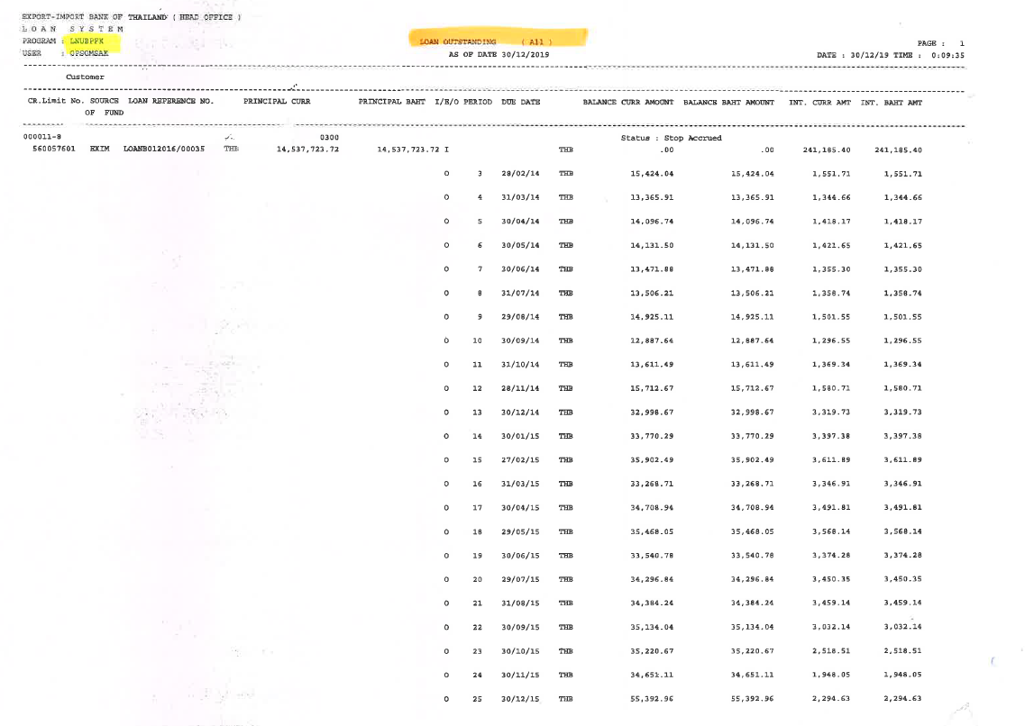

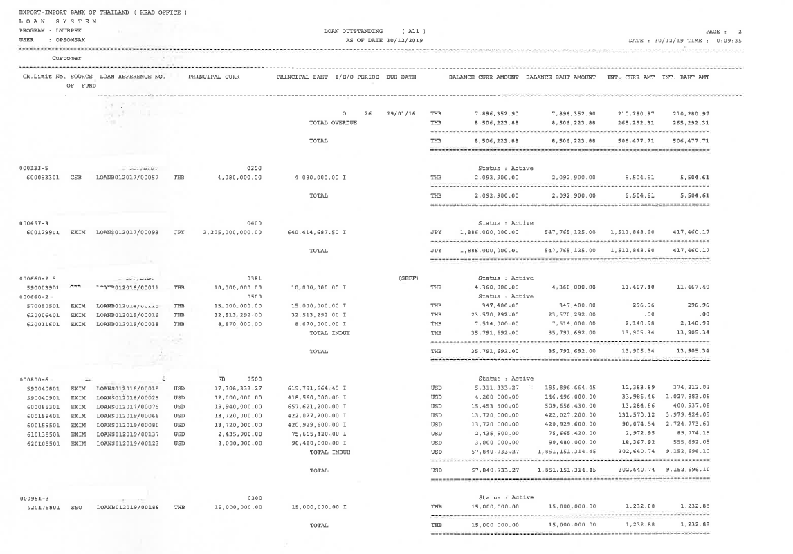

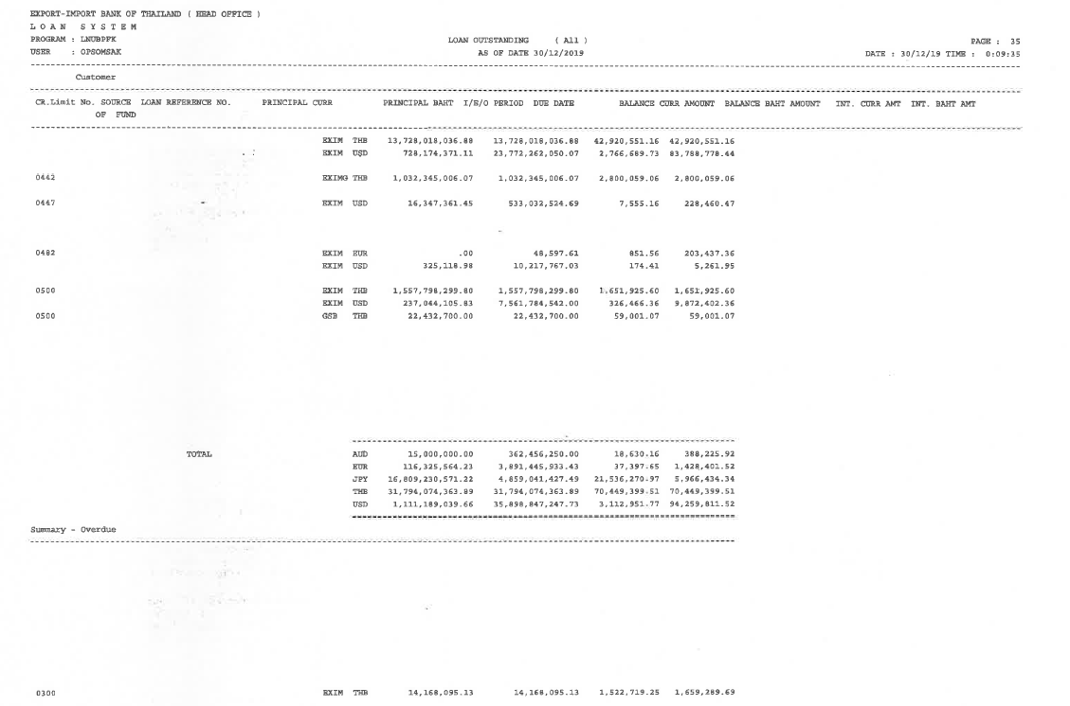

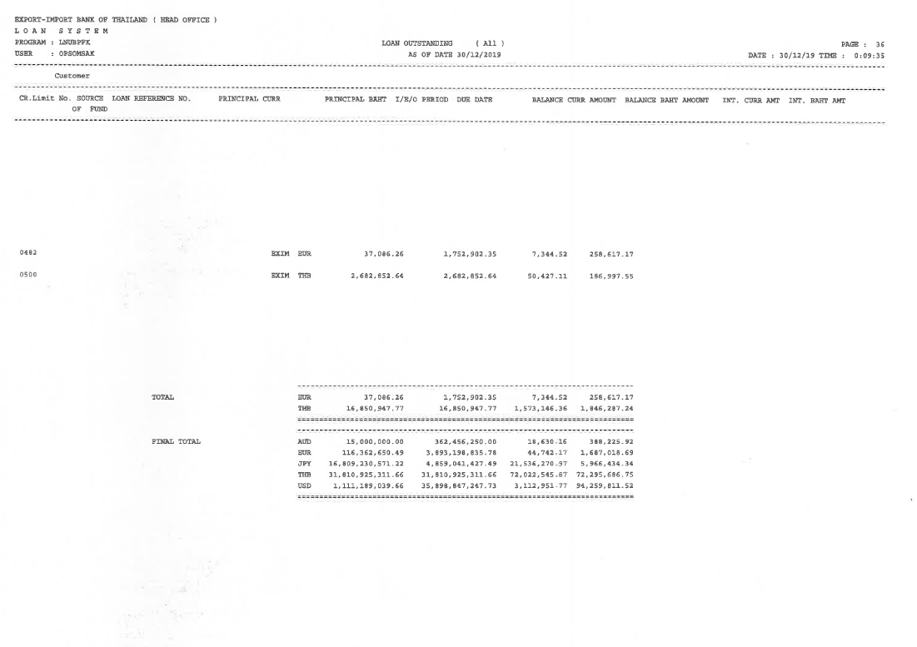

Note:

* CBS9 Supported
* All report are integate with ECM as End of day Process. (PDF Format). If ECM can not supported to store PDF report from symmetri CBS that no need to store in ECM.
* Symmetri support for retrieve the historical data for report.

### Menu Modification

Not applicable

### Screen Layout and Data Sheet

Not applicable

### To-be Process

|  |
| --- |
| Menu |
| OutstandingLoans by Account Executive |
| Outstanding Loan by Loan Type |
| Outstanding Loans by Maturity Date |

|  |  |
| --- | --- |
| Paper size | A4 |
| Reprinting require | Reprint |
| Searching criteria | Branch Name/No.,Customer name, Customer ID., historical date, Product Type (Loan type, Loan Sub Type), Source of Fund, currencywise, Status(Indue/Overdue), Loan Reference No. |
| Generation Frequency | Online, On request |
| Report Purpose | To display the principal and interest outstanding for a particular date (as of date)  To support the historical data for a particular date (as of date) |
| Actual Owner | Lending |

|  |  |  |  |
| --- | --- | --- | --- |
| Report Title: Loan Outstanding | | Report Title: | Status |
| Exim Field: | Description/Formular | CBS9 Field: |
| As of date |  |  | Choose an item. |
| Page |  |  | Choose an item. |
| Date/ Time |  |  | Choose an item. |
| Export -Import Bank of Thailand (Head office) |  |  | Choose an item. |
| Loan System |  |  | Choose an item. |
| Program: |  |  | Choose an item. |
| User: |  |  | Choose an item. |
| Customer |  |  | Choose an item. |
| CR.Limit No. |  |  | Choose an item. |
| Source of Fund |  |  | Choose an item. |
| Loan Reference No. | Loan |  | Choose an item. |
| Principal Curr | originate currency accumulate disbursement amount |  | Choose an item. |
| Principal Baht | Bath accumulate disbursement amount  (Principal Baht equivalent to Thai Baht)  หามูลค่าบาทเทียบเท่ามูลค่าเหรียญ |  | Choose an item. |
| I/E/O | Status indue extend overdue  day past due  If O - indicate the no, of days past due  if I - In due  if E - if there is any payment holiday made in the loan |  | Choose an item. |
| Due Date |  |  | Choose an item. |
| Balance Curr Amount |  |  | Choose an item. |
| Balance Baht Amount | (THB) |  | Choose an item. |
| Int. Curr amt | Interest currency amount |  | Choose an item. |
| Int. Baht amt |  |  | Choose an item. |
| Branch No. |  |  | Choose an item. |
| Branch Name. |  |  |  |
| Total Balance Amount for each customer |  |  | Choose an item. |
| Total Balance Amount for each customer (separated Indue Balance & Overdue Balance) | Displays the customer's indue overdue balance.  แสดง indue overdue balance ของ ลูกค้า |  | Choose an item. |
| Grand Total Balance Amount for all customer for currencywise | The total sum of the customer showing the currency of the actual amount of the customer (Currencywise).  ยอดรวมทั้งหมดของลูกค้าตามสกุลนั้นผลรวมทั้งหมดของลูกค้าโดยแสดง สกุลเงิน ของ amount ที่แท้จริง ของลูกค้า |  | Choose an item. |
| Grand Total Balance Amount for all for currencywise & equivalent to Thai Baht | The total amount of customers (Currencywise) and showing the amount of rate thai baht.  ยอดรวมทั้งหมดของลูกค้าตามสกุลนั้นๆๆ และแสดงจำนวน rate Thai Bath |  | Choose an item. |
| Product Type Summary | Details of Product Type  รายละเอียดของ Product type |  | Choose an item. |
| Period |  |  | Choose an item. |

#### Enhancement

Not Applicable.

#### After Enhancement

Not Applicable.

### File / API Layout and Data Sheet

Not Applicable.

### Report Layout and Data Sheet

Not Applicable.

### Additional Impacts

#### Integration

Not Applicable.

#### Migration

Not Applicable.

## Overdue principal/Interest Report

### Supported Sample Transaction and Case from Customer

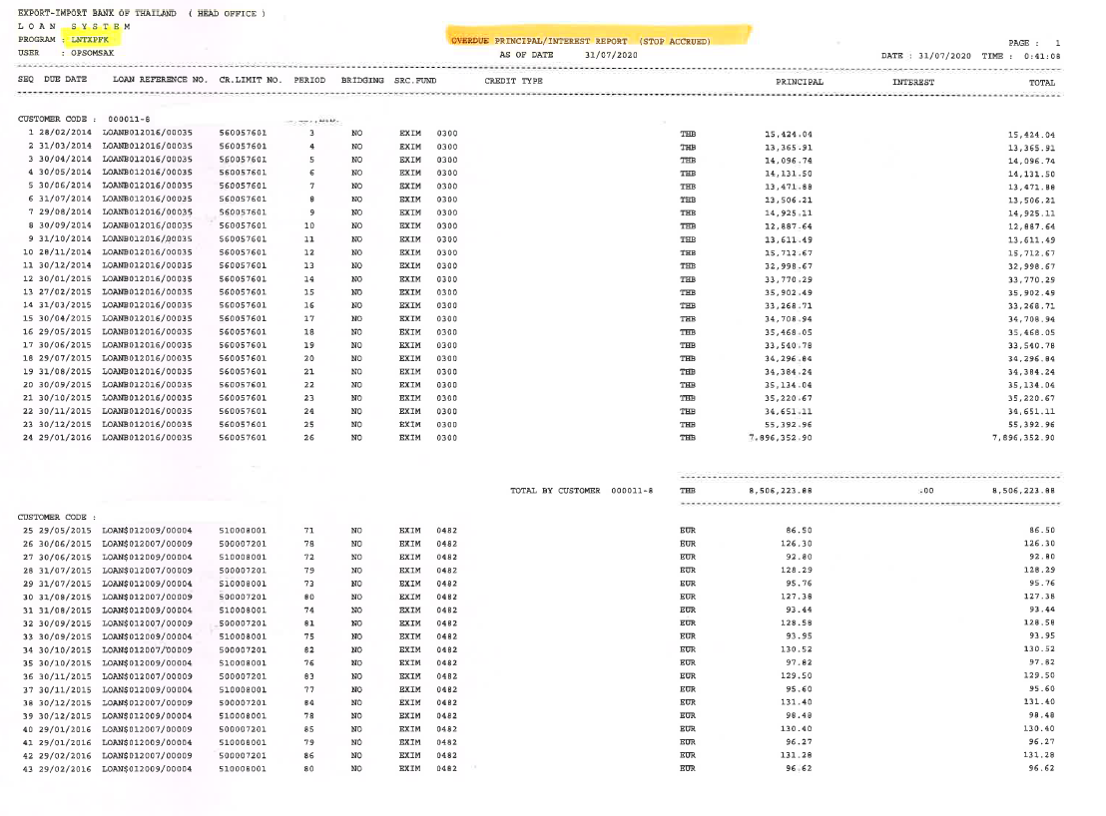

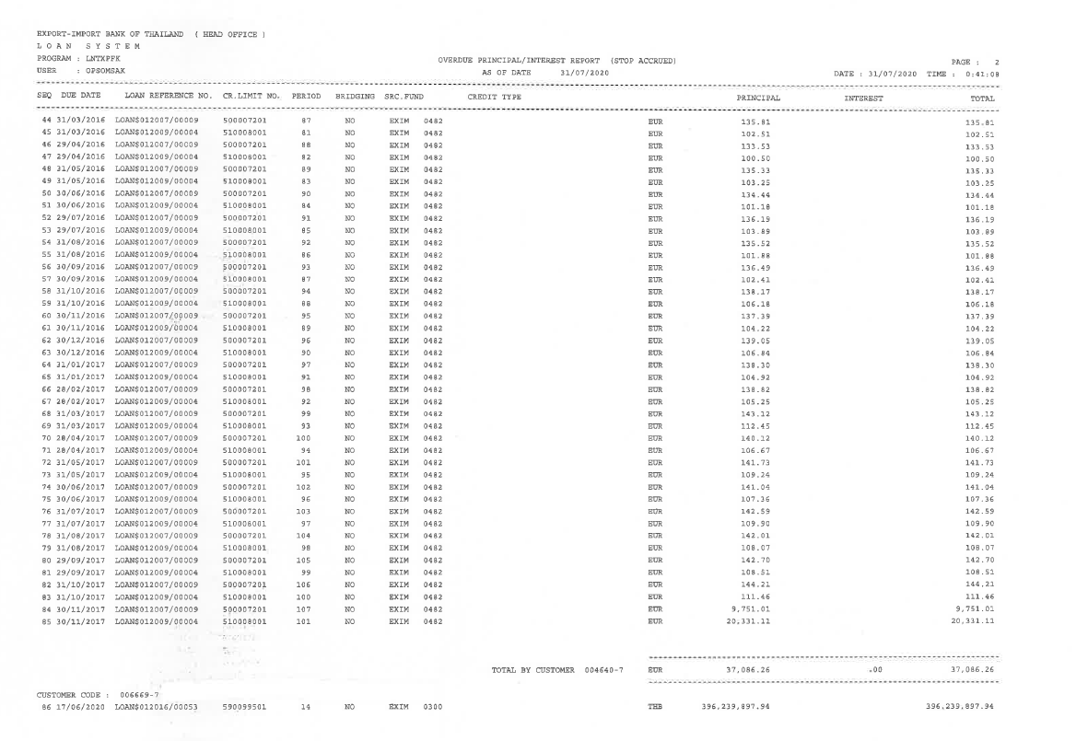

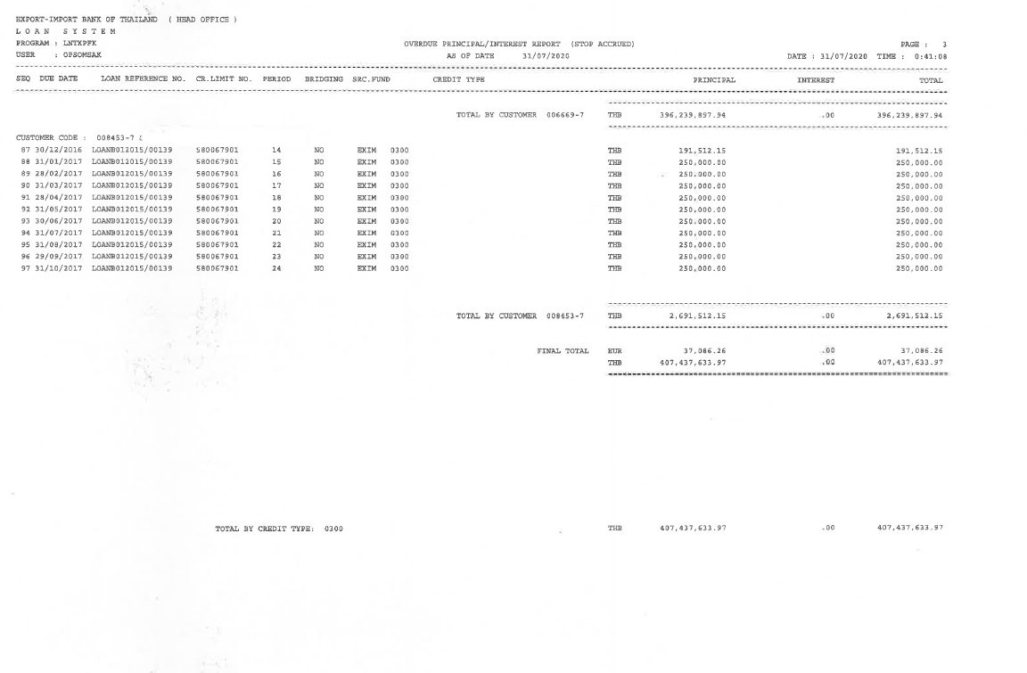

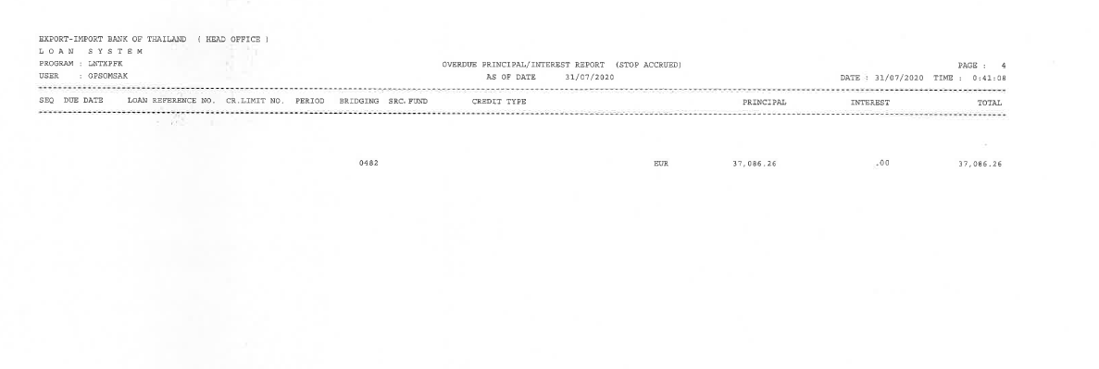

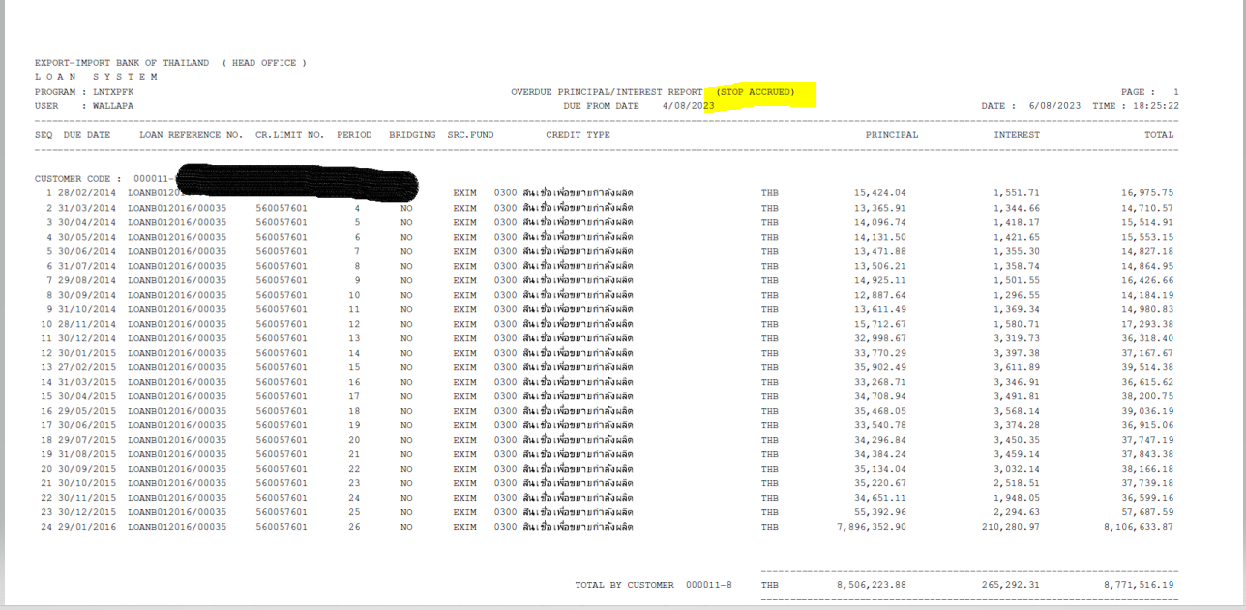

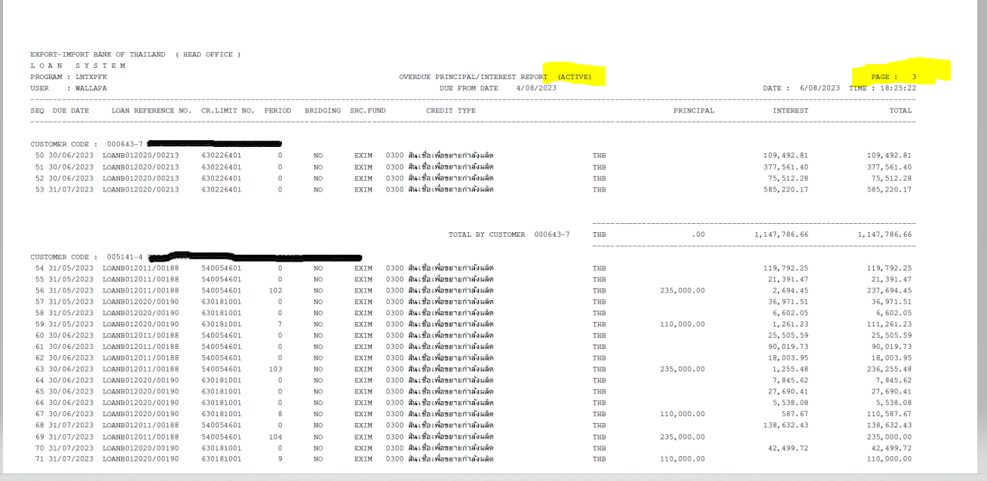

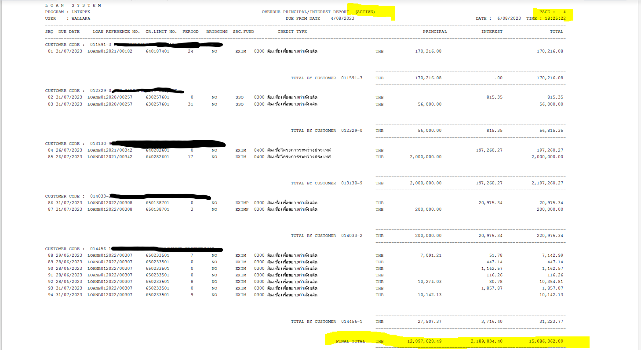

Note:

* CBS9 Supported
* All report are integate with ECM as End of day Process. (PDF Format). If ECM can not supported to store PDF report from symmetri CBS that no need to store in ECM.
* Symmetri support for retrieve the historical data for report.
* Report Title – remove (Stop Accrual) due to for entire report need to show both stop accrued type and normal overdue type.
* When user select for the particular loan status such Stop Accrued , Active(Normal Overdue), need loan status display on the Title name for the condition as follows ;
* Selecting Not specific loan status : Title Name = Overdue Principal/Interest Report : display for both stop accrued and active status
* Selecting specific loan status “ Stop Accrued ” : Title Name = Overdue Principal/Interest Report ( Stop Accrued) : display for particular Stop Accrued status
* Selecting specific loan status “ Active ” : Title Name = Overdue Principal/Interest Report ( Active) : display for particular Stop Accrued status
* Add the Loan Status information ( Stop Accrued Interest, Active(Normal Overdue) ) for each loan account in the report.

### Menu Modification

Not Applicable.

### Screen Layout and Data Sheet

Not Applicable.

### To-Be Process

|  |
| --- |
|  |

|  |  |
| --- | --- |
| Paper size | A4 |
| Reprinting require | Reprint |
| Searching criteria | Branch Name/No.,  Customer name,  Customer ID.,  historical date,  Product Type (Loan Type/Loan Sub Type),  Source of Fund,  currencywise,  Due Date,  Day Past Due,  Loan Reference No.  Loan status ( Stop Accrued , Active(Normal Overdue)) |
| Generation Frequency | Online, On request |
| Report Purpose | To display the overdue principal and interest oustanding for a particular date (as of date)  To support the historical data for a particular date (as of date) |
| Actual Owner | Lending |

|  |  |  |  |
| --- | --- | --- | --- |
| Report Title: Overdue Principal/Interest report | | Report Title: | Status |
| Exim Field: | Description/Formular | CBS9 Field: |
| As of date | Date of requesting report, can request history of day past due  วันที่ของการเรียกรายงาน สามารถเรียกประวัติวันที่เลยกำหนดชำระ |  | Choose an item. |
| Page |  |  | Choose an item. |
| Date / Time | Date/Time of Report generate  วันเวลาตอนเรียก Report |  | Choose an item. |
| Export -Import Bank of Thailand (Head office) |  |  | Choose an item. |
| Loan system |  |  | Choose an item. |
| Program |  |  | Choose an item. |
| User |  |  | Choose an item. |
| Loan Status | To show the exactly status which is separated for Stop Accrued and Active (Normal Overdue))  Remark : related to reclassification  status |  |  |
| Due Date | Due date of principal and interest  Due date เงินต้นและดอกเบี้ย |  | Choose an item. |
| Loan Reference No. |  |  | Choose an item. |
| CR. Limit No. | Project code number |  | Choose an item. |
| Period | Missing installment/customer  Example customer pays 55th and 56th installment but not 57th, report will show 57th but not 55th and 56th.  งวดที่ผิดนัด ลูกค้าผิดนัด เช่น ลูกค้ามี60 งวด  ลูกค้าไม่ได้จ่าย งวดที่ 50 report จะแสดงเริ่มต้นที่งวด 50 แต่ถ้าหากลูก ค้า มีจ่ายงวดที่ 55 ,และ 56 แต่ 57 ไม่ได้จ่าย Report จะต้องแสดง งวดที่ 57 ด้วย ไม่ต้องแสดง งวดที่ 55, 56  (แสดงเฉพาะงวดที่ผิดนัดเท่านั้น) |  | Choose an item. |
| Bridging |  |  | Choose an item. |
| SRC.Fund | Source of fund |  | Choose an item. |
| Credit Type | Product type of loan (checking loan type and Loan subtype) |  | Choose an item. |
| Principal | Missing principal  เงินต้นที่ผิดนัด |  | Choose an item. |
| Interest | Missing interest  ดอกเบี้ยที่ผิดนัด |  | Choose an item. |
| Total | Total of missing principal and interest  ผลรวมของเงินต้นและดอกเบี้ยที่ผิดนัด |  | Choose an item. |
| Customer Code |  |  | Choose an item. |
| Customer Name |  |  | Choose an item. |
| Day Past Due | Amount of days past due. Example due date of 1st March missed, request report on 22nd March, report will show 21 days  (Legacy don’t have but need in CBS9)  จำนวนวันผิดนัด ความต้องการ เช่น วันผิดนัด 1 มีนาคม วันที่เรียก report คือ วันที่ 22 มีนาคม ต้อง นับตั้งแต่วันที่ ผิดนัดจนถึง วันที่ดึง report ให้แสดง 21 วัน (ปัจจุบันไม่มี need in CBS) |  | Choose an item. |
| Total Overdue Balance Amount for each customer (Currency wise) | Overdue Principal + interest  The sum of the missing principal and interest (separate currencies according to data form Final total)  ผลรวมของเงินต้นและดอกเบี้ยที่ผิดนัด (แยกสกุลเงิน ตาม แบบ ข้อมูล Final total) |  | Choose an item. |
| Grand Total Overdue Balance Amount for all customer for currencywise | The total of the customer. (currencywise)  ผลรวมทั้งหมดของลูกค้าโดยแสดง สกุลเงิน ของ overdue ที่แท้จริง ของลูกค้า |  | Choose an item. |
| Grand Total Balance Amount for all for currencywise & equivalent to Thai Baht |  |  | Choose an item. |
| Product Type Summary |  |  | Choose an item. |
| Branch No. |  |  | Choose an item. |
| Branch Name. |  |  | Choose an item. |

### File / API Layout and Data Sheet

Not Applicable.

### Report Layout and Data Sheet

Not Applicable.

### Additional Impacts

#### Integration

Not Applicable.

#### Migration

Not Applicable.

## List due report

### Supported Sample Transaction and Case from Customer

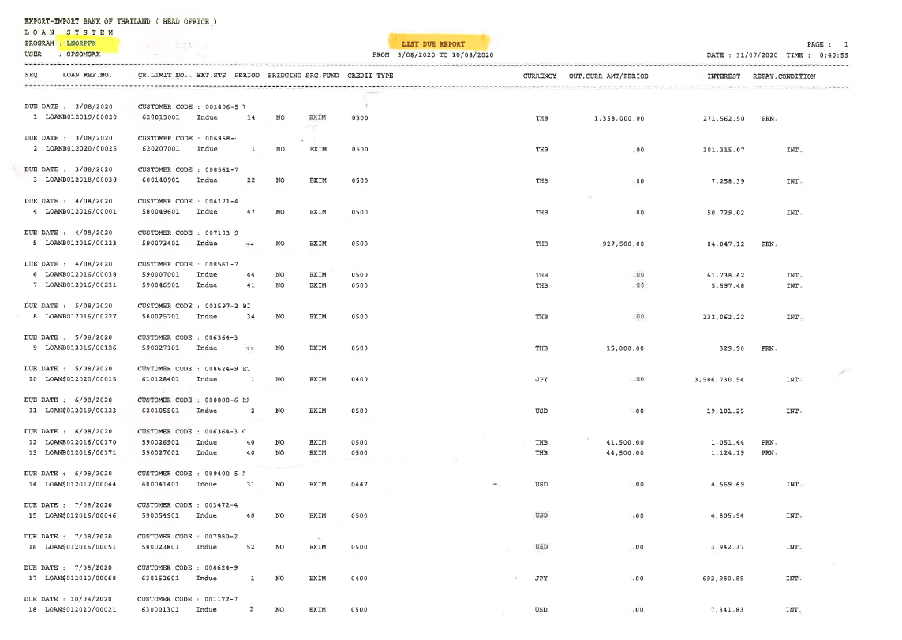

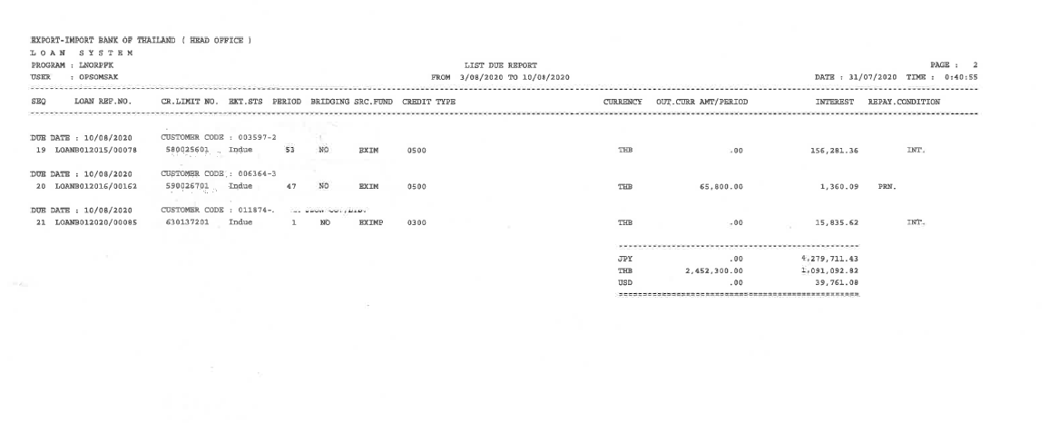

Note:

* CBS9 Supported
* All report are integate with ECM as End of day Process. (PDF Format) If ECM can not supported to store PDF report from symmetri CBS that no need to store in ECM.
* Symmetri support for retrieve the historical data for report.

### Menu Modification

Not Applicable.

### Screen Layout and Data Sheet

Not Applicable.

### To-be Process

Both Outstanding Loans and the Outstanding Debit Note reports can be used as List Due Report.

|  |  |
| --- | --- |
| Paper size | A4 |
| Reprinting require | Reprint |
| Searching criteria | Branch Name/No., Customer name, Customer ID., historical date, Product Type(Loan Type/Loan Sub Type), Source of Fund, currencywise, Due Date, Day Past Due, Loan Reference No. |
| Generation Frequency | Online, On request |
| Report Purpose | The list of due amounts (principal, interest, penalties, fees, etc) for a particular date (from-to date) |
| Actual Owner | Lending |

|  |  |  |  |
| --- | --- | --- | --- |
| Report Title: List Due | | Report Title: | Status |
| Exim Field: | Description/Formular | CBS9 Field: |
| From To | (Due report show every drawdown of every loan account. Must show time period of search FROM-TO  (สิ่งที่จะครบกำหนด)รายงานครบกำหนดแสดง ทุก Drawdown ทุก Loan account จะต้องแสดงตามช่วงระยะเวลาที่ค้นหา From - To |  | Choose an item. |
| Page |  |  | Choose an item. |
| Date / Time | Date/time of printing  เวลา ณ เวลาที่ปริ้นเอกสาร |  | Choose an item. |
| Export -Import Bank of Thailand (Head office) |  |  | Choose an item. |
| Loan system | Display Loan Module  ให้แสดง Loan Module |  | Choose an item. |
| Program | File name) key word for future searching in ECM system, kept as PDF in ECM.   (ชื่อไฟล์) Key word สำหรับ เพื่อค้นหาในอนาคตในระบบ ECM จะถูกเก็บเป็น PDF ไฟล์ ใน ECM |  | Choose an item. |
| User | Name of User Login  User ที่ใช้เข้าระบบ |  | Choose an item. |
| SEQ | SEQ of Transaction |  | Choose an item. |
| Loan Ref. No. | Loan account number, Drawdown number |  | Choose an item. |
| CR. Limit No. |  |  | Choose an item. |
| Ext. Sts | Extend status |  | Choose an item. |
| Period | Current installment plan, if overdue show in overdue report  งวดผ่อนปัจจุบันของลูกค้า หากไม่ชำระจะไปแสดงที่ overdue report |  | Choose an item. |
| Bridging |  |  | Choose an item. |
| SRC. Fund |  |  | Choose an item. |
| Credit Type | Product type of loan (checking loan type and Loan subtype) |  | Choose an item. |
| Currency | Currencywise |  | Choose an item. |
| Out. Curr Amt/Period | Outstanding Currency amount / Period  Amount of principal due  Show only principal  If only interest to be paid, don’t show principal amount  Outstanding Currency amount / Period ค่าของเงินต้นที่ครบกำหนดชำระ แสดงแต่เงินต้นถ้าชำระแต่ดอกเบี้ย จะไม่แสดงค่าเงินต้น |  | Choose an item. |
| Interest Amount up to due date | Show interest up to and excluding due date (Legacy don’t have but need in CBS)  ให้แสดงดอกเบี้ยจนถึงวันที่ก่อนกำหนดชำระ ถ้าดิวลูกค้าวันที่ 28 จะให้แสดงข้อมูลถึง วันที่ 27 (เพิ่มใหม่ CBS) |  | Choose an item. |
| Interest Rate | (Add new) show rate as of due date (Legacy system don’t have but need in CBS9)  (เพิ่มใหม่) แสดงอัตราเบี้ย Rate ณ วันครบกำหนด |  | Choose an item. |
| Repay. Condition | What currency customer must pay with, include or exclude interest with payment  Only principal = PRN  Only interest = INT  Both = PRN+INT   เงินที่ลูกค้าชำระเป็นเงินประเภทไหน เช่น ชำระเงินต้นแยกดอก หรือ ต้นบวกดอก  ลูกค้าจ่ายต้นอย่างเดียว แสดง PRN  ดอก อย่างเดียวแสดง INT  ต้น + ดอก แสดง PRN+INT |  | Choose an item. |
| Settlement Account No. | (LN-49,58) |  | Choose an item. |
| Settlement Account Name. | (LN-49,58) |  | Choose an item. |
| Branch No. |  |  | Choose an item. |
| Branch Name. |  |  | Choose an item. |
| Fee due date | Show due fee in search period  (Legacy system don’t have but need in CBS9)  ให้แสดง Fee ที่ครบกำหนดในช่วงระยะเวลาที่ค้นหา |  | Choose an item. |

### File / API Layout and Data Sheet

Not Applicable.

### Report Layout and Data Sheet

Not Applicable.

### Additional Impacts

#### Integration

Not Applicable.

#### Migration

Not Applicable.

## Accrued Interest report

### Supported Sample Transaction and Case from Customer

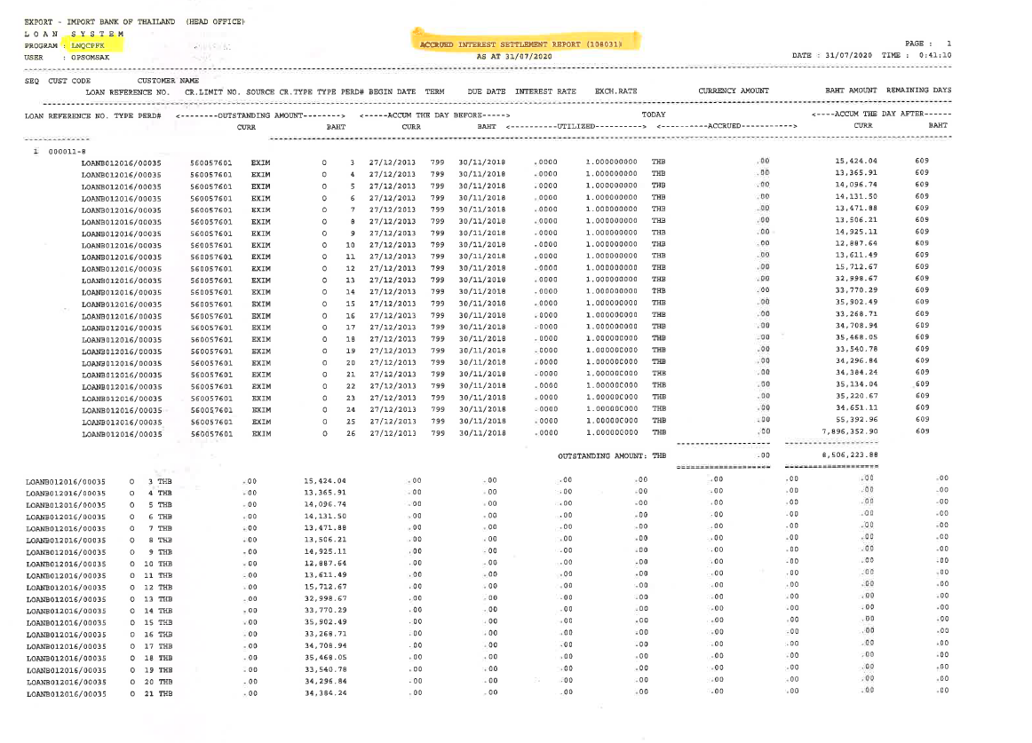

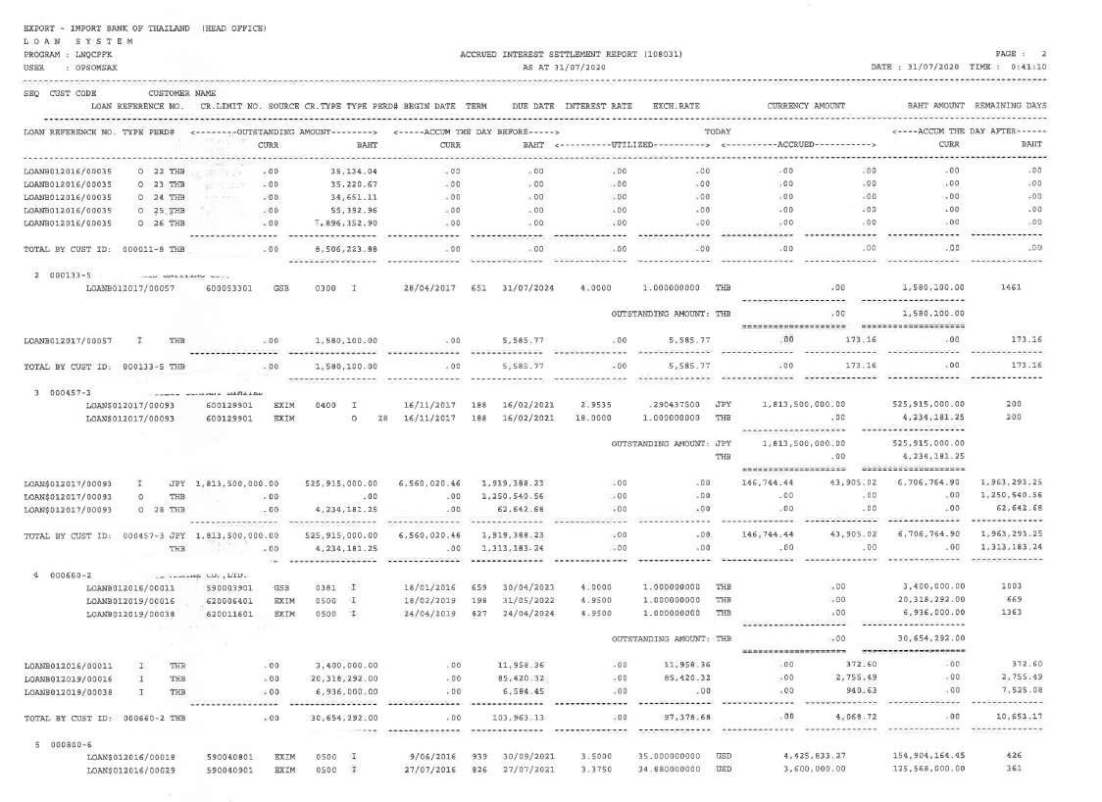

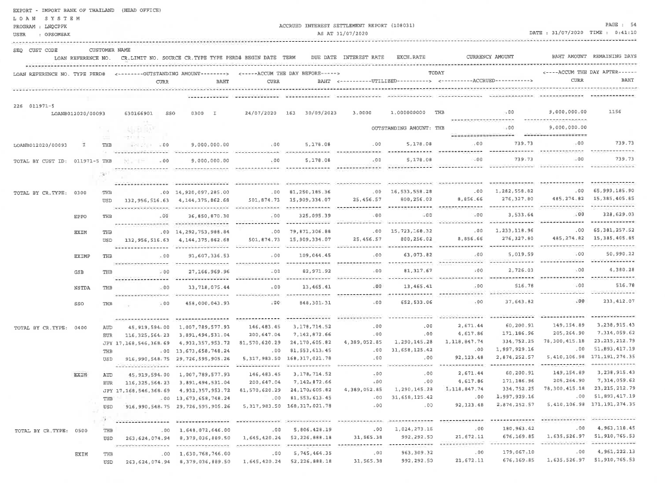

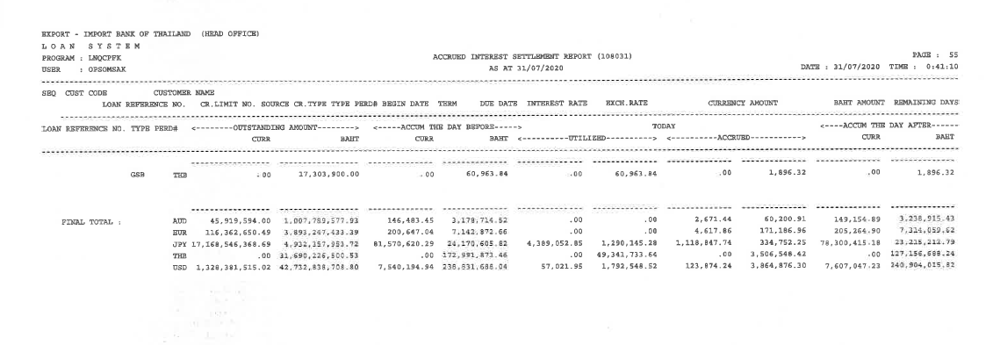

Note:

* The word ‘Settlement’ from the report title is to be removed as decided by the EXIM Lending team. New report title should be ‘Accrued Interest report’
* The report requirement is now to make it ‘as of ‘ accumulated accrual balance instead of showing the daily accrual amount just like the illustration above.
* CBS9 Supported
* All report are integate with ECM as End of day Process. (PDF Format) If ECM can not supported to store PDF report from symmetri CBS that no need to store in ECM.
* Symmetri support for retrieve the historical data for report.

### Menu Modification

Not Applicable.

### Screen Layout and Data Sheet

Not Applicable.

### To-be Process

|  |
| --- |
|  |

|  |  |
| --- | --- |
| Paper size | A4 |
| Reprinting require | Reprint |
| Searching criteria | Branch Name/No., Customer name, Customer ID., historical date, Product Type(Loan Type/Loan Sub Type), Source of Fund, currencywise, Loan Reference No. |
| Generation Frequency | Daily |
| Report Purpose | List of accumulated interest accruals for a particular date (as of date) |
| Actual Owner | Lending |

|  |  |  |  |
| --- | --- | --- | --- |
| Report Title: Accrued Interest | | Report Title: | Status |
| Exim Field: | Description/Formular | CBS9 Field: |
| AS AT | Date of finished report (today is 22nd June, requested report 31st May, must show 31st May)  วันที่สินสุดรายงาน เช่น วันปัจุบัน คือ 22 มิถนา แต่ เรียกรายงาน วันที่ 31 พฤษภาคม จะต้องแสดงวันที่31 พฤษภาคม |  | Choose an item. |
| Page |  |  | Choose an item. |
| Date / Time |  |  | Choose an item. |
| Export -Import Bank of Thailand (Head office) |  |  | Choose an item. |
| Loan system |  |  | Choose an item. |
| Program |  |  | Choose an item. |
| User |  |  | Choose an item. |
| SEQ |  |  | Choose an item. |
| Cust Code |  |  | Choose an item. |
| Loan Reference No. |  |  | Choose an item. |
| CR. Limit No. |  |  | Choose an item. |
| Source CR. Type | Source of fund |  | Choose an item. |
| Type | Type status indue overdue payment delay (Extend) |  | Choose an item. |
| PERD# | Show amount of times accrued amount has been calculated for that customer  งวดของการคิด Accrued แสดงเป็นจำนวนครั้งของการคิด Accrued ของลูกค้ารายนั้น |  | Choose an item. |
| Begin Date | Date for start Accrued  วันที่เริ่มต้นการคิด Accrued |  | Choose an item. |
| Term | Amount of days to calculate accrued  จำนวนวันสะสมที่คิด Accrued |  | Choose an item. |
| Due Date | Due Date of Loan account or Drawdown  วันที่ครบกำหนดชำระของ Loan account หรือ drawdown |  | Choose an item. |
| Interest Rate | pick up the interest rate during that time.  Rate ของ ก่อเกิด Accrued อัตราดอกเบี้ยที่ใช้คำนวณ (หยิบอัตราดอกเบี้ยในช่วงเวลานั้น) |  | Choose an item. |
| Exch.Rate | Use mid rate of the last day before accrual  อัตราแลกเปลี่ยนอ้างอิงที่เทียบกับเงินบาท ใช้ mid rate ของวันสุดท้ายก่อนถึงวัน Accrued |  | Choose an item. |
| Currency Amount | Currencywise  สกุลเงินที่แท้จริงของลูกค้า |  | Choose an item. |
| Baht Amount | Equivalent to Thai Baht |  | Choose an item. |
| Remaining Days | Accrued days remaining after partial payment  (In the future, it may not be on CBS.)  จำนวนวันที่เหลือของ Accrued หลังจากที่ได้ชำระไปบางส่วน  (ในอนาคต อาจจะไม่มีใน CBS) |  | Choose an item. |
| Product Type |  |  | Choose an item. |
| Customer Name |  |  | Choose an item. |
| Branch No. |  |  | Choose an item. |
| Branch Name |  |  | Choose an item. |
| Outstanding amount | Outstanding amount in currency, and equivalent to Thai baht amount (using mid rate)  เงินต้นคงค้าง และแสดงยอดเงินของสกุลเงินที่แท้จริงของลูกค้าและ เทียบค่าบาท (mid rate) |  | Choose an item. |
| Accum the day defore | Accumulative up to the day before day of report request  ยอด Accum ที่ยกมาจาก วันก่อนหน้าที่จะดึง report เช่น วันดึง report วันที่ 10 ยอด Accum คือวันที่ 9 |  | Choose an item. |
| Today Utilized |  |  | Choose an item. |
| Today Accrued | Accrued ที่ได้รับชำระ |  | Choose an item. |
| Accum the day after | Show remaining accrued amount for customer  แสดงจำนวนเงิน Accued ที่เหลือของลูกค้า |  | Choose an item. |
| Final total by currency wise | Sum of all customers  ผลรวมของลูกค้าทั้งหมด |  | Choose an item. |

### File / API Layout and Data Sheet

Not Applicable.

### Report Layout and Data Sheet

Not Applicable.

### Additional Impacts

#### Integration

Not Applicable.

#### Migration

Not Applicable.

## Daily Interest Transaction (summary)

### Supported Sample Transaction and Case from Customer

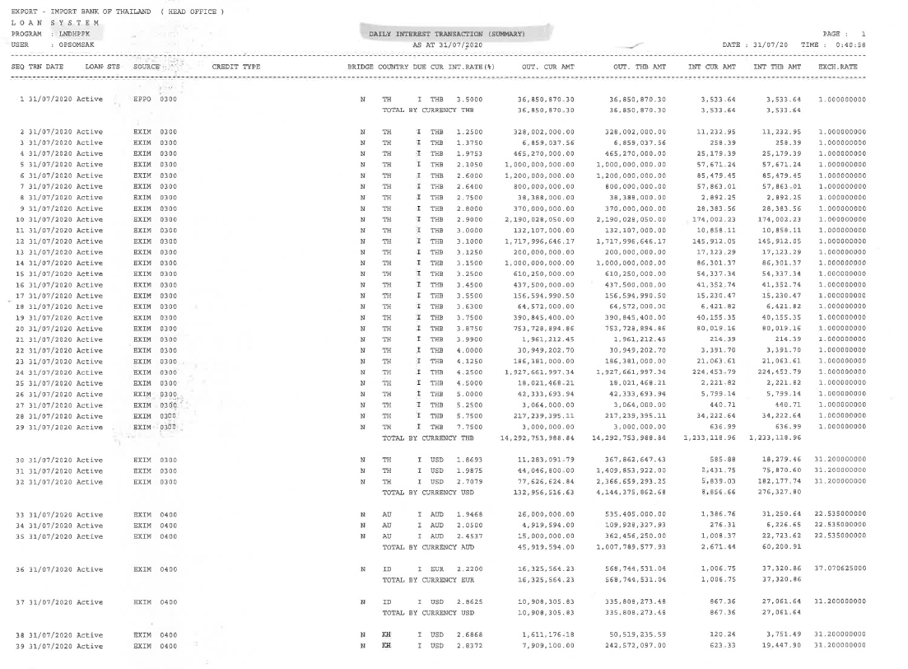

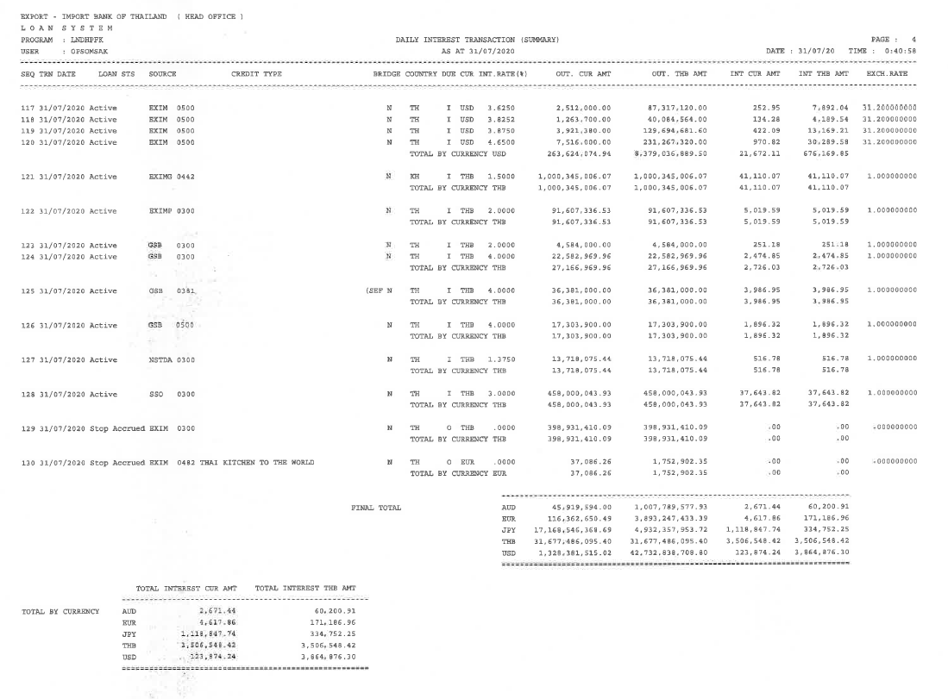

Note:

* CBS9 Supported
* All report are integate with ECM as End of day Process. (PDF Format). If ECM can not supported to store PDF report from symmetri CBS that no need to store in ECM.
* Symmetri support for retrieve the historical data for report.

### Menu Modification

Not Applicable.

### Screen Layout and Data Sheet

Not Applicable.

### To-be Process

|  |
| --- |
|  |

|  |  |
| --- | --- |
| Paper size | A4 |
| Reprinting require | Reprint |
| Searching criteria | Branch Name/No., Customer name, Customer ID., historical date, Product Type(Loan Type/Loan Sub Type), Source of Fund, currencywise, Due Date, Day Past Due, Loan Reference No. |
| Generation Frequency | Daily |
| Report Purpose | To display the total interest due for a particular date (interest amount, rate and other details to be able to calculate the interest amount) |
| Actual Owner | Lending |

|  |  |  |  |
| --- | --- | --- | --- |
| Report Title: Daily Interest Transaction (Summary) | | Report Title: | Status |
| Exim Field: | Description/Formular | CBS9 Field: |
| AS AT |  |  | Choose an item. |
| Page |  |  | Choose an item. |
| Date / Time |  |  | Choose an item. |
| Export -Import Bank of Thailand (Head office) |  |  | Choose an item. |
| Loan system |  |  | Choose an item. |
| Program |  |  | Choose an item. |
| User |  |  | Choose an item. |
| SEQ |  |  | Choose an item. |
| TRN Date | date of searched data (Transaction date)  วันที่ของข้อมูลที่ค้นหา |  | Choose an item. |
| Loan STS | Loan status  Active (liability Normal)  Inactive liability NPL (Non performing Loan)  Active (หนี้ปกติ)  Inactive หนี้ NPL (Non performing Loan) |  | Choose an item. |
| Source | Source of fund |  | Choose an item. |
| Credit Type |  |  | Choose an item. |
| Bridge |  |  | Choose an item. |
| Country | สัญชาติลูกค้า |  | Choose an item. |
| Due | Status of Loan (Indue, Overdue)  Status ของรายการ Loan |  | Choose an item. |
| Cur | Currency is specified by contractual conditions. If Overdue, Currency is THB   สกุลเงินขึ้นอยุ่กับ สกุลเงินที่แท้จริงของลูกค้า แต่ขึ้นอยุ่กับ เงื่อนไข Status due (filed ข้างบน) ถ้าเป็น overdue จะต้องแสดงเป็น เงินสกุลบาท |  | Choose an item. |
| Int.Rate(%) | Daily Interest rate  อัตราดอกเบี่ยรายวัน เช่นใน report คือ 31/7 |  | Choose an item. |
| Out. CUR AMT | Outstanding principal amount of every customer in currency wise, depending on interest rate conditions. E.g. 5 customers total, 2 of which have the same interest rate, those two customer’s outstanding will be summed together to a single display amount  จำนวนเงินของเงินต้นทั้งหมดที่แท้จริง ของลูกค้าทั้งหมด ขึ้นอยู่กับเงื่อนไข อัตราดอกเบี้ย รายวัน เช่น มีลูกค้าอยู่ 5 ราย ใช้อัตราดอกเบี้ย เดียวกันอยู่ 2 ราย จะต้องแสดงผลรวมของลุกค้า 2 รายที่ใช้ อัตราดอกเบี้ยเดียวกัน |  | Choose an item. |
| Out. THB AMT | Outstanding principal amount of every customer in THB bath, depending on interest rate conditions. E.g. 5 customers total, 2 of which have the same interest rate, those two customer’s outstanding will be summed together to a single display amount  จำนวนเงินของเงินต้นทั้งหมดเป็นเงินบาทไทย ของลูกค้าทั้งหมด ขึ้นอยู่กับเงื่อนไข อัตราดอกเบี้ย รายวัน เช่น มีลูกค้าอยู่ 5 ราย ใช้อัตราดอกเบี้ย เดียวกันอยู่ 2 ราย จะต้องแสดงผลรวมของลุกค้า 2 รายที่ใช้ อัตราดอกเบี้ยเดียวกัน |  | Choose an item. |
| INT CUR AMT | Outstanding interest amount of every customer in currencywise, depending on interest rate conditions. E.g. 5 customers total, 2 of which have the same interest rate, those two customer’s outstanding will be summed together to a single display amount  จำนวนเงินของดอกเบี้ยทั้งหมดที่แท้จริง ของลูกค้าทั้งหมด ขึ้นอยู่กับเงื่อนไข อัตราดอกเบี้ย รายวัน เช่น มีลูกค้าอยู่ 5 ราย ใช้อัตราดอกเบี้ย เดียวกันอยู่ 2 ราย จะต้องแสดงผลรวมของลุกค้า 2 รายที่ใช้ อัตราดอกเบี้ยเดียวกัน |  | Choose an item. |
| INT THB AMT | Outstanding interest amount of every customer in THB bath, depending on interest rate conditions. E.g. 5 customers total, 2 of which have the same interest rate, those two customer’s outstanding will be summed together to a single display amount  จำนวนเงินของดอกเบี้ยทั้งหมดที่แท้เงินบาท ของลูกค้าทั้งหมด ขึ้นอยู่กับเงื่อนไข อัตราดอกเบี้ย รายวัน เช่น มีลูกค้าอยู่ 5 ราย ใช้อัตราดอกเบี้ย เดียวกันอยู่ 2 ราย จะต้องแสดงผลรวมของลุกค้า 2 รายที่ใช้ อัตราดอกเบี้ยเดียวกัน |  | Choose an item. |
| EXCH.RATE | Using Mid Rate |  | Choose an item. |
| Final Total |  |  | Choose an item. |
| Total by currency wise | Separated by currency  แยกตาม สกุลของลุกค้าที่มีในreport ทั้งหมด |  | Choose an item. |
| Total Interest currency amount |  |  | Choose an item. |
| Total Interest THB amount | Using Mid Rate |  | Choose an item. |

### File / API Layout and Data Sheet

Not Applicable.

### Report Layout and Data Sheet

Not Applicable.

### Additional Impacts

#### Integration

Not Applicable.

#### Migration

Not Applicable.

## Monthly Accrued interest

### Supported Sample Transaction and Case from Customer

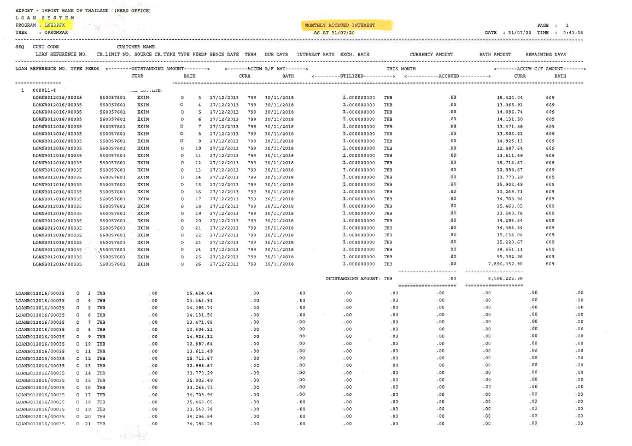

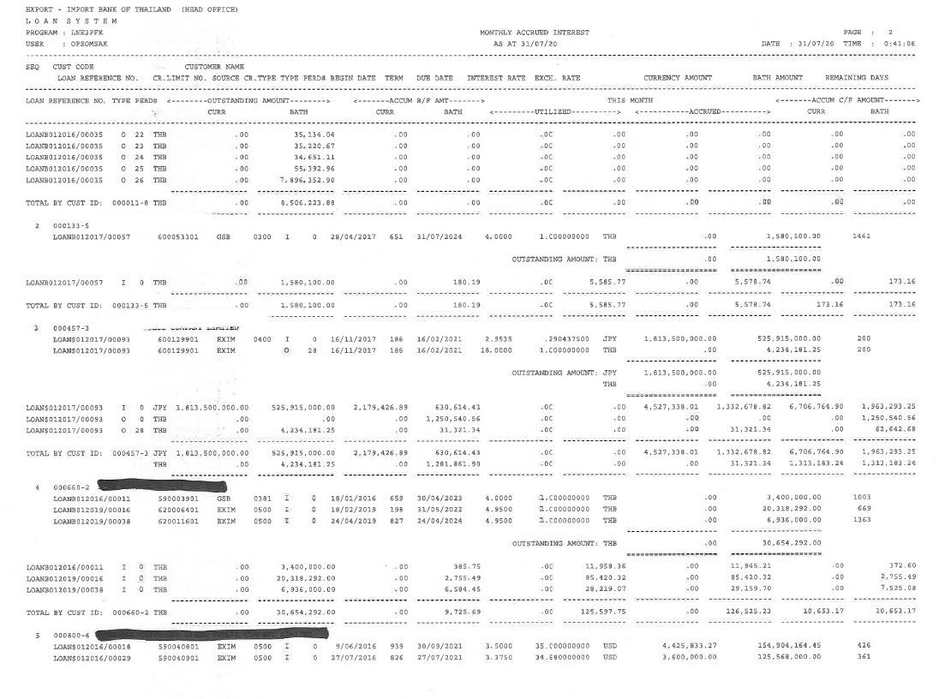

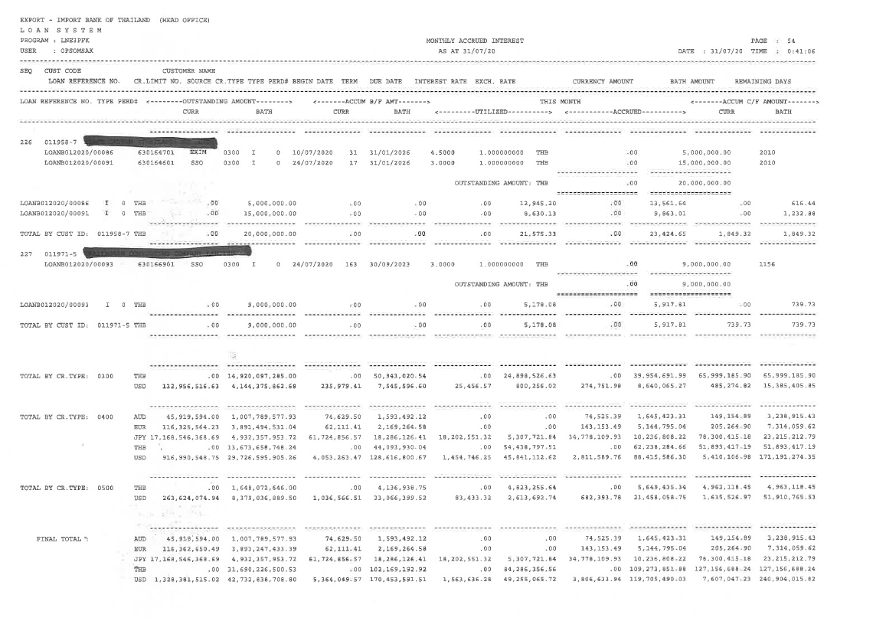

Note:

* CBS9 Supported
* All report are integate with ECM as End of day Process. (PDF Format). If ECM can not supported to store PDF report from symmetri CBS that no need to store in ECM.
* Symmetri support for retrieve the historical data for report.

### Menu Modification

Not Applicable.

### Screen Layout and Data Sheet

Not Applicable.

### To-be Process

|  |
| --- |
|  |

|  |  |
| --- | --- |
| Paper size | A4 |
| Reprinting require | Reprint |
| Searching criteria | Branch Name/No., Customer name, Customer ID., historical date, Product Type(Loan Type/Loan Sub Type), Source of Fund, currencywise, Due Date, Day Past Due, Loan Reference No. |
| Generation Frequency | Online, On request, Monthly |
| Report Purpose | To display the total interest accruals for a particular period date (From - To , Any day) |
| Actual Owner | Lending |

|  |  |  |  |
| --- | --- | --- | --- |
| Report Title: Monthly Accrued Interest | | Report Title: | Status |
| Exim Field: | Description/Formular | CBS9 Field: |
| AS AT |  |  | Choose an item. |
| Page |  |  | Choose an item. |
| Date / Time |  |  | Choose an item. |
| Export -Import Bank of Thailand (Head office) |  |  | Choose an item. |
| Loan system |  |  | Choose an item. |
| Program |  |  | Choose an item. |
| User |  |  | Choose an item. |
| SEQ |  |  | Choose an item. |
| Cust Code |  |  | Choose an item. |
| Loan Reference No. |  |  | Choose an item. |
| Customer Name |  |  | Choose an item. |
| CR.Limit No. |  |  | Choose an item. |
| Source CR. Type |  |  | Choose an item. |
| Type |  |  | Choose an item. |
| PERD# | Accrued row in AS400  บรรทัดที่เกิด Accrued ใน AS400 |  | Choose an item. |
| Begin Date | date for start Accrued  วันที่เริ่มต้น Accrued |  | Choose an item. |
| Term | Accrued period (Number of days Accrued)  ระยะเวลาในการ Accrued (จำนวนวันที่ค้างAccrued) |  | Choose an item. |
| Due Date | วันที่ครบกำหนดชำระสัญญา |  | Choose an item. |
| Interest Rate | Interest rate at that time  ดอกเบี้ย ณ ช่วงเวลานั้น |  | Choose an item. |
| Exch.Rate | Using Mid rate |  | Choose an item. |
| Currency Amount |  |  | Choose an item. |
| Baht Amount |  |  | Choose an item. |
| Remaining Days | From report release date to last installment date  วันที่ออก รายงาน จนถึงวันที่ the last installment date |  | Choose an item. |
| Utilized | (Accrued interest only)  รับชำระเฉพาะดอกเบี้ย |  | Choose an item. |
| Final Total | every product, every customer  (By currency wise and equivalent to Thai bath)  ยอดรวมทั้งหมดของทุก product และทุกลูกค้า |  | Choose an item. |
| Total by cust ID | Separated by currency  ยอดรวมของแต่ละ customer แบ่งตามสกลุเงินที่แท้จริง |  | Choose an item. |
| Accum C/F Amount |  |  | Choose an item. |
| Total by Product type | Product code product type CR.Type  (สินเชื่อหลักสินเชื่อรอง สินเชื่อขยายกำลังการผลิต) |  | Choose an item. |

### File / API Layout and Data Sheet

Not Applicable.

### Report Layout and Data Sheet

Not Applicable.

### Additional Impacts

#### Integration

Not Applicable.

#### Migration

Not Applicable.

## Daily Foreign currency report (Final)

### Supported Sample Transaction and Case from Customer

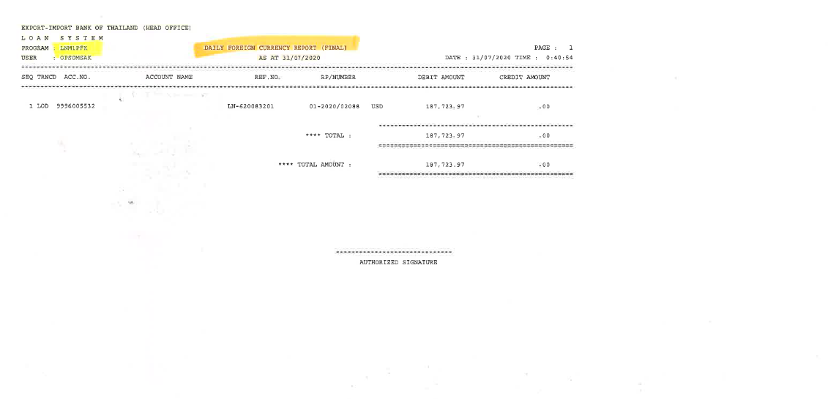

Note:

* By branch when searching on CBS All transactions whether Debit credit credited/debited from Foreign currency diposit (customer's foreign currency account in deposit module) or Retail.
* All report are integate with ECM as End of day Process. (PDF Format). If ECM can not supported to store PDF report from symmetri CBS that no need to store in ECM.
* Symmetri support for retrieve the historical data for report.

### Menu Modification

Not Applicable.

### Screen Layout and Data Sheet

Not Applicable.

### To-be Process

|  |  |
| --- | --- |
| Paper size | A4 |
| Reprinting require | Reprint |
| Searching criteria | Branch Name/No., Customer name, Customer ID., historical date, Product Type(Loan Type/Loan Sub Type), Source of Fund, currencywise, Due Date, Day Past Due, Loan Reference No., Settlement Account No., Settlement Account Name. |
| Generation Frequency | Daily |
| Report Purpose | List of the drawdowns and repayments where the foreign currency deposit account (CASA) is used during settlement |
| Actual Owner | Lending |

|  |  |  |  |
| --- | --- | --- | --- |
| Report Title: Daily Foreign Currency (Final) | | Report Title: | Status |
| Exim Field: | Description/Formular | CBS9 Field: |
| AS AT |  |  | Choose an item. |
| Page |  |  | Choose an item. |
| Date / Time |  |  | Choose an item. |
| Export -Import Bank of Thailand (Head office) |  |  | Choose an item. |
| Loan system |  |  | Choose an item. |
| Program |  |  | Choose an item. |
| User |  |  | Choose an item. |
| SEQ |  |  | Choose an item. |
| TRNCD | Event type of deposit  such as LND Loan disbursement |  | Choose an item. |
| ACC. No | Foreign currency number in Deposit module |  | Choose an item. |
| Account Name |  |  | Choose an item. |
| REF. No. | As IS = Credit limit number  To be need Loan account number and Drawdown number |  | Choose an item. |
| RP/Number | Drawdown / Receipt confirmation number (Sequence with in each branch) |  | Choose an item. |
| Debit Amount |  |  | Choose an item. |
| Credit Amount |  |  | Choose an item. |
| Total Amount | Total amount by currencywise of every account |  | Choose an item. |
| Total by Account number |  |  | Choose an item. |

### File / API Layout and Data Sheet

Not Applicable.

### Report Layout and Data Sheet

Not Applicable.

### Additional Impacts

#### Integration

Not Applicable.

#### Migration

Not Applicable.

## Daily Current account report (Final)

### Supported Sample Transaction and Case from Customer

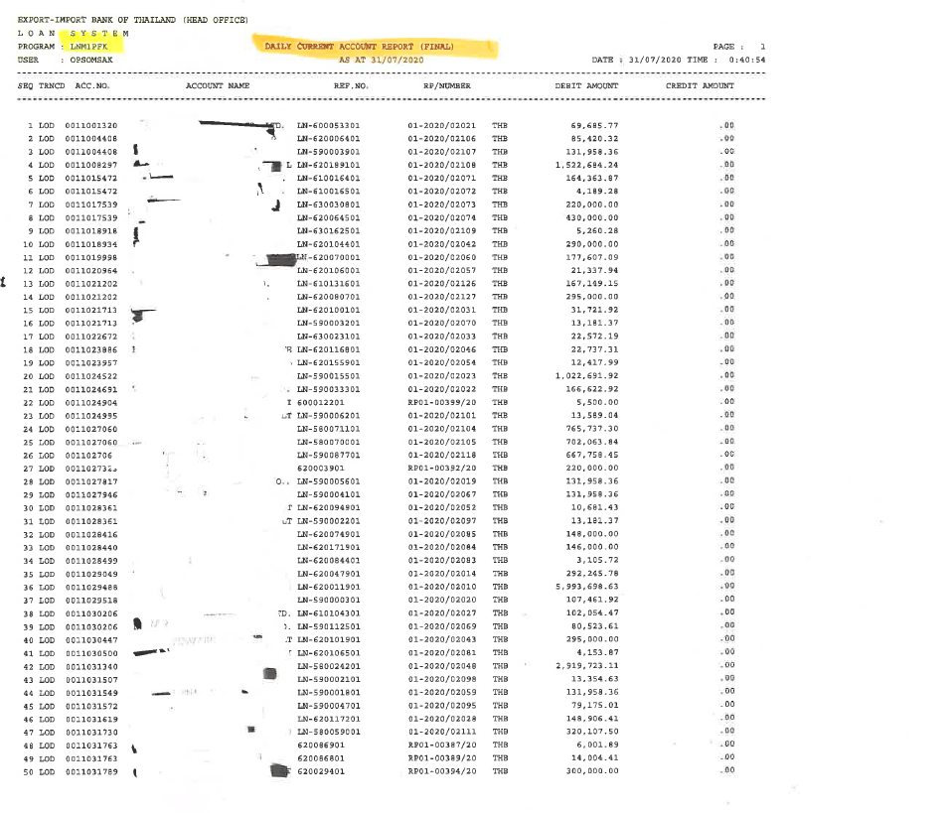

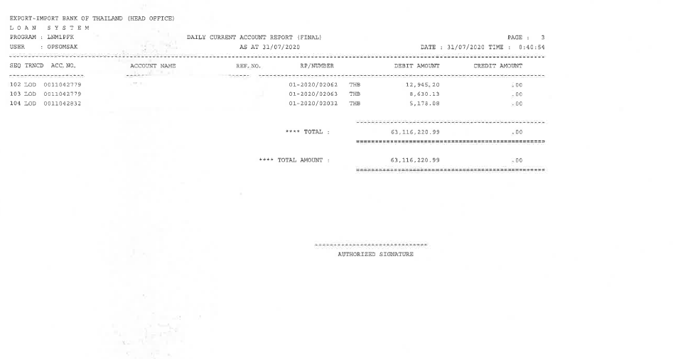

Note:

* By branch when searching on CBS All transactions whether Debit credit credited/debited from currency-THB diposit.
* All report are integate with ECM as End of day Process. (PDF Format). If ECM can not supported to store PDF report from symmetri CBS that no need to store in ECM.
* Symmetri support for retrieve the historical data for report.

### Menu Modification

Not Applicable.

### Screen Layout and Data Sheet

Not Applicable.

### To-be Process

|  |  |
| --- | --- |
| Paper size | A4 |
| Reprinting require | Reprint |
| Searching criteria | Branch Name/No., Customer name, Customer ID., historical date, Product Type(Loan Type/Loan Sub Type), Source of Fund, currencywise, Due Date, Day Past Due, Loan Reference No., Settlement Account No., Settlement Account Name. |
| Generation Frequency | Daily |
| Report Purpose | List of the drawdowns and repayments where the local currency-THB deposit account (CASA) is used during settlement |
| Actual Owner | Lending |

|  |  |  |  |
| --- | --- | --- | --- |
| Report Title: Daily Current Account (Final) | | Report Title: | Status |
| Exim Field: | Description/Formular | CBS9 Field: |
| AS AT |  |  | Choose an item. |
| Page |  |  | Choose an item. |
| Date / Time |  |  | Choose an item. |
| Export -Import Bank of Thailand (Head office) |  |  | Choose an item. |
| Loan system |  |  | Choose an item. |
| Program |  |  | Choose an item. |
| User |  |  | Choose an item. |
| SEQ |  |  | Choose an item. |
| TRNCD |  |  | Choose an item. |
| ACC. No |  |  | Choose an item. |
| Account Name |  |  | Choose an item. |
| REF. No. |  |  | Choose an item. |
| RP/Number |  |  | Choose an item. |
| Debit Amount |  |  | Choose an item. |
| Credit Amount |  |  | Choose an item. |
| Total Amount THB Currency |  |  | Choose an item. |
| Total by Account number |  |  | Choose an item. |

### File / API Layout and Data Sheet

Not Applicable.

### Report Layout and Data Sheet

Not Applicable.

### Additional Impacts

#### Integration

Not Applicable.

#### Migration

Not Applicable.

## Change Interest rate report

### Supported Sample Transaction and Case from Customer

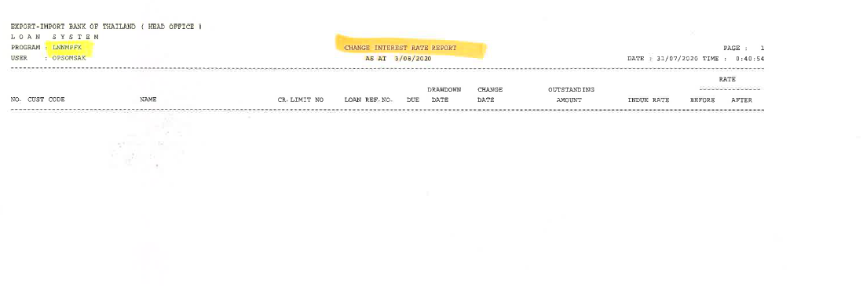

Note:

* Partially Supported
* All report are integate with ECM as End of day Process. (PDF Format). If ECM can not supported to store PDF report from symmetri CBS that no need to store in ECM.
* Symmetri support for retrieve the historical data for report.
* Compare with rollover/repricing function
* No change Rate = Report blank amount (Report daily ตาม AS AT date ถ้าวันไหนที่ไม่มีการเปลี่ยนแปลง Rate Report จะเป็นค่าว่าง)
* Report for changes in interest rate.
* originate rollover setting not require.

### Menu Modification

Not Applicable.

### Screen Layout and Data Sheet

Not Applicable.

### To-be Process

|  |
| --- |
|  |

|  |  |
| --- | --- |
| Paper size | A4 |
| Reprinting require | Reprint |
| Searching criteria | Branch Name/No., Customer name, Customer ID., historical date, Product Type(Loan Type/Loan Sub Type), Source of Fund, currencywise, Due Date, Day Past Due, Loan Reference No., Settlement Account No., Settlement Account Name. |
| Generation Frequency | Daily |
| Report Purpose | List of account with interest rate change for the current date (= system run date) only. |
| Actual Owner | Lending |

|  |  |  |  |
| --- | --- | --- | --- |
| Report Title: Change Interest Rate | | Report Title: | Status |
| Exim Field: | Description/Formular | CBS9 Field: |
| AS AT | Date of changing interest rate |  | Choose an item. |
| Page |  |  | Choose an item. |
| Date / Time |  |  | Choose an item. |
| Export -Import Bank of Thailand (Head office) |  |  | Choose an item. |
| Loan system |  |  | Choose an item. |
| Program |  |  | Choose an item. |
| User |  |  | Choose an item. |
| No. |  |  | Choose an item. |
| Cust Code |  |  |  |
| Name | Name of customer |  | Choose an item. |
| CR.Limit No. |  |  | Choose an item. |
| Due | End date of interest rate  (วันสิ้นสุดดอกเบี้ย) |  | Choose an item. |
| Drawdown Date | วันที่เบิกเงินกู้ |  | Choose an item. |
| Change Date | Change date interest rate  วันที่เปลี่ยนแปลง อัตราดอกเบี้ย |  | Choose an item. |
| Outstanding Amount | ยอดรวมเงินต้น |  | Choose an item. |
| Indue Rate | before due date  อัตราดอกเบี้ย ช่วงก่อนวันครบกำหนด |  | Choose an item. |
| Rate Before | Current interest rate  อัตราดอกเบี้ย ณ ปัจจุบัน |  | Choose an item. |
| Rate After | interest rate changing  อัตราดอกเบี้ย ที่เปลี่ยนแปลง |  | Choose an item. |
| Loan Reference No. | Add new in report  Loan account number, loan drawdown |  | Choose an item. |
| Branch No. |  |  | Choose an item. |
| Branch Name |  |  | Choose an item. |

### File / API Layout and Data Sheet

Not Applicable.

### Report Layout and Data Sheet

Not Applicable.

### Additional Impacts

#### Integration

Not Applicable.

#### Migration

Not Applicable.

## G/L Summary report (Final)

### Supported Sample Transaction and Case from Customer

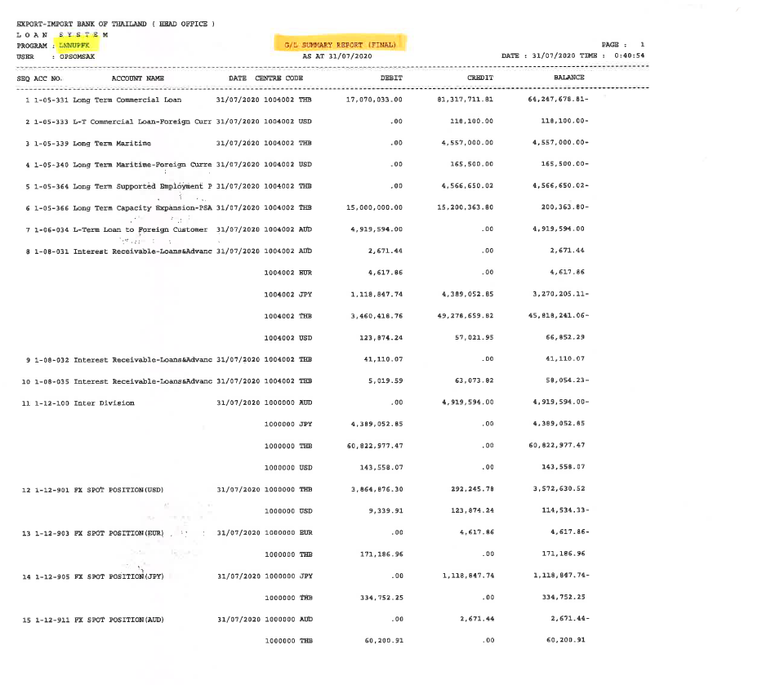

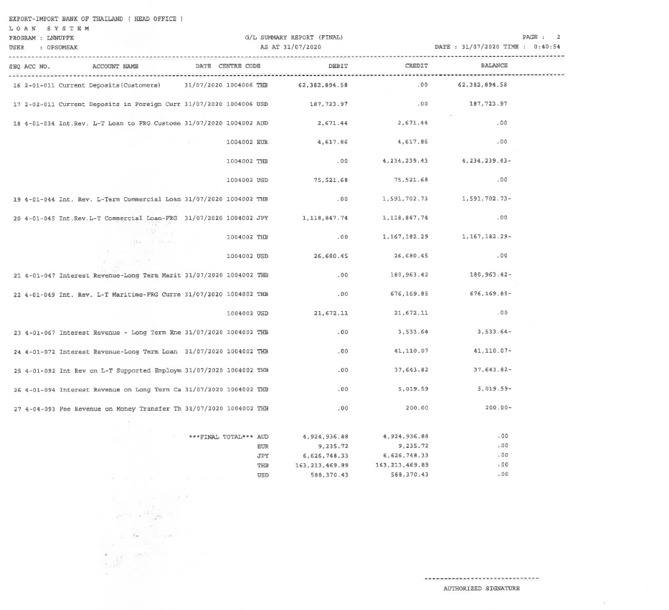

Note:

* All report are integate with ECM as End of day Process. (PDF Format). If ECM can not supported to store PDF report from symmetri CBS that no need to store in ECM.
* Symmetri support for retrieve the historical data for report.
* Process all entries. Every entry date that impact GL Number must be included in report.

### Menu Modification

Not Applicable.

### Screen Layout and Data Sheet

Not Applicable.

### To-be Process

|  |  |
| --- | --- |
| Paper size | A4 |
| Reprinting require | Reprint |
| Searching criteria | Branch Name/No., Customer name, Customer ID., historical date, Product Type(Loan Type/Loan Sub Type), Source of Fund, currencywise, Account/GL Name, Account/GL Code, Loan Reference No., Settlement Account No., Settlement Account Name., Posting/Transaction Date, Value Date |
| Generation Frequency | Daily |
| Report Purpose | List of entries posted for all the lending transactions after end of day |
| Actual Owner | Lending |

|  |  |  |  |
| --- | --- | --- | --- |
| Report Title: G/L Summary (Final) | | Report Title: | Status |
| Exim Field: | Description/Formular | CBS9 Field: |
| AS AT |  |  | Choose an item. |
| Page |  |  | Choose an item. |
| Date / Time |  |  | Choose an item. |
| Export -Import Bank of Thailand (Head office) |  |  | Choose an item. |
| Loan system |  |  | Choose an item. |
| Program |  |  | Choose an item. |
| User |  |  | Choose an item. |
| SEQ |  |  | Choose an item. |
| Acc No. | Account number of GL |  | Choose an item. |
| Account name | Account name of GL |  | Choose an item. |
| Date | Day of generating report is the same day as search day on printing report |  | Choose an item. |
| Centre code | 1004002 = Profit center code  Compare  If the payment will come from Payments Module (GFT), system should get the profit center attached to the loan account number in Customer Lending. |  | Choose an item. |
| Debit | Every item on accounting GL |  | Choose an item. |
| Credit | Every item on accounting GL, total amount of lending module |  | Choose an item. |
| Balance | Debit - Credit = Balance |  | Choose an item. |
| Branch No. |  |  | Choose an item. |
| Branch Name |  |  | Choose an item. |
| Transaction Date | Currently not in legacy system but need in the report |  | Choose an item. |
| Value Date | Currently not in legacy system but need in the report |  | Choose an item. |

### File / API Layout and Data Sheet

Not Applicable

### Report Layout and Data Sheet

Not Applicable.

### Additional Impacts

#### Integration

Not Applicable.

#### Migration

Not Applicable.

## Transfer overdue principal report

### Supported Sample Transaction and Case from Customer

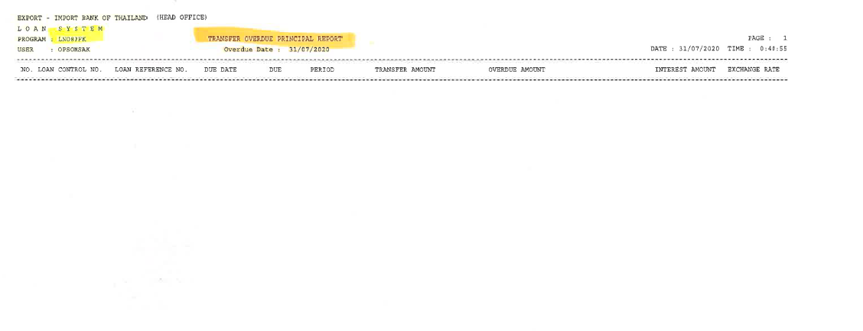

Note:

* All report are integate with ECM as End of day Process. (PDF Format). If ECM can not supported to store PDF report from symmetri CBS that no need to store in ECM.
* Symmetri support for retrieve the historical data for report.
* All transaction that past due including principal will be shown in the report.

### Menu Modification

Not Applicable.

### Screen Layout and Data Sheet

Not Applicable.

### To-be Process

|  |  |
| --- | --- |
| Paper size | A4 |
| Reprinting require | Reprint |
| Searching criteria | Branch Name/No., Customer name, Customer ID., historical date, Product Type(Loan Type/Loan Sub Type), Source of Fund, currencywise, Due Date, Day Past Due, Loan Reference No. |
| Generation Frequency | Online, On request |
| Report Purpose | List of all the Loan accounts which have been transferred to overdue. (As-of date) |
| Actual Owner | Lending |

|  |  |  |  |
| --- | --- | --- | --- |
| Report Title: Transfer overdue principal report | | Report Title: | Status |
| Exim Field: | Description/Formular | CBS9 Field: |
| AS AT |  |  | Choose an item. |
| Page |  |  | Choose an item. |
| Date / Time |  |  | Choose an item. |
| Export -Import Bank of Thailand (Head office) |  |  | Choose an item. |
| Loan system |  |  | Choose an item. |
| Program |  |  | Choose an item. |
| User |  |  | Choose an item. |
| No. |  |  | Choose an item. |
| Loan Control No | 9 digits limit number, take from limit module |  | Choose an item. |
| Loan Reference No. | Loan number/ Drawdown number |  | Choose an item. |
| Due Date | Loan number/ Drawdown number |  | Choose an item. |
| Due |  |  | Choose an item. |
| Period | Installment number  if adhoc is show "-" |  | Choose an item. |
| Transfer Amount | Indue original per currecywise  Separate lines, principal and interest  Such as  Principal 1000  Interest 10 |  | Choose an item. |
| Overdue Amount | Equivalent to Thai Bath |  | Choose an item. |
| Interest Amount |  |  | Choose an item. |
| Exchange rate | Exchange rate at that time, if foreign currency |  | Choose an item. |
| Branch No. |  |  | Choose an item. |
| Branch Name |  |  | Choose an item. |

### File / API Layout and Data Sheet

Not Applicable.

### Report Layout and Data Sheet

Not Applicable.

### Additional Impacts

#### Integration

Not Applicable.

#### Migration

Not Applicable.

## Interest convert to thai baht report

### Supported Sample Transaction and Case from Customer

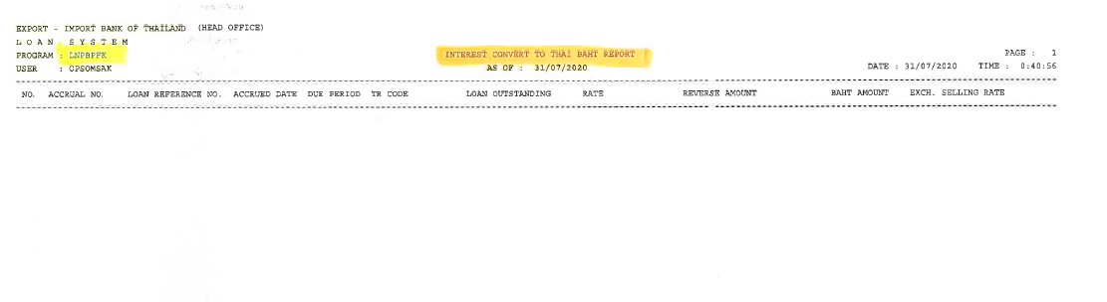

Note:

* All report are integate with ECM as End of day Process. (PDF Format). If ECM can not supported to store PDF report from symmetri CBS that no need to store in ECM.
* Symmetri support for retrieve the historical data for report.
* Only foreign interest that has reached maturity.

### Menu Modification

Not Applicable

### Screen Layout and Data Sheet

Not Applicable.

### To-be Process

|  |  |
| --- | --- |
| Paper size | A4 |
| Reprinting require | Reprint |
| Searching criteria | Branch Name/No., Customer name, Customer ID., historical date, Product Type(Loan Type/Loan Sub Type), Source of Fund, currencywise, Due Date, Day Past Due, Loan Reference No. |
| Generation Frequency | Online, On request |
| Report Purpose | List of all the interest amount for the Loan accounts which have been converted from FCY to LCY (THB) - (As-of date)  This report should automatically send to ECM . If ECM can not supported to store PDF report from symmetri CBS that no need to store in ECM.  - Symmetri support for retrieve the historical data for report. |
| Actual Owner | Lending |

|  |  |  |  |
| --- | --- | --- | --- |
| Report Title: Interest convert to Thai baht report | | Report Title: | Status |
| Exim Field: | Description/Formular | CBS9 Field: |
| AS AT |  |  | Choose an item. |
| Page |  |  | Choose an item. |
| Date / Time |  |  | Choose an item. |
| Export -Import Bank of Thailand (Head office) |  |  | Choose an item. |
| Loan system |  |  | Choose an item. |
| Program |  |  | Choose an item. |
| User |  |  | Choose an item. |
| No. |  |  | Choose an item. |
| Accrual No. | (No need for to be)  Row/installment in AS400  บรรทัด/งวด ใน AS400 |  | Choose an item. |
| Loan Reference No. |  |  | Choose an item. |
| Accrued Date | Day of accrual end  วันที่คิด Accrued สิ้นสุด |  | Choose an item. |
| Due | Foreign interest due date  Due ของดอกเบี้ยต่างประเทศ |  | Choose an item. |
| Period | Installments of Due Interest  งวดของ Due ดอกเบี้ย |  | Choose an item. |
| TR Code | (No need for to be if don’t have in CBS)  Code for running entries in AS400  เลขสำหรับ running รายการใน AS 400 |  | Choose an item. |
| Loan Outstanding | ยอดคงเหลือของเงินต้น |  | Choose an item. |
| Rate |  |  | Choose an item. |
| Reverse Amount | Interest amount per currencywise |  | Choose an item. |
| Baht Amount |  |  | Choose an item. |
| EXCH. | Exchange rate as of that time |  | Choose an item. |
| Selling Rate | Selling Rate as of that time  ณ ช่วงเวลานั้น ขณะที่แปลง |  | Choose an item. |
| Branch No. |  |  | Choose an item. |
| Branch Name. |  |  | Choose an item. |

### File / API Layout and Data Sheet

Not Applicable.

### Report Layout and Data Sheet

Not Applicable.

### Additional Impacts

#### Integration

Not Applicable.

#### Migration

Not Applicable.

## Daily Cheque return report

### Supported Sample Transaction and Case from Customer

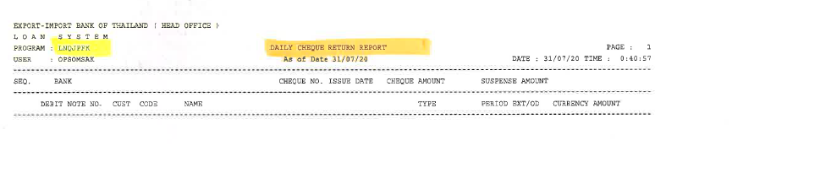

Note:

* All report are integate with ECM as End of day Process. (PDF Format). If ECM can not supported to store PDF report from symmetri CBS that no need to store in ECM.
* Symmetri support for retrieve the historical data for report.
* Show transaction cheque return after clearing check.

### Menu Modification

Not Applicable.

### Screen Layout and Data Sheet

Not Applicable.

### To-be Process

|  |  |
| --- | --- |
| Paper size | A4 |
| Reprinting require | Reprint |
| Searching criteria | Branch Name/No., Customer name, Customer ID., historical date, Product Type(Loan Type/Loan Sub Type), Source of Fund, currencywise, Due Date, Day Past Due, Loan Reference No. |
| Generation Frequency | Daily |
| Report Purpose | Current EXIM Report - This applies to all the cheque returned as payment for the loan  EXIM New Requirement - To list not only the returned cheques but also all the reversal transactions for the period (from-to). EXIM needs to know the settle account type used , no need for the cheque details |
| Actual Owner | Lending |

|  |  |  |  |
| --- | --- | --- | --- |
| Report Title: Daily Cheque return report | | Report Title: | Status |
| Exim Field: | Description/Formular | CBS9 Field: |
| AS AT |  |  | Choose an item. |
| Page |  |  | Choose an item. |
| Date / Time |  |  | Choose an item. |
| Export -Import Bank of Thailand (Head office) |  |  | Choose an item. |
| Loan system |  |  | Choose an item. |
| Program |  |  | Choose an item. |
| User |  |  | Choose an item. |
| SEQ. |  |  | Choose an item. |
| Bank | Bank owner of cheque |  | Choose an item. |
| Cheque No. |  |  | Choose an item. |
| Issue Date |  |  | Choose an item. |
| Cheque amount |  |  | Choose an item. |
| Suspense Amount | Difference between the amount that the customer borrows and the amount in the check, for example, the amount that the customer pays is 900,000 and the amount in the check is 1 million, the difference is 100,000. |  | Choose an item. |
| Debit Note No. | Receipt drawdown information CBS |  | Choose an item. |
| Cust code | Customer id |  | Choose an item. |
| Name | Customer name |  | Choose an item. |
| Type |  |  | Choose an item. |
| Period Ext/OD | In due  over due  extend |  | Choose an item. |
| Currency Amount | Amount that customer must pay, including interest (Show amount) |  | Choose an item. |
| Branch No. |  |  | Choose an item. |
| Branch Name. |  |  | Choose an item. |

### File / API Layout and Data Sheet

Not Applicable.

### Report Layout and Data Sheet

Not Applicable.

### Additional Impacts

#### Integration

Not Applicable.

#### Migration

Not Applicable.

## Daily Payment/ Repayment detail

### Supported Sample Transaction and Case from Customer

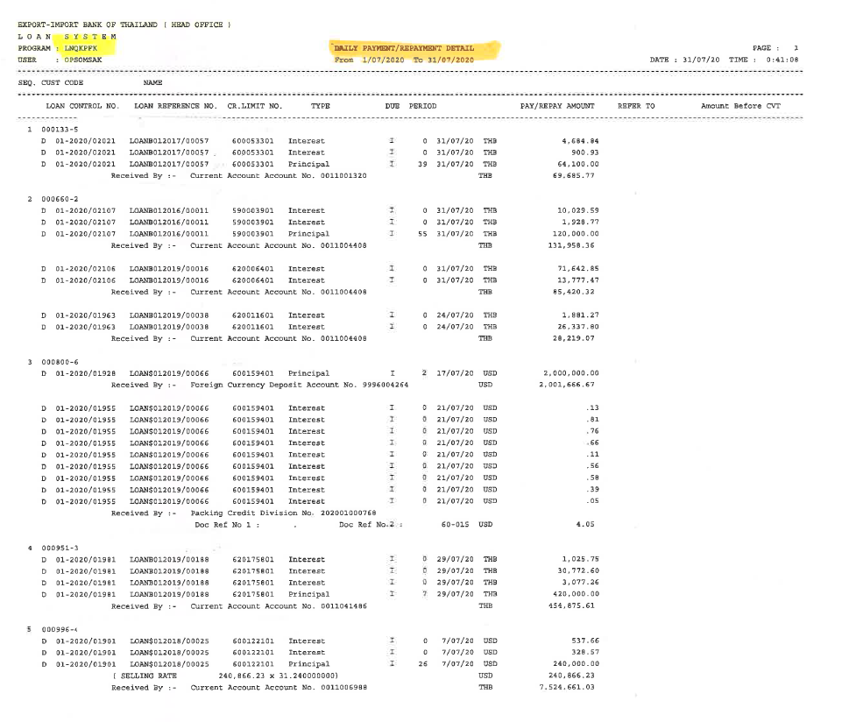

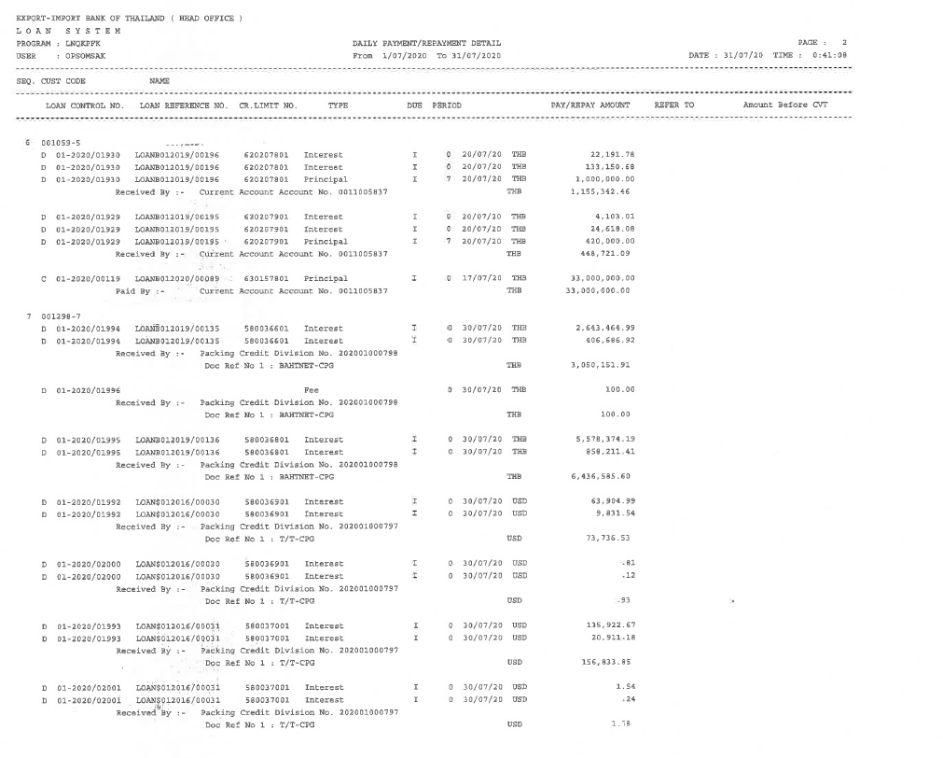

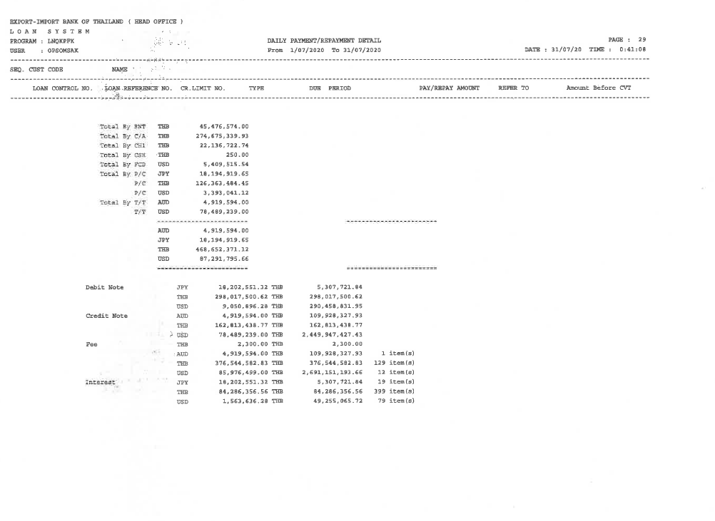

Note:

* All report are integate with ECM as End of day Process. (PDF Format). If ECM can not supported to store PDF report from symmetri CBS that no need to store in ECM.
* Symmetri support for retrieve the historical data for report.
* CBS9 Supported

### Menu Modification

Not Applicable.

### Screen Layout and Data Sheet

Not Applicable.

### To-be Process

|  |
| --- |
| Drawdown Settlement Instructions |
| Receipt Settlement Instruction |
| Drawdown Increase Settlement Instruction |

|  |  |
| --- | --- |
| Paper size | A4 |
| Reprinting require | Reprint |
| Searching criteria | Branch Name/No., Customer name, Customer ID., historical date, Product Type(Loan Type/Loan Sub Type), Source of Fund, currencywise, Due Date, Day Past Due, Loan Reference No. |
| Generation Frequency | Daily |
| Report Purpose | List of the disbursements (payment to customer) and repayments received from the customer daily. (From-To) |
| Actual Owner | Lending |

|  |  |  |  |
| --- | --- | --- | --- |
| Report Title: Daily Payment/ Repayment detail | | Report Title: | Status |
| Exim Field: | Description/Formular | CBS9 Field: |
| AS AT |  |  | Choose an item. |
| Page |  |  | Choose an item. |
| Date / Time |  |  | Choose an item. |
| Export -Import Bank of Thailand (Head office) |  |  | Choose an item. |
| Loan system |  |  | Choose an item. |
| Program |  |  | Choose an item. |
| User |  |  | Choose an item. |
| SEQ |  |  | Choose an item. |
| Cust Code |  |  | Choose an item. |
| Name |  |  | Choose an item. |
| Loan Control No. | Debit note number credit note number (Drawdown confirmation number) ordered by Brach (related to advice document) |  | Choose an item. |
| Loan Reference No. |  |  | Choose an item. |
| CR. Limit No. |  |  | Choose an item. |
| Type | Principal/Interest/Fee. If customer paid more than one, show all applicable  Principal, Interest (Need to check CBS, Legacy show separate)  เงินต้น ดอกเบี่ย ค่าธรรมเนียม แต่ถ้า ชำระทั้งต้นและดอกให้ขึ้น เช็ค CBS แต่ปัจจุบันแสดงแยก |  | Choose an item. |
| Due | Status  - Indue  - Overdue |  | Choose an item. |
| Period | Period of Type  งวดที่ ของ Type (interest =0) |  | Choose an item. |
| Pay/Repay Amount | (Receipt) |  | Choose an item. |
| Refer To | Reference No. of Credit |  | Choose an item. |
| Amount Before CVT |  |  | Choose an item. |
| Branch No. |  |  | Choose an item. |
| Branch Name. |  |  | Choose an item. |
| Account No. | Number of internal account, not account code (Nostro bank) (bank of Thailand) |  | Choose an item. |
| Paid by | Show customer code (if transferred to CASA, show CA account no.)  แสดงเลข บัญชีลูกค้า (ถ้าโอนเข้า บัญชีCASA จะแสดง Current account account no. )  (If transfer through GFT, use destination account number from Field 59F in SWIFT message)  (ถ้าโอนผ่าน GFT จะเป็นเลขที่บัญชีปลายทาง ซึ่งอยู่ใน Field 59 F (59 F คือ Field ใน SWIFT message) (Beneficiary customer: account number )  *Relation to nostro account เช่น Account code number 12011313 (Nostro bank = JP mogan)  For cashier cheque, show internal code (from bank side)  จ่าย แคสเชียเช็ค แสดง internal account ที่แสดง Account code ที่เป็น Cashier เช็ค ((มาจากผังบัญชีธนาคาร)ax account number 22310001) (CASHIER order) |  | Choose an item. |
| Received by | Show customer code (if transferred to CASA, show CA account no.)  แสดงเลข บัญชีลูกค้า (ถ้าโอนเข้า Exim บัญชีCASA จะแสดง Current account account no. )  (If transfer through GFT, use destination account number from Field 59F in SWIFT message)  (ถ้ารับเงินโอนผ่าน GFT (o) จะเป็นเลขที่บัญชีปลายทาง ซึ่งอยู่ใน Field 59 F (59 F คือ Field ใน SWIFT message) (Beneficiary customer: account number )  *Relation to nostro account เช่น Account code number 12011313 (Nostro bank = JP mogan)  For cashier cheque, show internal code (from bank side)  รับ เช็ค ต่างธนาคารเพื่อชำระหนี้ แสดง internal account ที่แสดง Account code ที่เป็น C/A BOT (มาจากผังบัญชีธนาคาร)ax account number 12011101) (C/A BOT) |  | Choose an item. |
| Total by | Type of payment made/received  ประเภทการรับชำระ/ การจ่าย  Separate by making or receiving payment  แยกประเภทการรับชำระและจ่าย |  | Choose an item. |
| Total by currency wise | Separate currencywise following payment receiving type  แยก currency wise ตาม ประเภทรับชำระ |  | Choose an item. |
| Total by Type | Separate debit note, credit note, Fee, Interest  (Total by payment type) |  | Choose an item. |
| Total item | total by payment type |  | Choose an item. |

### File / API Layout and Data Sheet

Not Applicable.

### Report Layout and Data Sheet

Not Applicable.

### Additional Impacts

#### Integration

Not Applicable.

#### Migration

Not Applicable.

## G/L summary (Outstanding) report

### Supported Sample Transaction and Case from Customer

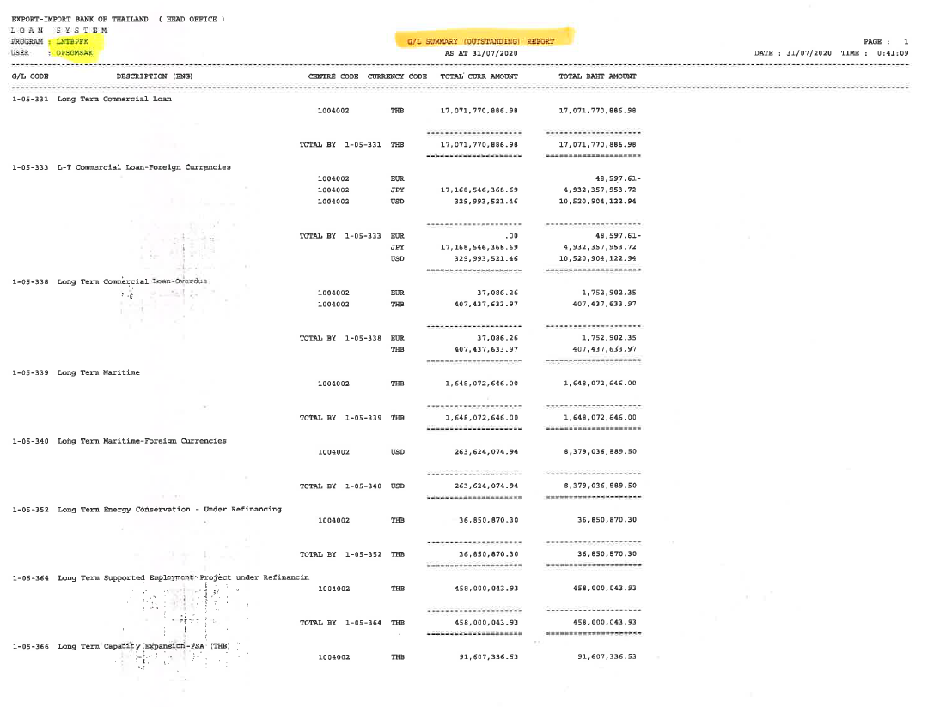

Note:

* All report are integate with ECM as End of day Process. (PDF Format). If ECM can not supported to store PDF report from symmetri CBS that no need to store in ECM.
* Symmetri support for retrieve the historical data for report.
* This report is the same as the G/L Summary report (Final).

### Menu Modification

Not Applicable.

### Screen Layout and Data Sheet

Not Applicable.

### To-be Process

|  |  |
| --- | --- |
| Paper size | A4 |
| Reprinting require | Reprint |
| Searching criteria | Branch Name/No., Customer name, Customer ID., historical date, Product Type(Loan Type/Loan Sub Type), Source of Fund, currencywise, Account/GL Name, Account/GL Code., Posting Date, Value Date, Loan Reference No. |
| Generation Frequency | Daily |
| Report Purpose | List of entries posted (total per GL Code) for all the lending transactions after end of day , per currency. |
| Actual Owner | Lending |

|  |  |  |  |
| --- | --- | --- | --- |
| Report Title: G/L summary (Outstanding) report | | Report Title: | Status |
| Exim Field: | Description/Formular | CBS9 Field: |
| AS AT |  |  | Choose an item. |
| Page |  |  | Choose an item. |
| Date / Time |  |  | Choose an item. |
| Export -Import Bank of Thailand (Head office) |  |  | Choose an item. |
| Loan system |  |  | Choose an item. |
| Program |  |  | Choose an item. |
| User |  |  | Choose an item. |
| G/L Code |  |  | Choose an item. |
| Description (ENG) |  |  | Choose an item. |
| Centre code |  |  | Choose an item. |
| Currency code |  |  | Choose an item. |
| Total Curr Amount |  |  | Choose an item. |
| Total Baht Amount |  |  | Choose an item. |
| Branch No. |  |  | Choose an item. |
| Branch Name |  |  | Choose an item. |
| Account/GL Name |  |  | Choose an item. |
| Account/GL Code |  |  | Choose an item. |
| Posting Date |  |  | Choose an item. |
| Value Date |  |  | Choose an item. |

### File / API Layout and Data Sheet

Not Applicable.

### Report Layout and Data Sheet

Not Applicable.

### Additional Impacts

#### Integration

Not Applicable.

#### Migration

Not Applicable.

## Loan Turnover - Drawdown report

### Supported Sample Transaction and Case from Customer

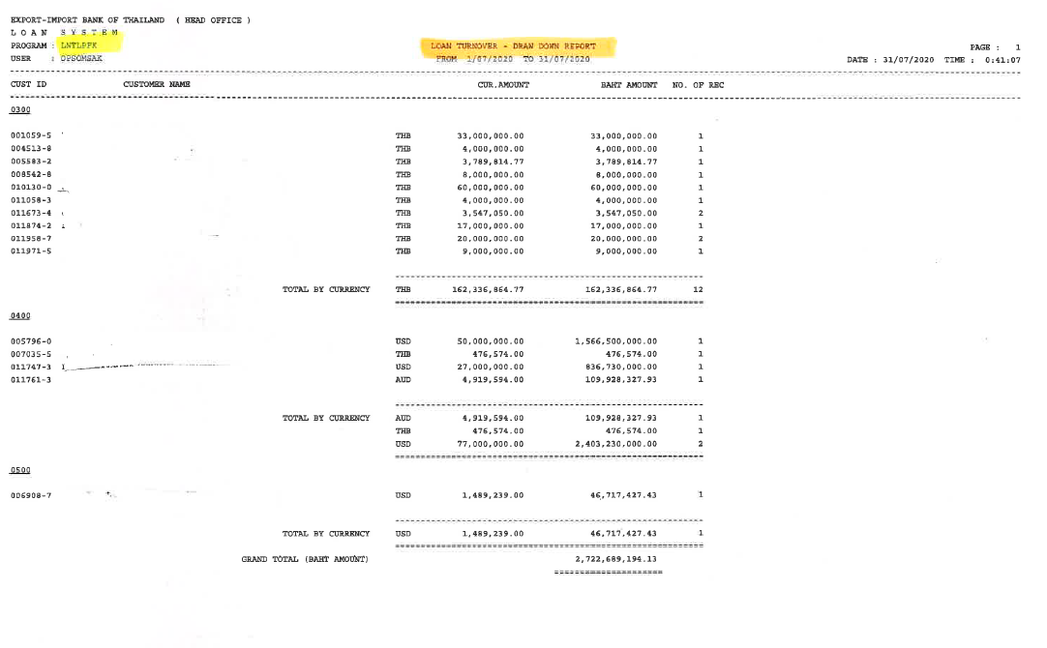

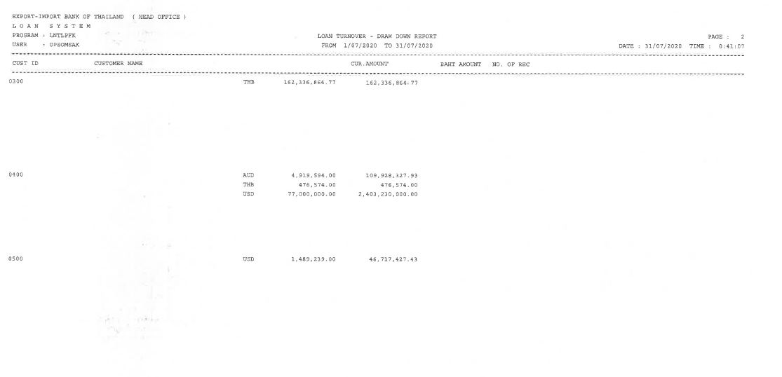

Note:

* All report are integate with ECM as End of day Process. (PDF Format). If ECM can not supported to store PDF report from symmetri CBS that no need to store in ECM.
* Symmetri support for retrieve the historical data for report.
* Partially Supported

### Menu Modification

Not Applicable.

### Screen Layout and Data Sheet

Not Applicable.

### To-be Process

|  |
| --- |
|  |

|  |  |
| --- | --- |
| Paper size | A4 |
| Reprinting require | Reprint |
| Searching criteria | Branch Name/No., Customer name, Customer ID., historical date, From day to day, Product Type(Loan Type/Loan Sub Type), Source of Fund, currencywise, Loan Account No., Loan Reference No. |
| Generation Frequency | Daily |
| Report Purpose | List of Drawdown for the period, per product type. The report displays the loan number, dd number, amounts |
| Actual Owner | Lending |

|  |  |  |  |
| --- | --- | --- | --- |
| Report Title: Loan Turnover - Draw Down report | | Report Title: | Status |
| Exim Field: | Description/Formular | CBS9 Field: |
| AS AT |  |  | Choose an item. |
| Page |  |  | Choose an item. |
| Date / Time |  |  | Choose an item. |
| Export -Import Bank of Thailand (Head office) |  |  | Choose an item. |
| Loan system |  |  | Choose an item. |
| Program |  |  | Choose an item. |
| User |  |  | Choose an item. |
| Cust ID |  |  | Choose an item. |
| Customer name |  |  | Choose an item. |
| Cur. Amount | Show total drawn by customer between days 1/07/2020 - 31/07/2020 |  | Choose an item. |
| Baht Amount |  |  | Choose an item. |
| No. of REC | Such as Number 2 means customer made 2 drawdowns in same month, and will show total amount drawn as 3million |  | Choose an item. |
| Branch No. |  |  | Choose an item. |
| Branch Name |  |  | Choose an item. |
| Total Drawdown Amount | Show total by currencywise  โดยแยก Currency wise และ สกุลบาท |  | Choose an item. |
| Grand total drawdown Amount (BAHT) | Show THB total using midrate |  | Choose an item. |
| Product Type |  |  | Choose an item. |

### File / API Layout and Data Sheet

Not Applicable.

### Report Layout and Data Sheet

Not Applicable.

### Additional Impacts

#### Integration

Not Applicable.

#### Migration

Not Applicable.

## G/L Detail Outstanding Report

### Supported Sample Transaction and Case from Customer

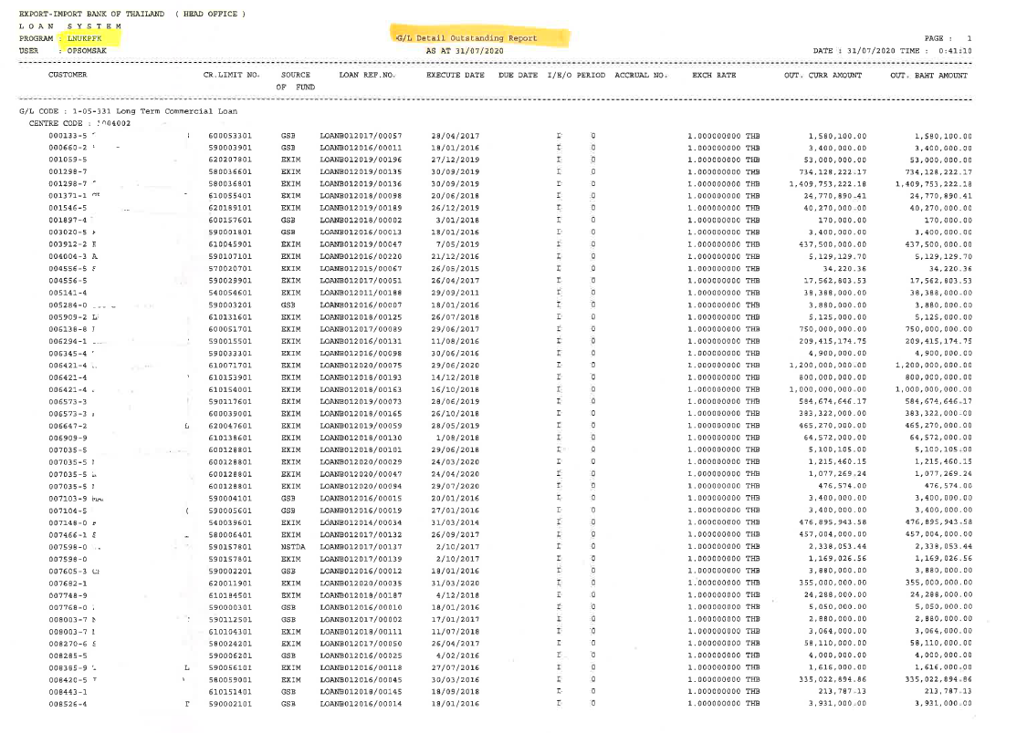

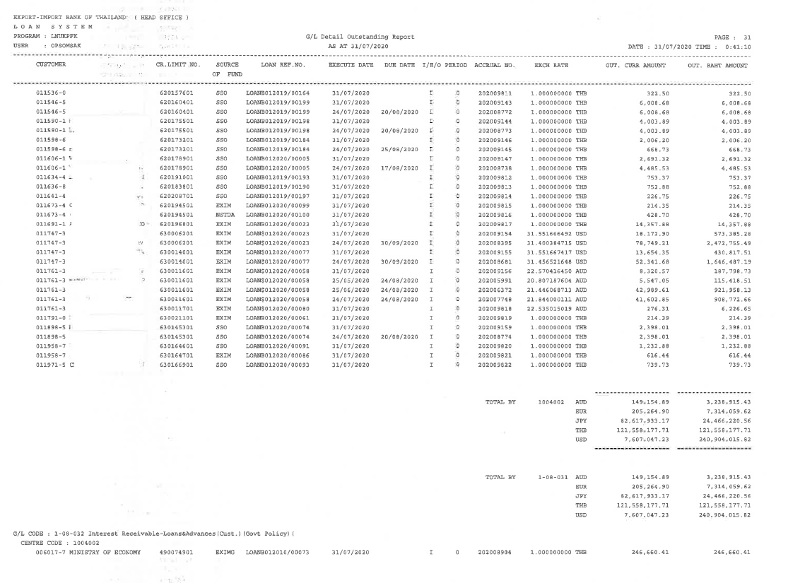

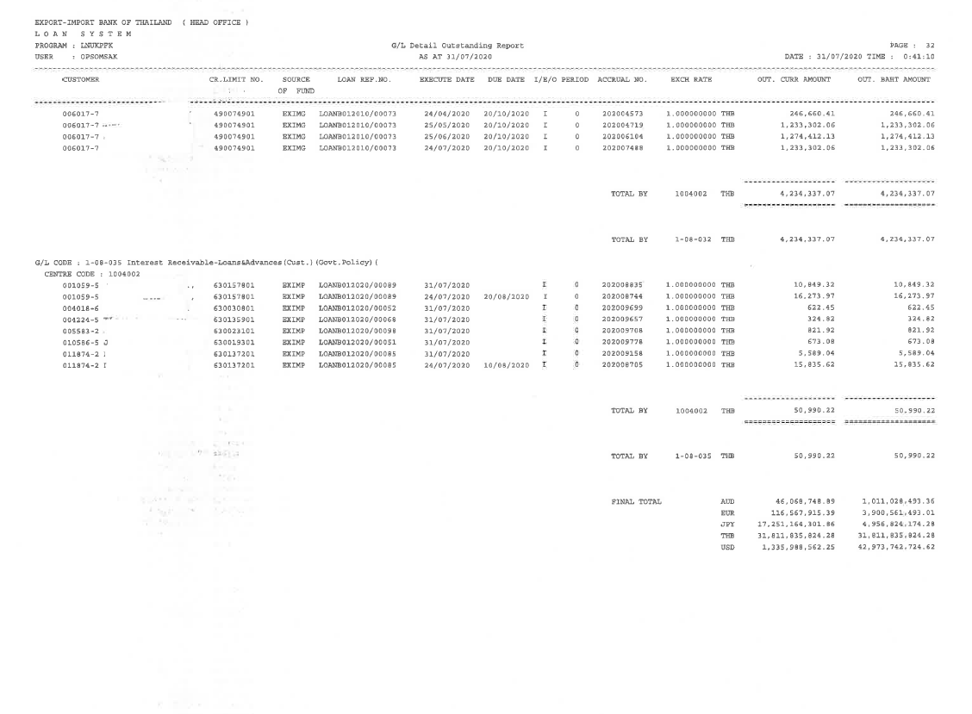

Note:

* All report are integate with ECM as End of day Process. (PDF Format). If ECM can not supported to store PDF report from symmetri CBS that no need to store in ECM.
* Symmetri support for retrieve the historical data for report.

### Menu Modification

Not Applicable.

### Screen Layout and Data Sheet

Not Applicable.

### To-be Process

|  |  |
| --- | --- |
| Paper size | A4 |
| Reprinting require | Reprint |
| Searching criteria | Branch Name/No., Customer name, Customer ID., historical date, Product Type(Loan Type/Loan Sub Type), Source of Fund, currencywise, Account/GL Name, Account/GL Code., Posting Date, Value Date, Loan Reference No. |
| Generation Frequency | Daily |
| Report Purpose | List of entries posted (per GL Code) for all the lending transactions after end of day with details - per loan acct number, per currency and with converted amount using the transaction xrate. |
| Actual Owner | Lending |

|  |  |  |  |
| --- | --- | --- | --- |
| Report Title: G/L Detail Outstanding Report | | Report Title: | Status |
| Exim Field: | Description/Formular | CBS9 Field: |
| AS AT |  |  | Choose an item. |
| Page |  |  | Choose an item. |
| Date / Time |  |  | Choose an item. |
| Export -Import Bank of Thailand (Head office) |  |  | Choose an item. |
| Loan system |  |  | Choose an item. |
| Program |  |  | Choose an item. |
| User |  |  | Choose an item. |
| Customer |  |  | Choose an item. |
| CR. Limit No. | 9 digits |  | Choose an item. |
| Source of fund |  |  | Choose an item. |
| Loan Rep. No. |  |  | Choose an item. |
| Execute date |  |  | Choose an item. |
| due date |  |  | Choose an item. |
| I/E/O | Status |  | Choose an item. |
| Accrual No. | No need to be |  | Choose an item. |
| EXCH Rate | Relevant exchange rate. Using rate during do the transaction |  | Choose an item. |
| Out. Curr Amount | Outstanding currencywise amount |  | Choose an item. |
| Out. Baht Amount |  |  | Choose an item. |
| Transaction date | Add in to be |  | Choose an item. |
| Value date | Add in to be |  | Choose an item. |
| Total by | By Centre code (Profit center) |  | Choose an item. |
| Final Total | Currencywise |  | Choose an item. |

### File / API Layout and Data Sheet

Not Applicable.

### Report Layout and Data Sheet

Not Applicable.

### Additional Impacts

#### Integration

Not Applicable.

#### Migration

Not Applicable.

## Loan Credit Limit (Sort by name)

### Supported Sample Transaction and Case from Customer

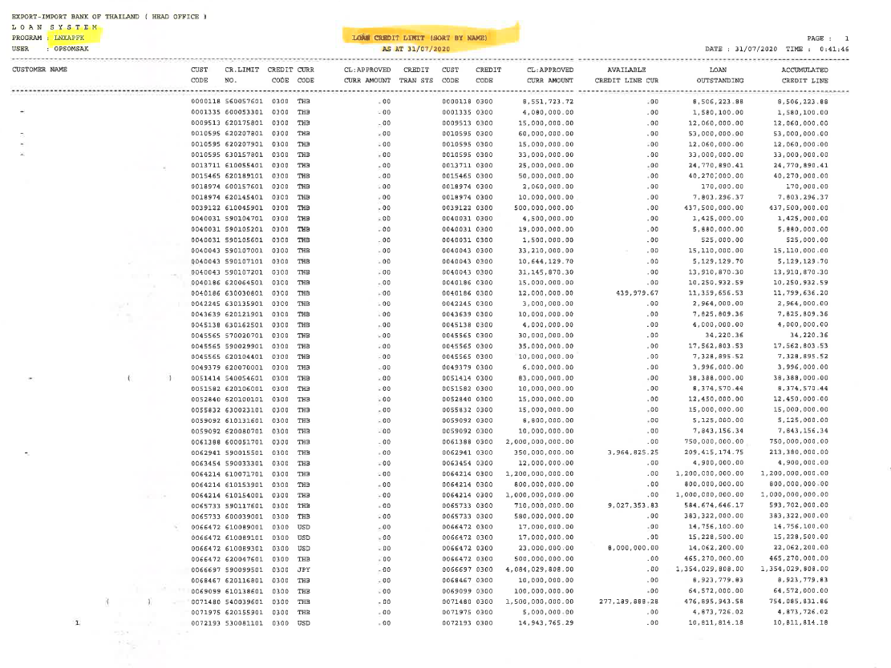

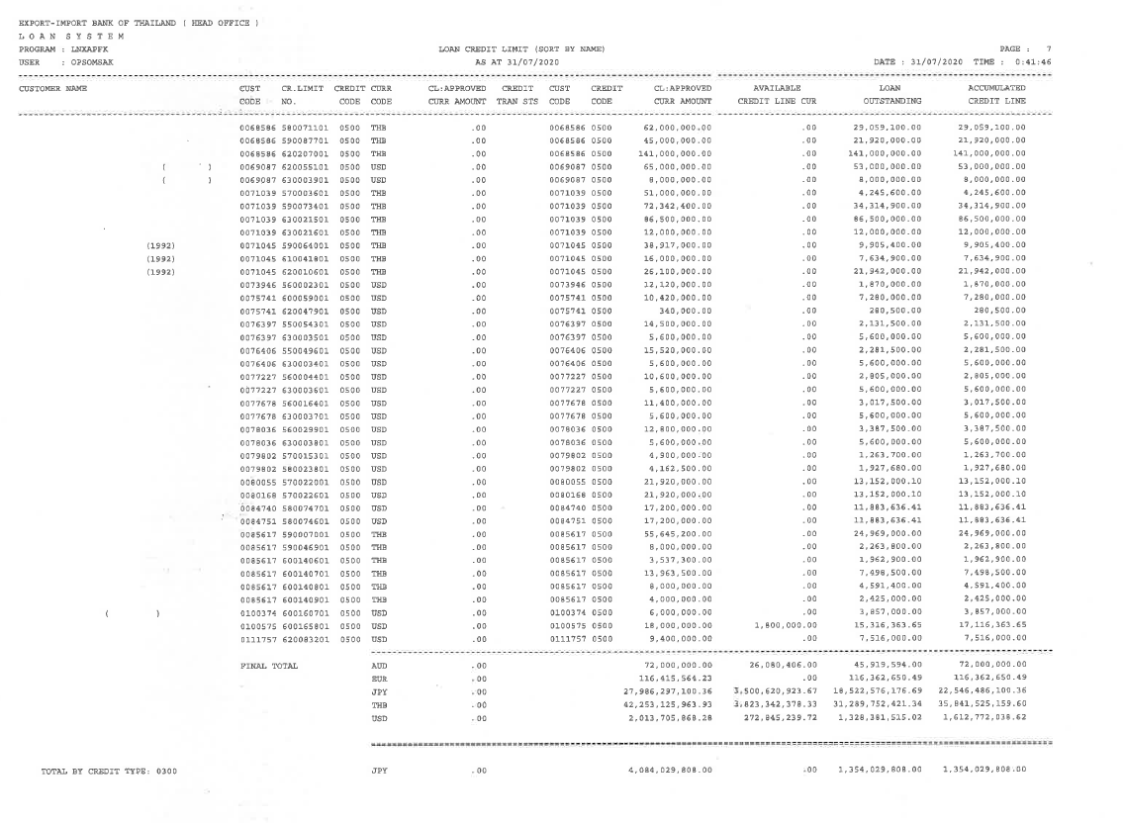

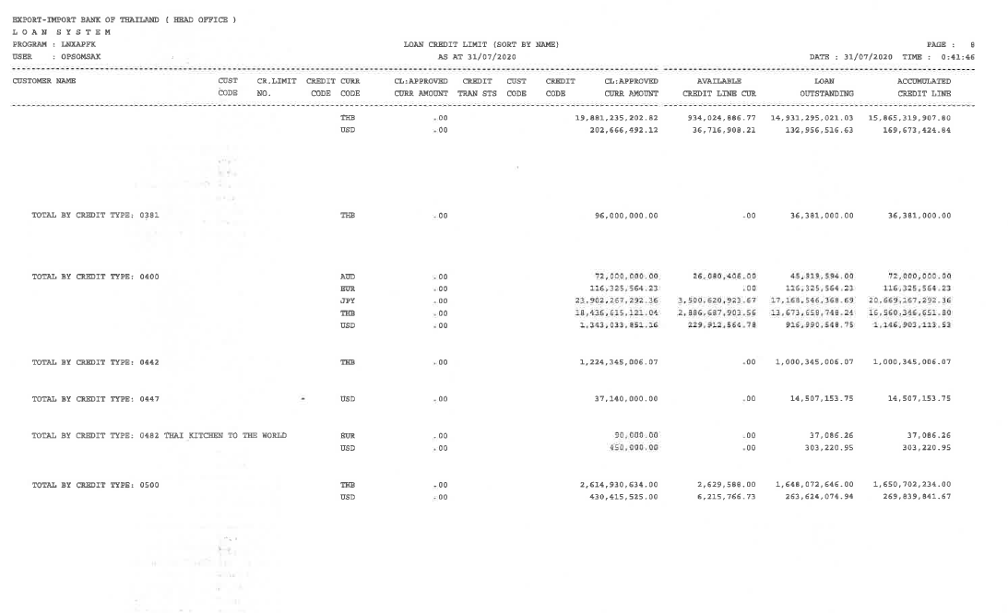

Note:

* All report are integate with ECM as End of day Process. (PDF Format). If ECM can not supported to store PDF report from symmetri CBS that no need to store in ECM.
* Symmetri support for retrieve the historical data for report.
* Credit limit report show total accumulated of withdrawal (Utilize).
* Partially Supported

### Menu Modification

Not Applicable.

### Screen Layout and Data Sheet

Not Applicable.

### To-be Process

|  |
| --- |
|  |

|  |  |
| --- | --- |
| Paper size | A4 |
| Reprinting require | Reprint |
| Searching criteria | Branch Name/No., Customer name, Customer ID., historical date, Product Type(Loan Type/Loan Sub Type), Source of Fund, currencywise, Loan Account No., Loan Reference No. |
| Generation Frequency | Daily |
| Report Purpose | List of Limit amount and the utilized exposure, with the available amount for the corresponding credit limit.Loan account number should also be displayed. |
| Actual Owner | Lending |

|  |  |  |  |
| --- | --- | --- | --- |
| Report Title: Loan Credit Limit (Sort by name) | | Report Title: | Status |
| Exim Field: | Description/Formular | CBS9 Field: |
| AS AT |  |  | Choose an item. |
| Page |  |  | Choose an item. |
| Date / Time |  |  | Choose an item. |
| Export -Import Bank of Thailand (Head office) |  |  | Choose an item. |
| Loan system |  |  | Choose an item. |
| Program |  |  | Choose an item. |
| User |  |  | Choose an item. |
| Customer name |  |  | Choose an item. |
| Cust code |  |  | Choose an item. |
| CR.Limit No. |  |  | Choose an item. |
| Credit code |  |  | Choose an item. |
| Curr code | Currencywise of customer |  | Choose an item. |
| CL: Approved Curr Amount | To be no need |  | Choose an item. |
| Credit Tran STS |  |  | Choose an item. |
| Cust code | To be no need |  | Choose an item. |
| Credit code | To be no need |  | Choose an item. |
| CL: Approved Curr Amount | Total approved |  | Choose an item. |
| Available Credit Line Cur | Remaining credit limit |  | Choose an item. |
| Loan Outstanding | Cumulative drawdown  For example, the first time the customer withdrew 1 million.  2nd time with another 1 million  Even if the customer has already paid back 5 hundred thousand  The amount shown must be 2 million. |  | Choose an item. |
| Accumulated Credit Line |  |  | Choose an item. |
| Final Total | Total amount, separate by currency |  | Choose an item. |

### File / API Layout and Data Sheet

Not Applicable.

### Report Layout and Data Sheet

Not Applicable.

### Additional Impacts

#### Integration

Not Applicable.

#### Migration

Not Applicable.

## Statement of Loan Account

### Supported Sample Transaction and Case from Customer

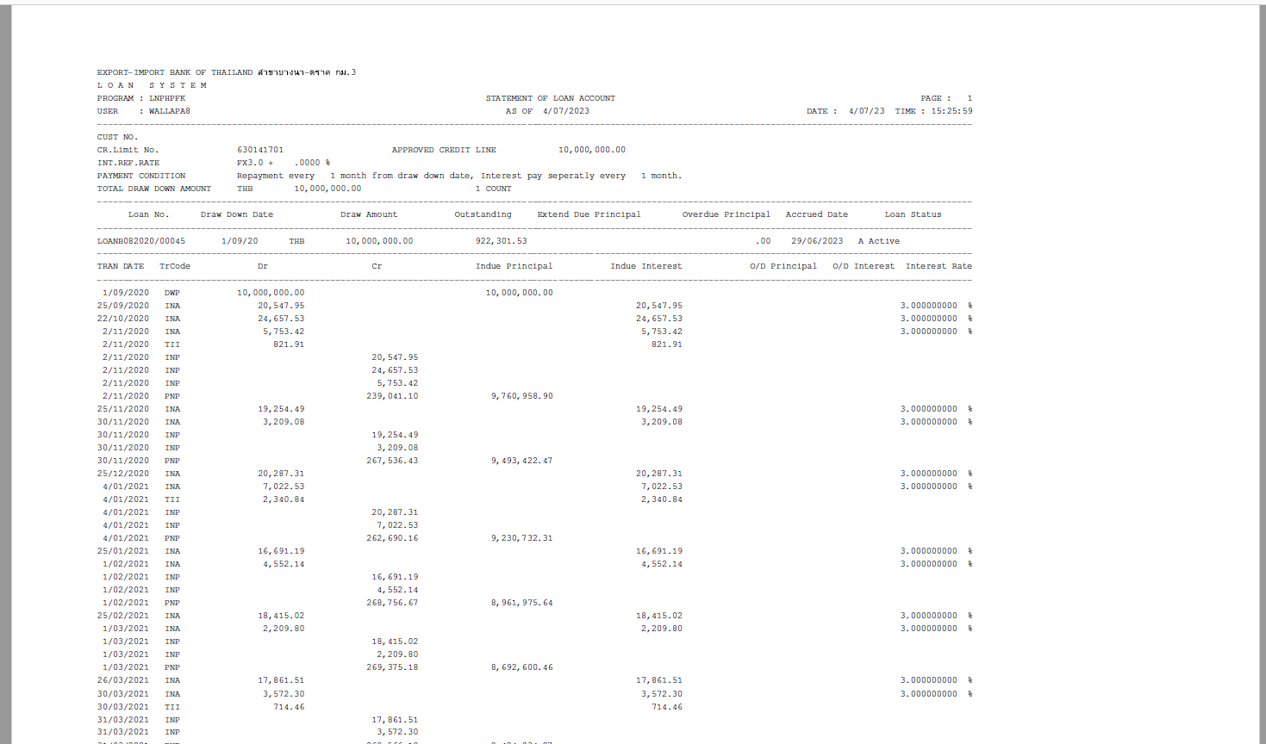

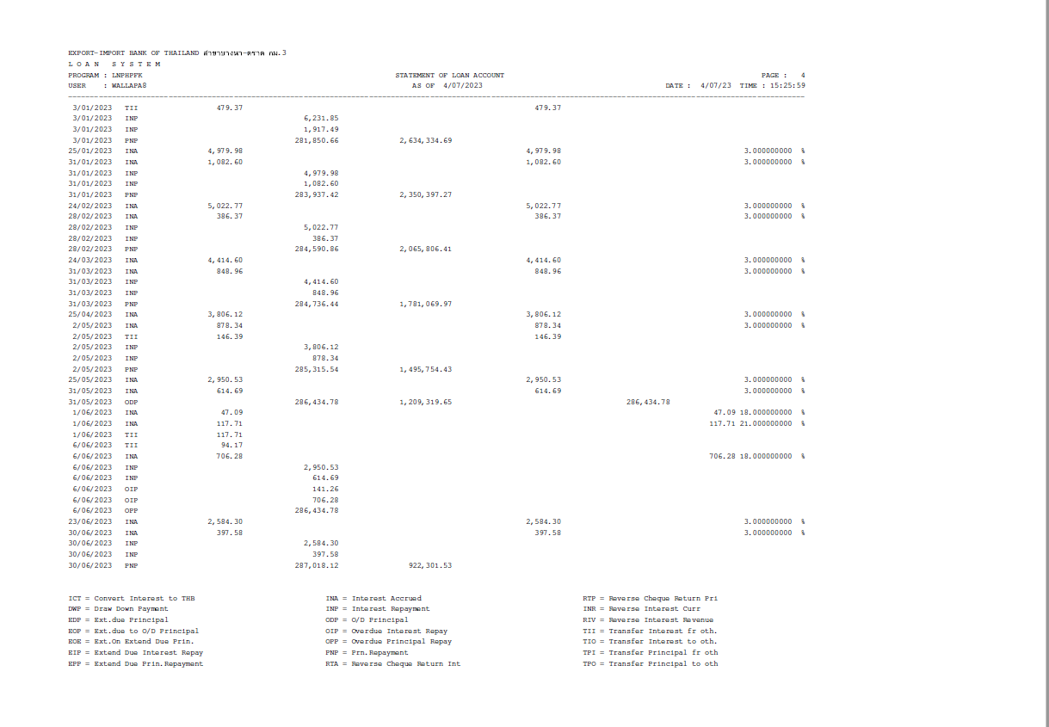

Example Multiple Drawdown:

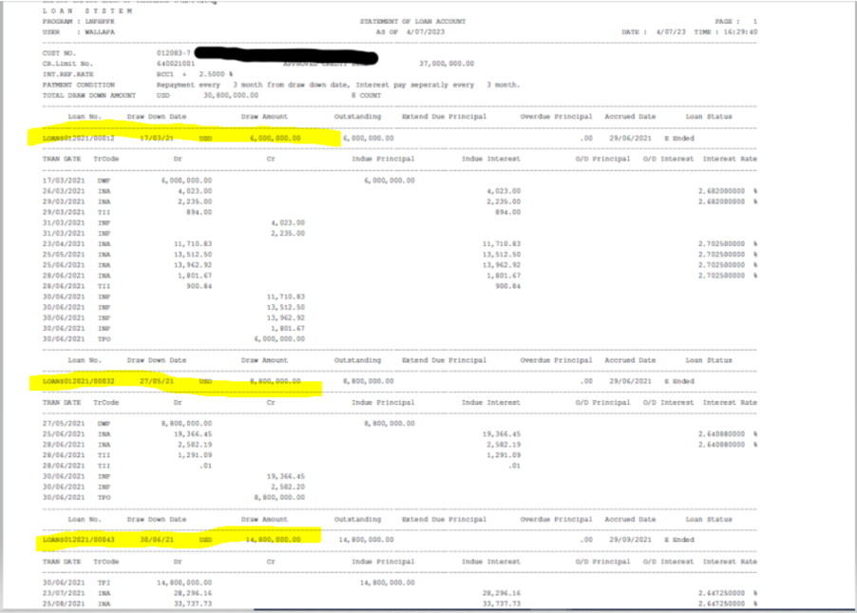

Transaction code:

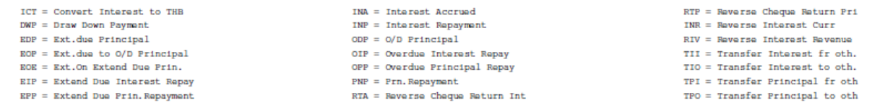

Note:

* All report are integate with ECM as End of day Process. (PDF Format). If ECM can not supported to store PDF report from symmetri CBS that no need to store in ECM.
* Symmetri support for retrieve the historical data for report.
* Searching criteria if leave as blank need to show all the data that customer drawdown.

### Menu Modification

Not Applicable.

### Screen Layout and Data Sheet

Not Applicable.

### To-be Process

|  |
| --- |
|  |

|  |  |
| --- | --- |
| Paper size | A4 |
| Reprinting require | Reprint |
| Searching criteria | Branch Name/No., Customer name, Customer ID,Project code (Credit limit number), Loan Account No., DrawDown number, From date – To date (if leave as blank need to show all the data that customer drawdown) |
| Generation Frequency | Online, On request |
| Report Purpose | To display the movement of the particular loan account number. All payments (principal, interest, etc.) |
| Actual Owner | Lending |

|  |  |  |  |
| --- | --- | --- | --- |
| Report Title: Statement of loan account | | Report Title: Loan Statement | Status |
| Exim Field: | Description/Formular | CBS9 Field: |
| From date – To date | From date to date (if leave as blank need to show all the data that customer drawdown) |  | Choose an item. |
| Page |  |  | Choose an item. |
| Date / Time |  |  | Choose an item. |
| Export -Import Bank of Thailand | Show according to search conditions |  | Choose an item. |
| Loan system |  |  | Choose an item. |
| Program |  |  | Choose an item. |
| User |  |  | Choose an item. |
| Cust no. |  |  | Choose an item. |
| CR.Limit No. | Project code / Loan account number |  | Choose an item. |
| Approved credit line | Loan amount (approved amount of the Project code) |  | Choose an item. |
| Int. Ref. Rate | interest rate from loan agreement |  | Choose an item. |
| Payment condition | payment conditions for customer, frequency of payment |  | Choose an item. |
| Total Draw down amount | The total amount of the loan disbursed. |  | Choose an item. |
| Count | Amount of times DD |  | Choose an item. |
| Loan No. | Loan number and draw down number |  | Choose an item. |
| Draw Down Date | Drawdown date |  | Choose an item. |
| Draw Amount | Amount loan currencywise |  | Choose an item. |
| Outstanding |  |  | Choose an item. |
| Extend due principal |  |  | Choose an item. |
| Overdue principal |  |  | Choose an item. |
| Accrued date | Accrued date, day before customer pays. |  | Choose an item. |
| Loan Status | Active  Inactive |  | Choose an item. |
| Tran Date |  |  | Choose an item. |
| Tr Code | Transaction code  Refer picture above |  | Choose an item. |
| DR |  |  | Choose an item. |
| CR |  |  | Choose an item. |
| Indue Principal |  |  | Choose an item. |
| Indue Interest |  |  | Choose an item. |
| O/D Principal | Overdue principal |  | Choose an item. |
| O/D interest | Overdue interest |  | Choose an item. |
| Interest Rate |  |  | Choose an item. |
| Maturity Date | (New field) วันที่ครบกำหนดชำระ |  | Choose an item. |

### File / API Layout and Data Sheet

Not Applicable.

### Report Layout and Data Sheet

Not Applicable.

### Additional Impacts

#### Integration

Not Applicable.

#### Migration

Not Applicable.

## ใบนำส่ง CHQ Clearing, cheque clearing report

### Supported Sample Transaction and Case from Customer

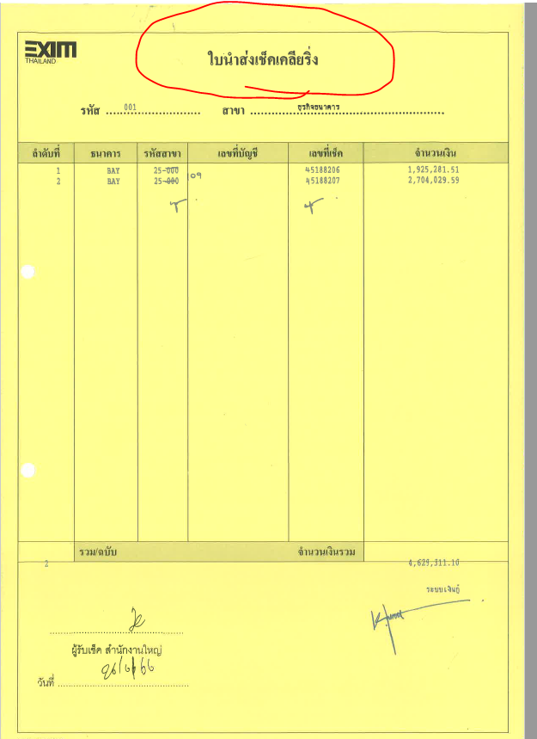

Note:

* Report generate:
  + input cheque data
  + this report after maker enter data entry
  + after maker done and need to print the report after maker done as that time (on demand)
* The language used in the report is based on As Is (every report).

### Menu Modification

Not Applicable.

### Screen Layout and Data Sheet

Not Applicable.

### To-be Process

|  |  |
| --- | --- |
| Paper size | A4 |
| Reprinting require | Reprint |
| Searching criteria | Branch Name (Of exim) (DropDownlist) during settlement transaction/ , As of date (Transaction date for make the repayment วันที่ทำรายการ repayment) |
| Generation Frequency | Daily |
| Report Purpose | List of the cheques sent for clearing - for the day.  Maker generate this report. |
| Actual Owner | Accounting Department |

|  |  |  |  |
| --- | --- | --- | --- |
| Report Title: cheque clearing report | | Report Title: Loan Statement | Status |
| Exim Field: | Description/Formular | CBS9 Field: |
| รหัส | Branch code of Exim for e.g. 001 is head office |  | Choose an item. |
| สาขา | Branch name of Exim e.g. head office |  | Choose an item. |
| ลำดับที่ | number Transaction of cheque (multi settlement screen) |  | Choose an item. |
| ธนาคาร | Bank in cheque |  | Choose an item. |
| รหัสสาขา | code of bank in cheque |  | Choose an item. |
| เลขที่บัญชี | Account number |  | Choose an item. |
| เลขที่เช็ค | Cheque number |  | Choose an item. |
| จำนวนเงิน | Amount in cheque |  | Choose an item. |
| รวม/ฉบับ | Count number of cheque |  | Choose an item. |
| จำนวนเงินรวม | Total amount |  | Choose an item. |
| …………………………………..  ผู้รับเช็ค สำนักงานใหญ่ | Signature of the person receiving cheque, Branch |  | Choose an item. |
| ……………………………………  วันที่ | Date of Received cheque |  | Choose an item. |
| As of date | Add new field "As of Date" to be same date as searching criteria |  | Choose an item. |

### File / API Layout and Data Sheet

Not Applicable.

### Report Layout and Data Sheet

Not Applicable.

### Additional Impacts

#### Integration

Not Applicable.

#### Migration

Not Applicable.

## ใบนำส่ง CHQ Clearing และเงินสด , cheque clearing and cash report

### Supported Sample Transaction and Case from Customer

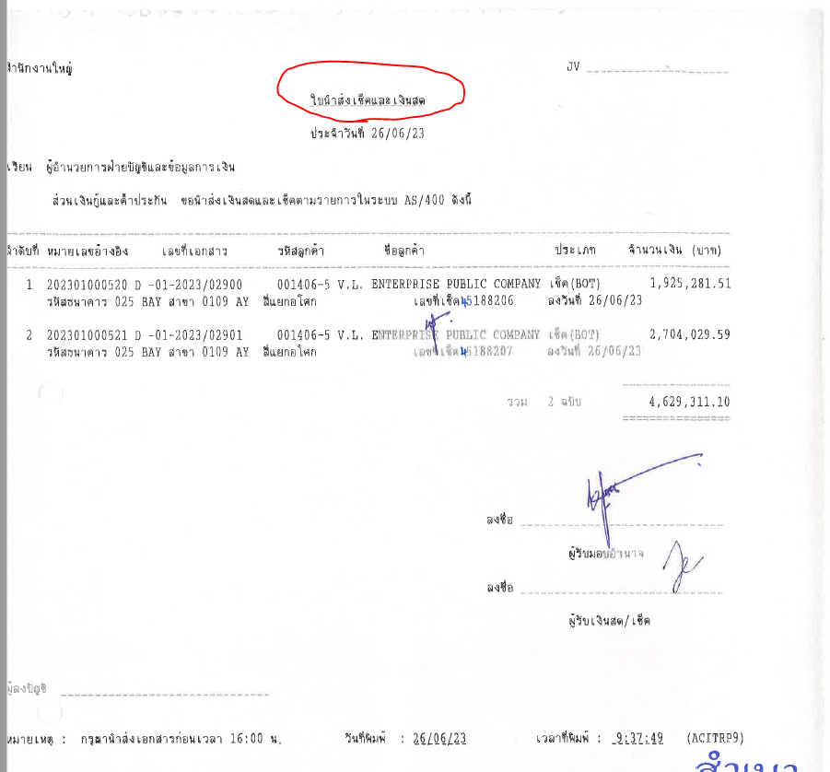

Note:

* Report generate:
  + Checker verify, after done verify need to print report at that time this report after maker enter data entry.
  + The language used in the report is based on As Is (every report).

### Menu Modification

Not Applicable.

### Screen Layout and Data Sheet

Not Applicable.

### To-be Process

|  |  |
| --- | --- |
| Paper size | A4 |
| Reprinting require | Reprint |
| Searching criteria | Branch Name (DropDownlist) during settlement transaction/ , As at date (Transaction date for make the repayment วันที่ทำรายการ repayment) |
| Generation Frequency | Daily |
| Report Purpose | List of the cheques sent for clearing - for the day. Checker generate this report. |
| Actual Owner | Accounting Department |

|  |  |  |  |
| --- | --- | --- | --- |
| Report Title: cheque clearing report and cash | | Report Title: Loan Statement | Status |
| Exim Field: | Description/Formular | CBS9 Field: |
| สำนักงานใหญ่ | Branch |  | Choose an item. |
| ประจำวันที่ | At as date |  | Choose an item. |
| เรียน ผู้อำนวยการฝ่ายบัญชีและข้อมูลการเงิน | Dear Director of Accounting and Financial Information |  | Choose an item. |
| ส่วนเงินกู้และคำประกัน ขอนำส่งเงินสดและเช็คตามรายการในระบบ Symmetri CBS ดังนี้ | Loans and guarantees Please send cash and checks according to the items in the Symmetri CBS system as follows: |  | Choose an item. |
| ลำดับที่ | Number Transaction of cheque |  | Choose an item. |
| หมายเลขอ้างอิง | Change from Ref. no to Loan number/ drawdown number |  | Choose an item. |
| เลขที่เอกสาร | Receipt number |  | Choose an item. |
| รหัสลูกค้า | Customer code |  | Choose an item. |
| ชื่อลูกค้า | Customer name |  | Choose an item. |
| ประเภท | Exim can use cbs9 virtual column (cheque or cash payment) for the user to choose the mode of customer's payment during internal GL settlements.  cbs9 to add virtual column also for other CHEQUE details during receipt settlements |  | Choose an item. |
| จำนวนเงิน | Amount in cheque currency bath |  | Choose an item. |
| จำนวนเงินรวม | Total amount |  | Choose an item. |
| รวม/ฉบับ | Count number of cheque |  |  |
| ……………………..  ผู้รับมอบอำนาจ |  |  |  |
| …………………….  ผู้รับเงินสด/เช็ค | Signature of the person receiving cash/cheque |  |  |
| หมายเหตุ: |  |  |  |
| วันที่พิมพ์เอกสาร | Date of printing document |  |  |
| เวลาที่พิมพ์เอกสาร | Time of printing document |  |  |

### File / API Layout and Data Sheet

Not Applicable.

### Report Layout and Data Sheet

Not Applicable.

### Additional Impacts

#### Integration

Not Applicable.

#### Migration

Not Applicable.

## ตารางดำเนินคดีลูกหนี้ (Lawsuit Report)

### Supported Sample Transaction and Case from Customer

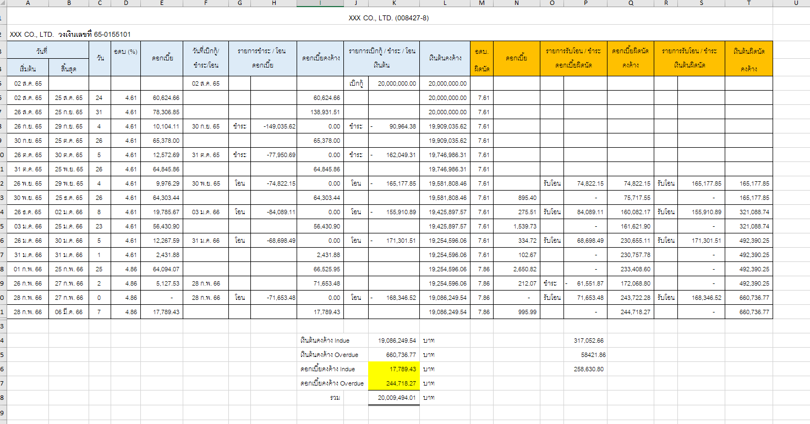

Note:

* Loan drawdown details for the purpose of filing a lawsuit.
* Export to excel flie need to display formular (Inculed Formular in Excel).
* The language used in the report is based on As Is (every report).

### Menu Modification

Not Applicable.

### Screen Layout and Data Sheet

Not Applicable.

### To-be Process

|  |  |
| --- | --- |
| Paper size | A4 |
| Reprinting require | Reprint |
| Searching criteria | Loan Account No., Loan Reference No. , Project code (Credit limit no.), Customer name, Customer ID, |
| Generation Frequency | Daily |
| Report Purpose | List of the loan accounts that has been past due and maybe cadidate for law suit. |
| Actual Owner | Legal Department/Problem Loan Division |

|  |  |  |  |
| --- | --- | --- | --- |
| Report Title: ตารางดำเนินคดีลูกหนี้ (Lawsuit Report) | | Report Title: | Status |
| Exim Field: | Description/Formular | CBS9 Field: |
| XXX.CO.LTD (008427) | Customer name/ Customer ID |  | Choose an item. |
| XXX.CO.LTD วงเงินเลขที่ 65-0155101 | Customer name /Credit limit number (Project code/ Loan number) |  | Choose an item. |
| วันที่ | Date |  | Choose an item. |
| เริ่มต้น | Start date of transaction |  | Choose an item. |
| สิ้นสุด | End date of Accrue interest |  | Choose an item. |
| วัน | Number of days  (CBS9 will calculate count of start date - customer paid date  column F if customer pays on 30th, calculate interest to 29th) |  | Choose an item. |
| อดบ% | Interest rate % (Contract rate) |  | Choose an item. |
| ดอกเบี้ย | (Interest amount)  20,000,000 * 4.61% =922,000 *24 /365 = 60,624.66  (customer paid principal * Interest rate%)* number of days/365 |  | Choose an item. |
| วันที่เบิกกู้/ชำระ/โอน | Date of loan drawdown/payment/transfer |  | Choose an item. |
| รายการชำระ/โอน/ดอกเบี้ย | Payment/transfer/interest transaction |  | Choose an item. |
| ดอกเบี้ยคงค้าง | Outstanding interest |  | Choose an item. |
| รายการเบิกกู้/ชำระ/โอนเงินต้น | Loan disbursement payment principal transfer |  | Choose an item. |
| เงินต้นคงค้าง | Outstanding principal |  | Choose an item. |
| อดบ. ผิดนัด | Overdue Interest rate |  | Choose an item. |
| ดอกเบี้ย | Interest amount  Loan disbursement payment principal transfer * Overdue Interest rate* number of Days/365 |  | Choose an item. |
| รายการรับโอน/ชำระดอกเบี้ยผิดนัด | Transfer payment of missed interest = information on paid interest column (in the case that customer misses payment) |  | Choose an item. |
| ดอกเบี้ยผิดนัดคงค้าง | Interest missed Outstanding = missing transfer/payment + interest |  | Choose an item. |
| รายการรับโอน/ชำระเงินต้นผิดนัด | Default transfer payment of principal = Loan disbursement payment principal transfer |  | Choose an item. |
| เงินต้นผิดนัดคงค้าง | Principal default outstanding = (Previous Principal default outstanding + Current Principal default outstanding) |  | Choose an item. |
| เงินต้นคงค้าง Indue | Total Outstanding principal indue |  | Choose an item. |
| เงินต้นคงค้าง Overdue | Total Outstanding principal Overdue |  | Choose an item. |
| ดอกเบี้ยคงค้าง Indue | Interest Outstanding indue |  | Choose an item. |
| ดอกเบี้ยคงค้าง Overdue | Interest Outstanding overdue |  | Choose an item. |
| รวม | total |  | Choose an item. |

### File / API Layout and Data Sheet

Not Applicable.

### Report Layout and Data Sheet

Not Applicable.

### Additional Impacts

#### Integration

Not Applicable.

#### Migration

Not Applicable.

## ตารางคำนวณชดเชยส่วนต่างดอกเบี้ย TG1 (Interest Differential Compensation: TG1 Report) (Related TOR – LN-55)

### Supported Sample Transaction and Case from Customer

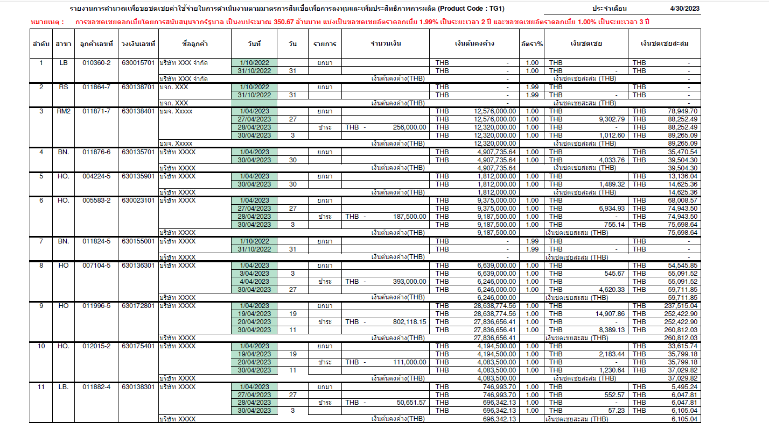

Incase mulitple drawdown

Should be shown the transaction drawdown when customer draw down

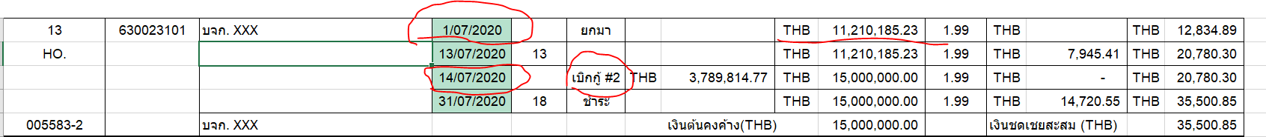

Page 2

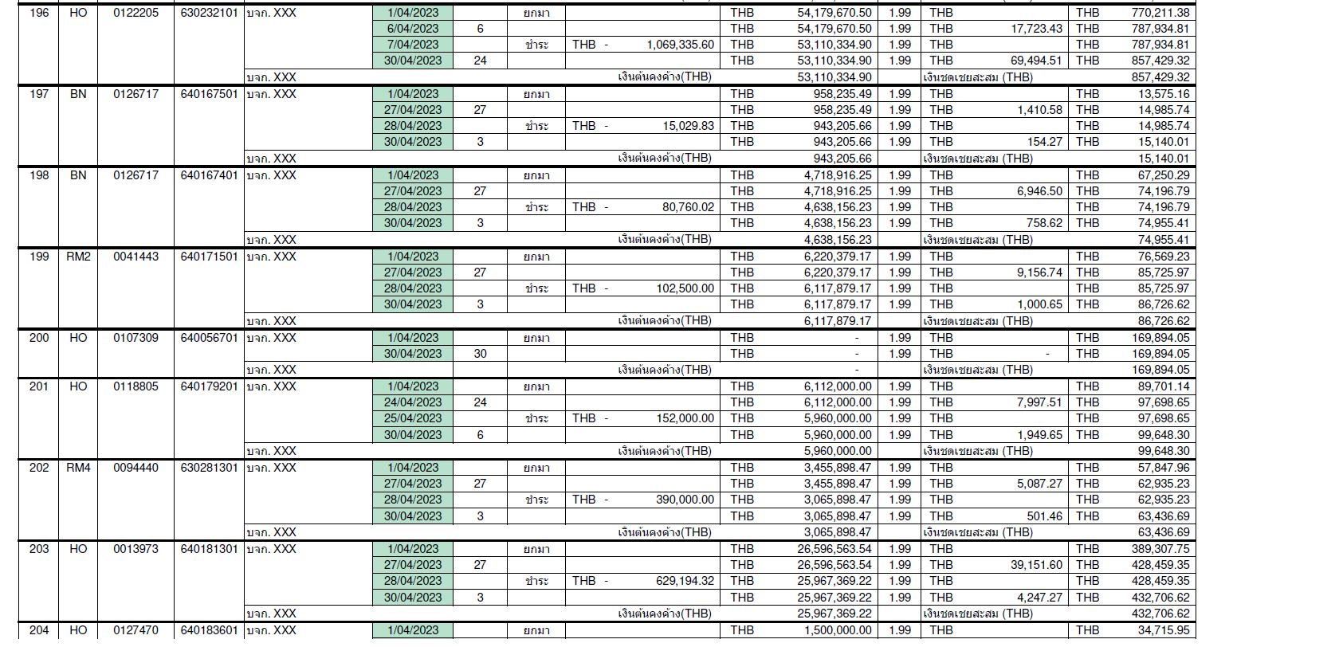

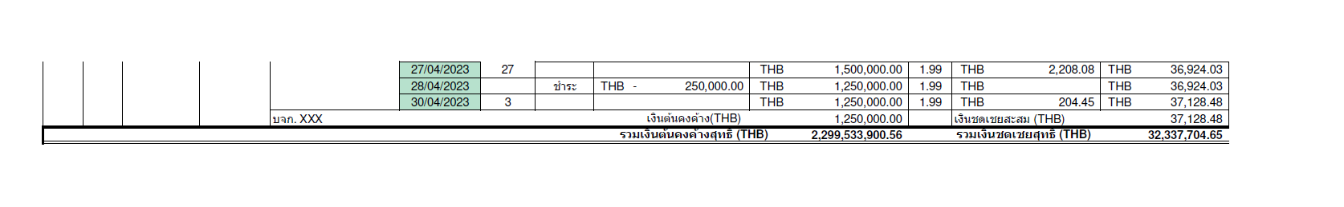

Note:

* Export to excel flie need to display formular (Inculed Formular in Excel).
* The language used in the report is based on As Is (every report).
* Need another people can print these report (Access authorize to another people to printing in CBS)

TG1 : Page 1

If customer have the fisrt drawdown in previous month the fisrt June dispaly outstanding amount form previous month.

If customer have the fisrt drawdown in the current report. The report should be inculde fisrt drawdown and display drawdown date.

Condition for using in the report are below:

* (Interest Differential Compensation: TG1 Report)
* (Interest Differential Compensation: BIZ Report)
* (Interest Differential Compensation: TT1, TT2 Report)

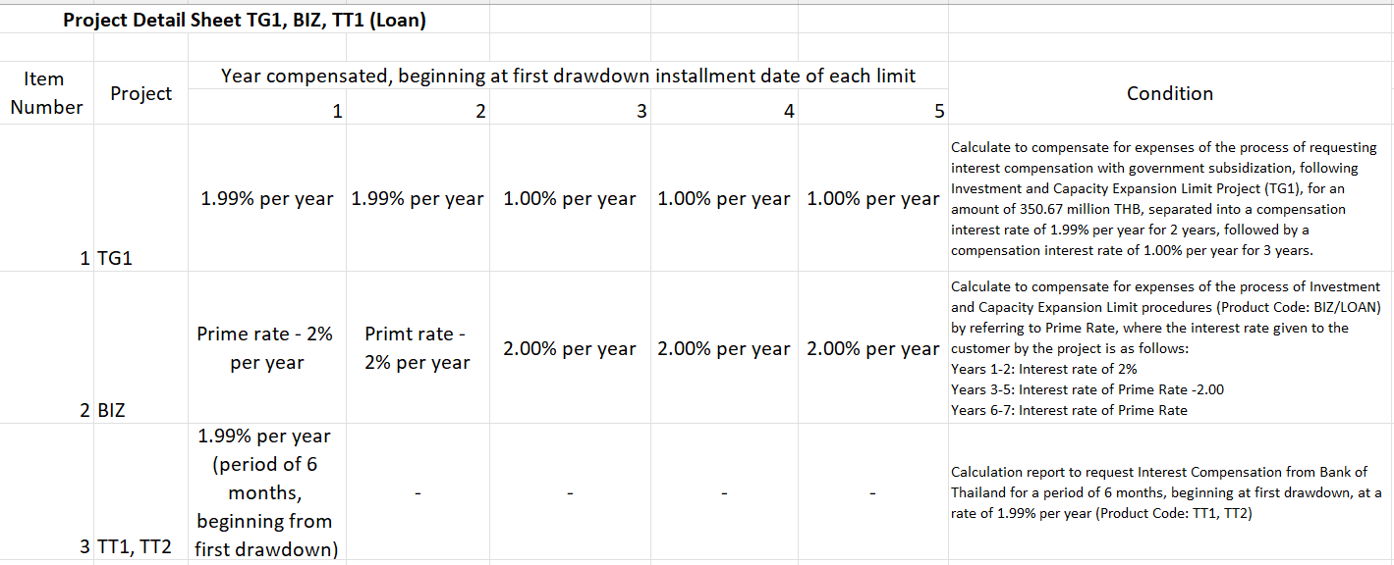

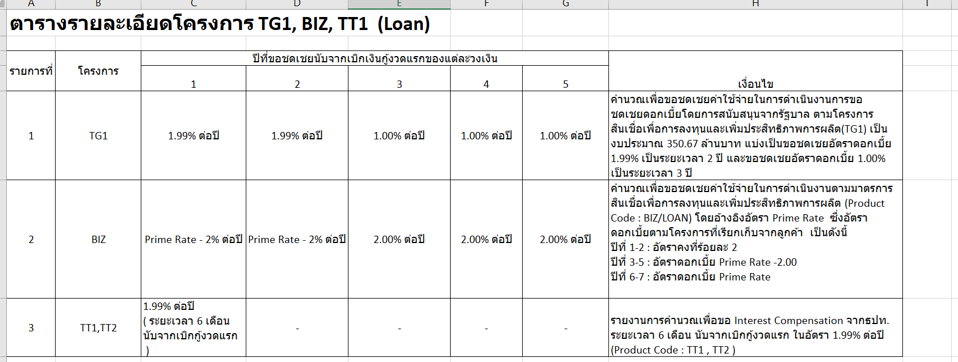

### Menu Modification

Not Applicable.

### Screen Layout and Data Sheet

Not Applicable.

### To-be Process

|  |  |
| --- | --- |
| Paper size | A4 |
| Reprinting require | Reprint |
| Searching criteria |  |
| Generation Frequency | Online, On request |
| Report Purpose | This report pertains to the loan with subsidy. |
| Actual Owner | Treasury, Accounting, Strategy |

|  |  |  |  |
| --- | --- | --- | --- |
| Report Title: ตารางดำเนินคดีลูกหนี้ TG1 (Lawsuit Report) | | Report Title: | Status |
| Exim Field: | Description/Formular | CBS9 Field: |
| ลำดับ | No of transaction |  | Choose an item. |
| สาขา | Operation code, branch code  customer code = book bank |  | Choose an item. |
| ลูกค้าเลขที่ | Customer ID |  | Choose an item. |
| วงเงินเลขที่ | Project code ID (Credit limit number) |  | Choose an item. |
| ชื่อลูกค้า | Customer Name |  | Choose an item. |
| วันที่ | date of drawdown  date of repayment  date of last day of the month  date of transaction |  | Choose an item. |
| วัน | Number of days |  | Choose an item. |
| รายการ | Transaction |  | Choose an item. |
| จำนวนเงิน | Amount |  | Choose an item. |
| เงินต้นคงค้าง | Principal Outstanding |  | Choose an item. |
| อัตรา% | subsidize interest rate  e.g. 2 year contract shows 1.99, 3 year contract shows 1.00  Ticker point will start calculated on first day |  | Choose an item. |
| เงินชดเชย | subsidize amount  (Principal Outstanding * Number of days * Subsidize interest rate/ year)  365 for currency bath |  | Choose an item. |
| เงินชดเชยสะสม | Accumulate subsidize amount  (The subsidize amount from last month + subsidize amount) |  | Choose an item. |
| เงินต้นคงค้าง (THB) | Total of principal outstanding by customer (THB) |  | Choose an item. |
| รวมเงินต้นคงค้างสุทธิ (THB) | Total Principal Outstanding |  | Choose an item. |
| รวมเงินต้นชดเชยสุทธิ (THB) | Total subsidize amount |  | Choose an item. |

### File / API Layout and Data Sheet

Not Applicable.

### Report Layout and Data Sheet

Not Applicable.

### Additional Impacts

#### Integration

Not Applicable.

#### Migration

Not Applicable.

## ตารางคำนวณชดเชยส่วนต่างดอกเบี้ย BIZ (Interest Differential Compensation: BIZ Report) (Related TOR – LN-55)

### Supported Sample Transaction and Case from Customer

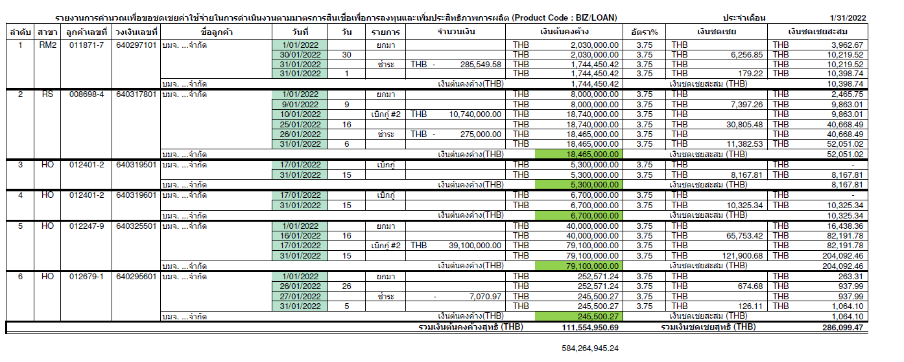Note:

* Export to excel flie need to display formular (Inculed Formular in Excel).
* The language used in the report is based on As Is (every report).
* Need another people can print these report (Access authorize to another people to printing in CBS)

### Menu Modification

Not Applicable.

### Screen Layout and Data Sheet

Not Applicable.

### To-be Process

|  |  |
| --- | --- |
| Paper size | A4 |
| Reprinting require | Reprint |
| Searching criteria |  |
| Generation Frequency | Online, On request |
| Report Purpose | This report pertains to the loan with subsidy. |
| Actual Owner | Treasury, Accounting, Strategy |

|  |  |  |  |
| --- | --- | --- | --- |
| Report Title: ตารางดำเนินคดีลูกหนี้ BIZ (Lawsuit Report) | | Report Title: | Status |
| Exim Field: | Description/Formular | CBS9 Field: |
| ลำดับ | No of transaction |  | Choose an item. |
| สาขา | Operation code, branch code  customer code = book bank |  | Choose an item. |
| ลูกค้าเลขที่ | Customer ID |  | Choose an item. |
| วงเงินเลขที่ | Project code ID (Credit limit number) |  | Choose an item. |
| ชื่อลูกค้า | Customer Name |  | Choose an item. |
| วันที่ | date of drawdown  date of repayment  date of last day of the month  date of transaction |  | Choose an item. |
| วัน | Number of days |  | Choose an item. |
| รายการ | Transaction |  | Choose an item. |
| จำนวนเงิน | Amount |  | Choose an item. |
| เงินต้นคงค้าง | Principal Outstanding |  | Choose an item. |
| อัตรา% | subsidize interest rate  e.g. 2 year contract shows 1.99, 3 year contract shows 1.00  Ticker point will start calculated on first day |  | Choose an item. |
| เงินชดเชย | subsidize amount  (Principal Outstanding * Number of days * Subsidize interest rate/ year)  365 for currency bath |  | Choose an item. |
| เงินชดเชยสะสม | Accumulate subsidize amount  (The subsidize amount from last month + subsidize amount) |  | Choose an item. |
| เงินต้นคงค้าง (THB) | Total of principal outstanding by customer (THB) |  | Choose an item. |
| รวมเงินต้นคงค้างสุทธิ (THB) | Total Principal Outstanding |  | Choose an item. |
| รวมเงินต้นชดเชยสุทธิ (THB) | Total subsidize amount |  | Choose an item. |

### File / API Layout and Data Sheet

Not Applicable.

### Report Layout and Data Sheet

Not Applicable.

### Additional Impacts

#### Integration

Not Applicable.

#### Migration

Not Applicable.

## ตารางคำนวณชดเชยส่วนต่างดอกเบี้ย TT1, TT2 (Interest Differential Compensation: TT1, TT2 Report) (Related TOR – LN-55)

### Supported Sample Transaction and Case from Customer

TT1,TT2 (Bank of Thailand project)

Example: Generate Report AS AT 1/31/2023

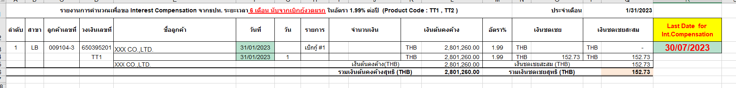

Example: Generate Report AS AT 5/31/2023

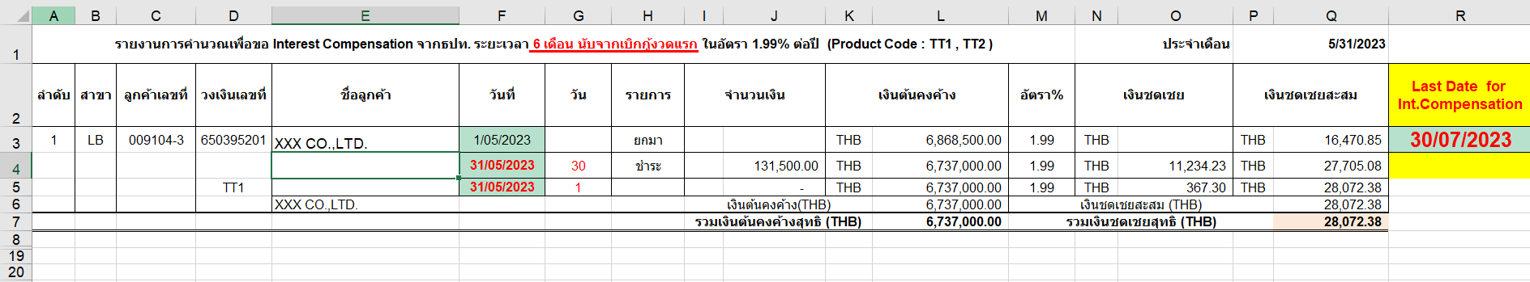

Note:

* Export to excel flie need to display formular (Inculed Formular in Excel).
* The language used in the report is based on As Is (every report).
* Need another people can print these report (Access authorize to another people to printing in CBS)
* Need to inculde interest of last date of the month.
* Starting from the date of the first drawdown until 6 months must be shown in the report.

### Menu Modification

Not Applicable.

### Screen Layout and Data Sheet

Not Applicable.

### To-be Process

|  |  |
| --- | --- |
| Paper size | A4 |
| Reprinting require | Reprint |
| Searching criteria | Date (EOM), Branch ID, Branch Name , Customer ID. Customer name . Project code (Credit limit number) |
| Generation Frequency | Online, On request |
| Report Purpose | This report pertains to the loan with subsidy. |
| Actual Owner | Treasury, Accounting, Strategy |

|  |  |  |  |
| --- | --- | --- | --- |
| Report Title: ตารางดำเนินคดีลูกหนี้ TT1,TT2 (Lawsuit Report) | | Report Title: | Status |
| Exim Field: | Description/Formular | CBS9 Field: |
| ลำดับ | No of transaction |  | Choose an item. |
| สาขา | Operation code, branch code  customer code = book bank |  | Choose an item. |
| ลูกค้าเลขที่ | Customer ID |  | Choose an item. |
| วงเงินเลขที่ | Project code ID (Credit limit number) |  | Choose an item. |
| ชื่อลูกค้า | Customer Name |  | Choose an item. |
| วันที่ | date of drawdown  date of repayment  date of last day of the month  date of transaction |  | Choose an item. |
| วัน | Number of days |  | Choose an item. |
| รายการ | Transaction |  | Choose an item. |
| จำนวนเงิน | Amount |  | Choose an item. |
| เงินต้นคงค้าง | Principal Outstanding |  | Choose an item. |
| อัตรา% | subsidize interest rate  e.g. 2 year contract shows 1.99, 3 year contract shows 1.00  Ticker point will start calculated on first day |  | Choose an item. |
| เงินชดเชย | subsidize amount  (Principal Outstanding * Number of days * Subsidize interest rate/ year)  365 for currency bath |  | Choose an item. |
| เงินชดเชยสะสม | Accumulate subsidize amount  (The subsidize amount from last month + subsidize amount) |  | Choose an item. |
| เงินต้นคงค้าง (THB) | Total of principal outstanding by customer (THB) |  | Choose an item. |
| รวมเงินต้นคงค้างสุทธิ (THB) | Total Principal Outstanding |  | Choose an item. |
| รวมเงินต้นชดเชยสุทธิ (THB) | Total subsidize amount |  | Choose an item. |

### File / API Layout and Data Sheet

Not Applicable.

### Report Layout and Data Sheet

Not Applicable.

### Additional Impacts

#### Integration

Not Applicable.

#### Migration

Not Applicable.

## ใบแจ้งยกเลิกวงเงิน/แจ้งหมดภาระหนี้ (Credit Limit Cancellation/Debt Discharge Notification report)

### Supported Sample Transaction and Case from Customer

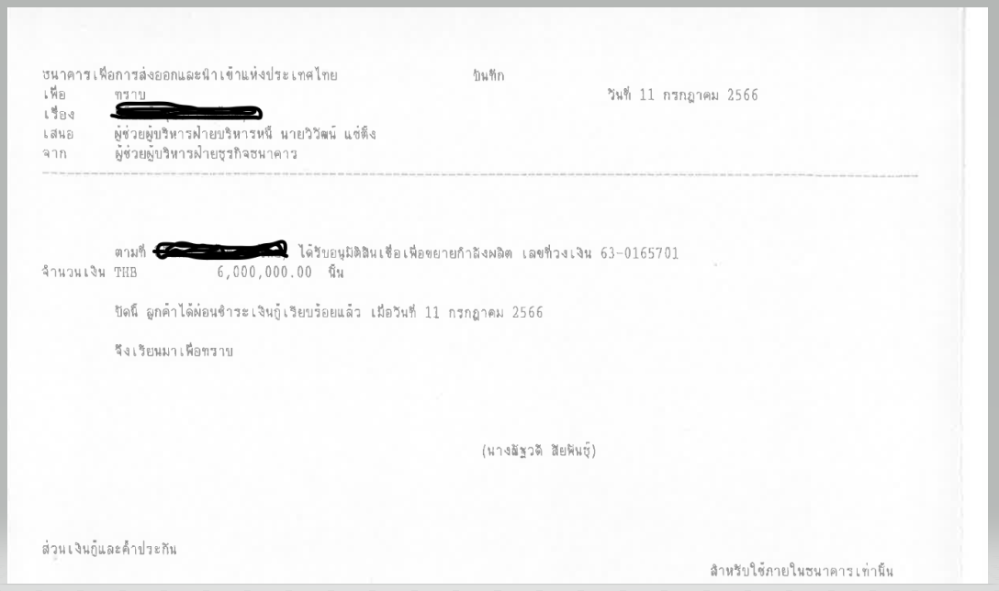

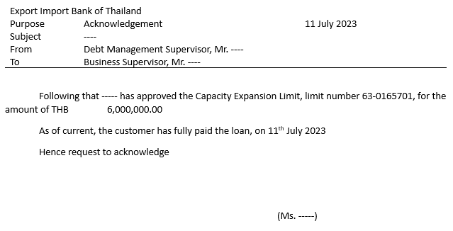

Note:

* This report contains all fully paid loan account (with zero outstanding). Report generation should be available on line and on demand. From-To date.
* The language used in the report is based on As Is (every report).

### Menu Modification

Not Applicable.

### Screen Layout and Data Sheet

Not Applicable.

### To-be Process

|  |  |
| --- | --- |
| Paper size | A4 |
| Reprinting require | Reprint |
| Searching criteria | Date , Customer ID, Customer name, Loan account number. |
| Generation Frequency | Online, On request |
| Report Purpose | Once the loan account is fully paid, Lending team submit this report to the Credit Limit team. |
| Actual Owner | Credit Limit Team |

|  |  |  |  |
| --- | --- | --- | --- |
| Report Title: ใบแจ้งยกเลิกวงเงิน/แจ้งหมดภาระหนี้ (Credit Limit Cancellation/Debt Discharge Notification report) | | Report Title: | Status |
| Exim Field: | Description/Formular | CBS9 Field: |
| บันทึก | Record |  | Choose an item. |
| ธนาคารเพื่อการส่งออกและนำเข้าแห่งประเทศไทย | Export Import Bank of Thailand |  | Choose an item. |
| เพื่อ ทราบ |  |  | Choose an item. |
| เรื่อง ชื่อลูกค้า |  |  | Choose an item. |
| เสนอ ผู้ช่วยผู้บริหารฝ่ายบริหารหนี้ |  |  | Choose an item. |
| จาก ผู้ช่วยผู้บริหารฝ่ายธุรกิจธนาคาร |  |  | Choose an item. |
| ตามที่ ชื่อลูกค้า ได้รับอนุมัติ ชื่อประเภทสินเชื่อ เลขที่วงเงิน.. จำนวนเงิน THB … นั้น |  |  | Choose an item. |
| ปัดนี้ ลูกค้าได้ผ่อนชำระเงินกู้เรีนบร้อยแล้ว เมื่อวันที่ … |  |  | Choose an item. |
| จึงเรียนมาเพื่อทราบ | Please be informed accordingly. |  | Choose an item. |
| ผู้ช่วยบริหารฝ่ายธุรกิจธนาคาร | Executive Assistant, Banking Business Department |  | Choose an item. |
| ส่วนเงินกู้ระยะยาว | long term loan |  | Choose an item. |
| สำหรับใช้ภายในธนาคารเท่านั้น | For bank internal use only |  | Choose an item. |

### File / API Layout and Data Sheet

Not Applicable.

### Report Layout and Data Sheet

Not Applicable.

### Additional Impacts

#### Integration

Not Applicable.

#### Migration

Not Applicable.

## List of transactions awaiting for Verification

CBS9 AS-IS Verification Screens for EXIM bank to use during their daily transactions.

Summary screen shown below is a standard CBS9 feature for the users to have a check of all their completed and pending transactions during the day.

This table can also be exported to an excel file and can be used as a report too.

Given this, report enhancements can be minimized.

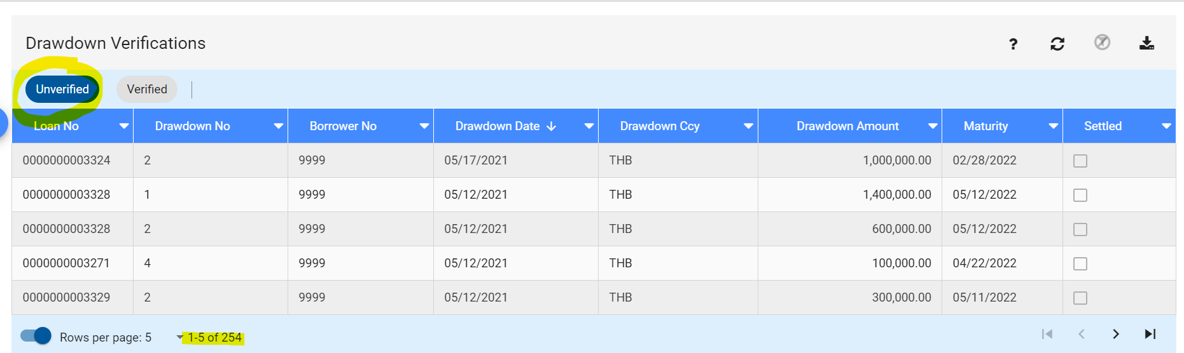

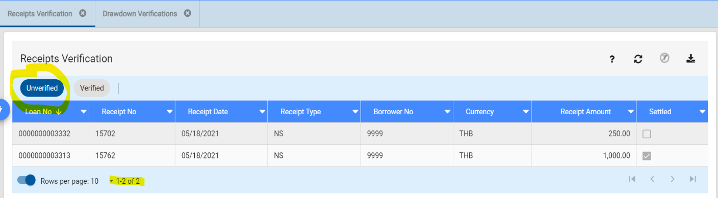

Other Verification screens (but not limited to) are:

• Drawdown Increase Verification

• Auto-receipt verification

• Repricing Verification

### Supported Sample Transaction and Case from Customer

### Menu Modification

Not Applicable.

### Screen Layout and Data Sheet

Not Applicable.

### To-be Process

|  |
| --- |
| Drawdown Settlement Instructions |
| Receipt Settlement Instruction    ไม่เอา |
| Drawdown Increase Settlement Instruction |

|  |  |
| --- | --- |
| Paper size | A4 |
| Reprinting require | Reprint |
| Searching criteria |  |
| Generation Frequency | Online, On request |
| Report Purpose | Requirement in G-33 to provide the report for all the Unverified transactions which EXIM will use as a workaround in checking |
| Actual Owner | Lending |

### File / API Layout and Data Sheet

Not Applicable.

### Report Layout and Data Sheet

Not Applicable.

### Additional Impacts

#### Integration

Not Applicable.

#### Migration

Not Applicable.

## Loan Fees and Charges

Requirement:

* Additional report criteria From Date - To Date.

### Supported Sample Transaction and Case from Customer

- Customer ID.

- Customer Name

- Loan No

- Fee no.

- Fee details (Fee Type)

- Fee Status : Paid, Unpaid

- Loan Account No./Drawdown No.

- Payment Details

- Date of Paymnet

- Payment method

- ccy

- Amount

- Fees collected from – to

- Fees Unpaid from – to

- Partially Supported

### Menu Modification

Not Applicable.

### Screen Layout and Data Sheet

Not Applicable.

### To-be Process

|  |
| --- |
|  |

|  |  |
| --- | --- |
| Paper size | A4 |
| Reprinting require | Reprint |
| Searching criteria | Fee status (Paid, Unpaud) , Fee Type, Loan Account No./Drawdown No., from date to date, Customer ID., Customer Name |
| Generation Frequency | Online, On request |
| Report Purpose | List of all the fees and charges attached to the loan account. |
| Actual Owner | Lending |

### File / API Layout and Data Sheet

Not Applicable.

### Report Layout and Data Sheet

Not Applicable.

### Additional Impacts

#### Integration

Not Applicable.

#### Migration

Not Applicable.

## Auto-Receipt / Fee Settlement Report (From-To Date)

### Supported Sample Transaction and Case from Customer

Sush as auto receitp with settlemet account number during draw down trasaction to meet TOR#LN-58 – LN-49.

- Partially Supported

### Menu Modification

Not Applicable.

### Screen Layout and Data Sheet

Not Applicable.

### To-be Process

|  |
| --- |
| Auto Receipt Settlement |

|  |  |
| --- | --- |
| Paper size | A4 |
| Reprinting require | Reprint |
| Searching criteria | Loan Account No./Drawdown No., from date to date, Customer ID., Customer Name |
| Generation Frequency | Online, On request |
| Report Purpose | This document serves as a reference for EXIM bank to contact their customer regarding funding the deposit account before the due date. Enhancement needed: To be able to generate report with From-To Date.  And need settlement A/C no. to display. In case customer no data for settlement A/C no. of themselves , need to display settlement A/C no. same as draw down transaction. |
| Actual Owner | Lending |

### File / API Layout and Data Sheet

Not Applicable.

### Report Layout and Data Sheet

Not Applicable.

### Additional Impacts

#### Integration

Not Applicable.

#### Migration

Not Applicable.

## Customer Movement Report (Loan Statement Generated per Customer)

### Supported Sample Transaction and Case from Customer

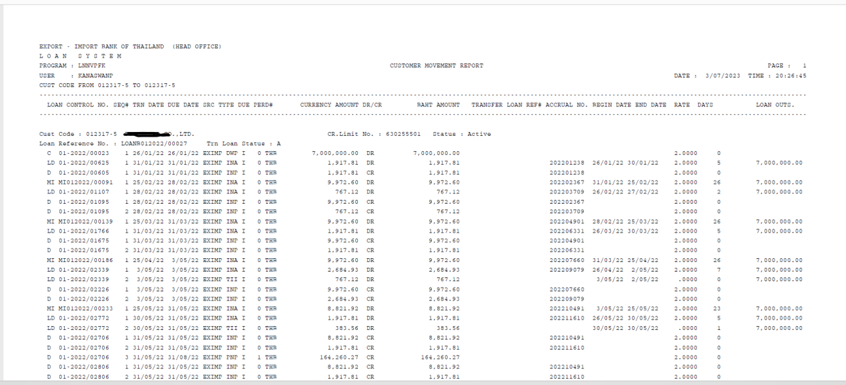

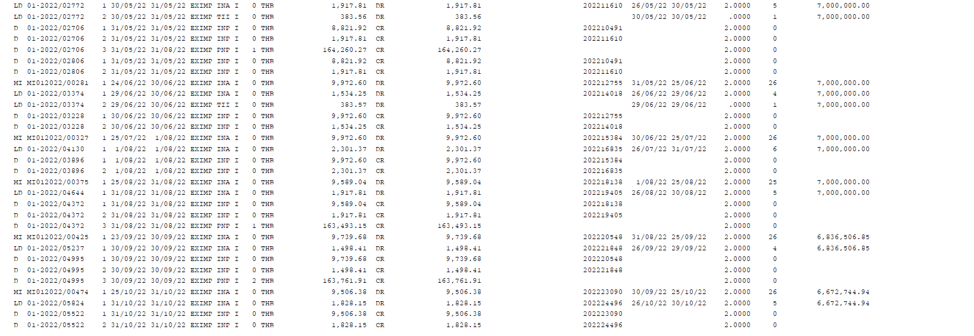

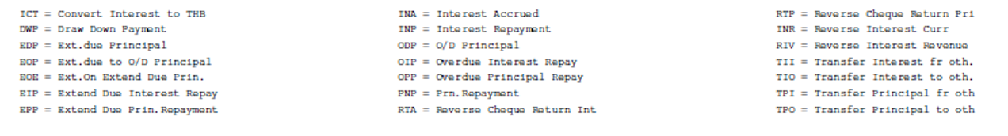

Note:

* No need MI because CBS 9 didn't accued ending 25th.

### Menu Modification

Not Applicable.

### Screen Layout and Data Sheet

Not Applicable.

### To-be Process

Same report from EXIM_LND_019 - Loan Statement can be used to generate.

|  |  |
| --- | --- |
| Paper size | A4 |
| Reprinting require | Reprint |
| Searching criteria | Customer ID From – To , Date (date for generate report), Project code (Credit limit number), Status (Status of customer), Loan Account No., Drawdown No. |
| Generation Frequency | Online, On request |
| Report Purpose | Same as statement of account, but this one is report generation per customer , having multiple loan accounts. |
| Actual Owner | Lending |

|  |  |  |  |
| --- | --- | --- | --- |
| Report Title: Customer Movement | | Report Title: Loan Statement | Status |
| Exim Field: | Description/Formular | CBS9 Field: |
| Page |  |  | Choose an item. |
| Date / Time | Date/Time for printing |  | Choose an item. |
| Export -Import Bank of Thailand (depend on search criteria) |  |  | Choose an item. |
| Loan system |  |  | Choose an item. |
| Program |  |  | Choose an item. |
| User |  |  | Choose an item. |
| Cust Code From - To |  |  | Choose an item. |
| Loan Control No | Credit note number (Receipt number)/ Accrued interest sequent (ถ้า CBS ไม่มีก็ไม่เอา) |  | Choose an item. |
| SEQ# |  |  | Choose an item. |
| TRN Date | Transaction date under Action C, LD, D  วันที่เกิดรายการภายใต้ Action C ,LD, D |  | Choose an item. |
| Due Date | Transaction end date under Action C, LD, D  วันที่สิ้นสุดรายการภายใต้ Action C ,LD, D |  | Choose an item. |
| SRC | Source of fund |  | Choose an item. |
| Type | Condition in picture |  | Choose an item. |
| Due | Status in due and overdue |  | Choose an item. |
| PERD# |  |  | Choose an item. |
| Currency amount | Currencywise |  | Choose an item. |
| DR/CR |  |  |  |
| BAHT Amount | Equivalent to Thai bath by using Mid rate |  | Choose an item. |
| Transfer Loan Ref# |  |  | Choose an item. |
| Accrual No. | Sequence of accrual |  | Choose an item. |
| Begin date | Date of accrual |  | Choose an item. |
| End date | Date of accrual |  | Choose an item. |
| Rate | The rate that occurs during the beginning date and end date periods.  อัตราที่เกิดขึ้นในช่วงเวลา Begin date and end date |  | Choose an item. |
| Days | (Count of stating - end date of accrual) Number of days |  | Choose an item. |
| Loan OUTS. |  |  | Choose an item. |
| Cust Code | Show the detail for each customer that selection |  | Choose an item. |
| Cust Name |  |  | Choose an item. |
| CR.Limit No. | CR. Limit No of Cust code |  | Choose an item. |
| Status: | Status of customer |  | Choose an item. |
| Loan Reference No | Loan account number/ Loan draw down number |  | Choose an item. |
| Tra Loan Status | Status of loan account |  | Choose an item. |

### File / API Layout and Data Sheet

Not Applicable.

### Report Layout and Data Sheet

Not Applicable.

### Additional Impacts

#### Integration

Not Applicable.

#### Migration

Not Applicable.

# Advices Specification

## Billing Notice

### Supported Sample Transaction and Case from Customer

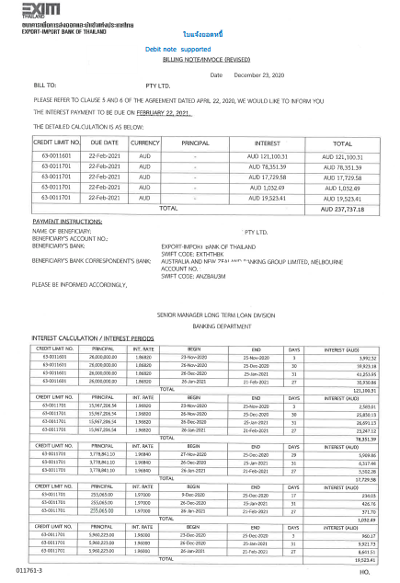

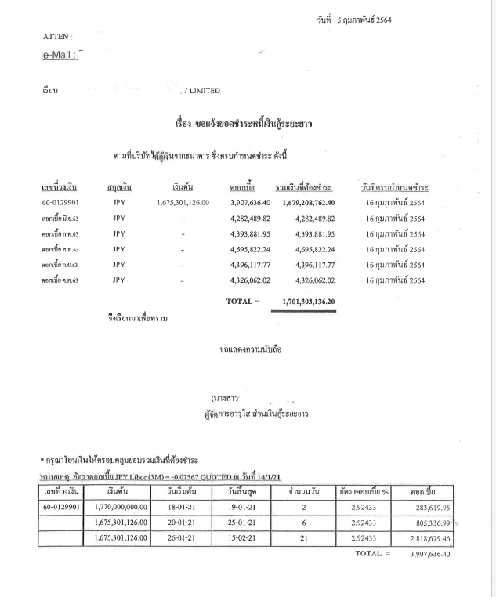

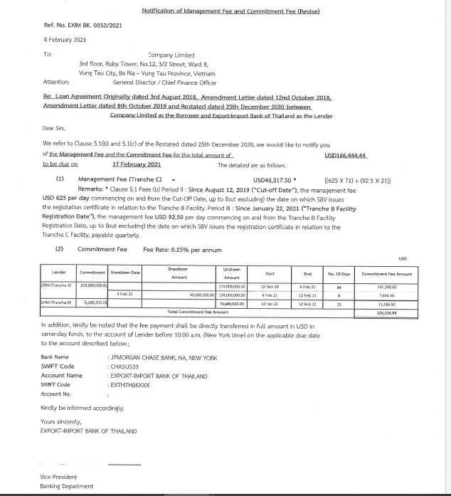

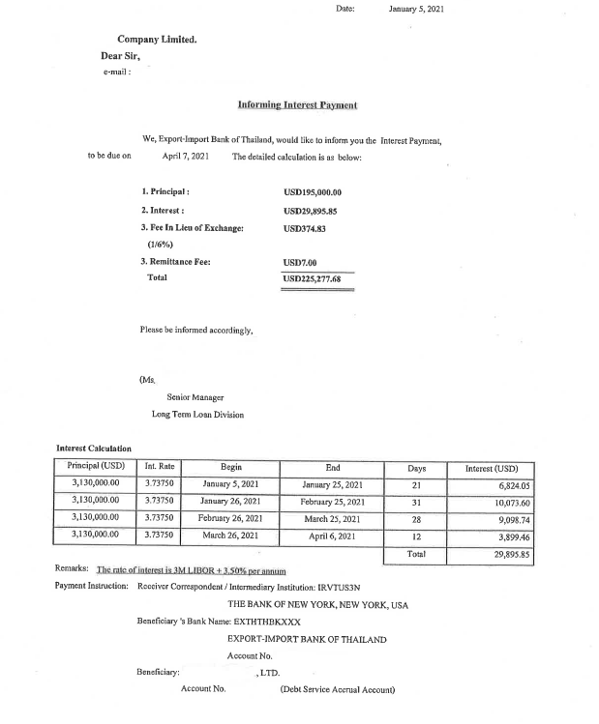

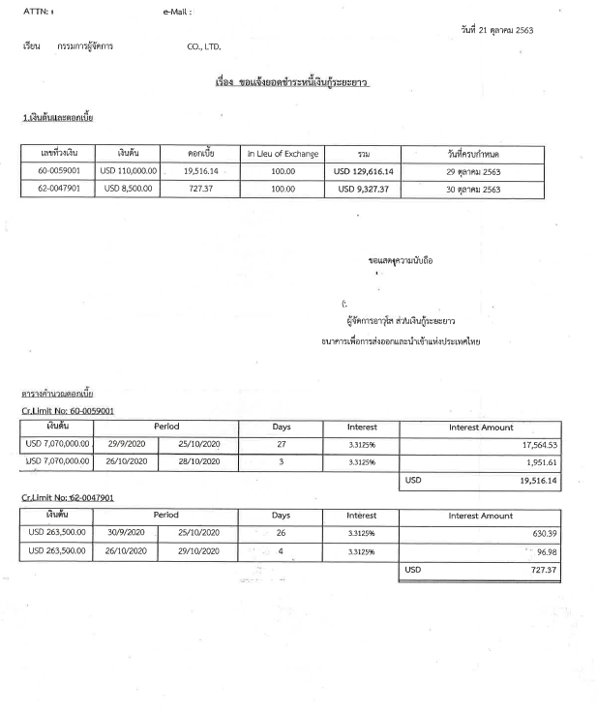

### To-be Process

AS IS CBS9

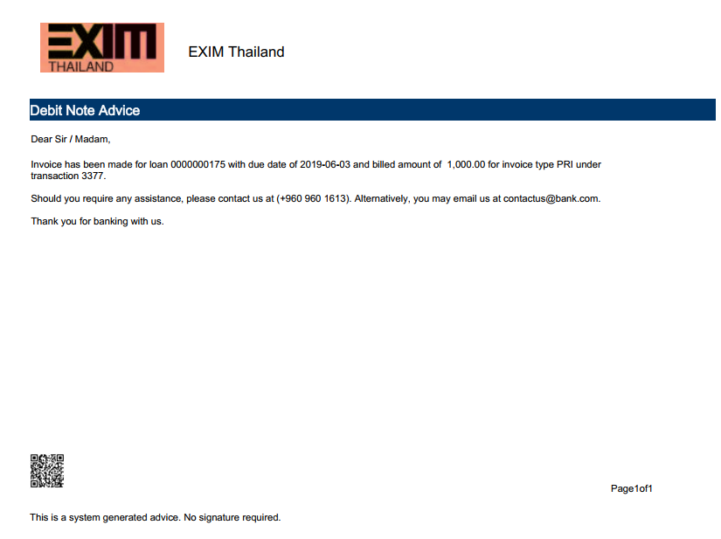

Requirement in CBS9

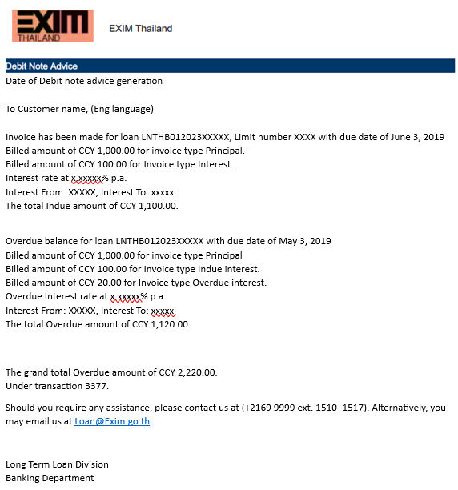

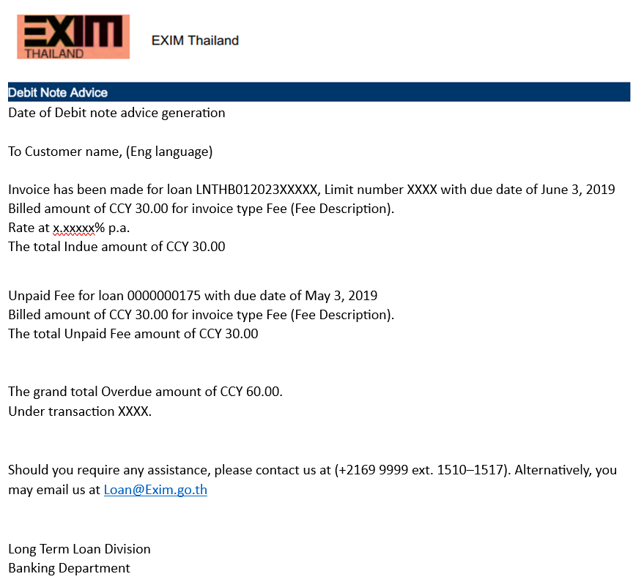

|  |  |
| --- | --- |
| Paper size | A4 |
| Reprinting require | Reprint |
| Searching criteria | Customer ID.,Customer Name,Loan account No./DD No., Due date ,Limit No./Project Code. |
| Generation Frequency | Online, On request, Interface |
| Report Purpose | To show total amount billed to the customer for the next due date. |
| Actual Owner | Client |
| File Document sample |  |
| Information ‘ s details | Should be shown the detail as topic Requirement in CBS9.  Indue and overdue amount displaying the total amounts will be shown in CBS Debit Confirmation advise.  Breakdown of due amounts can be generated in a separate report eg: Outstandign Debit Notes, Interest Calculation List, etc.  Billing notice for the Fees such as pre-payment fees and fees in lieu of exchange can also be generated based on the operational needs.  Prepayment fees can be set to create invoice automatically based on the prepayment principal amount while the Fee in Lieu of exhange can be created by EXIM bank manually as and when needed. |

**Note: Subsidized Product (TG1, BIZ, TT1, TT2)**

Incase Product is subsidized no need to shown subsidized interest amount in Billing Notice advices.(Show only actual interest rate which be collected from customer).

Example Picture:

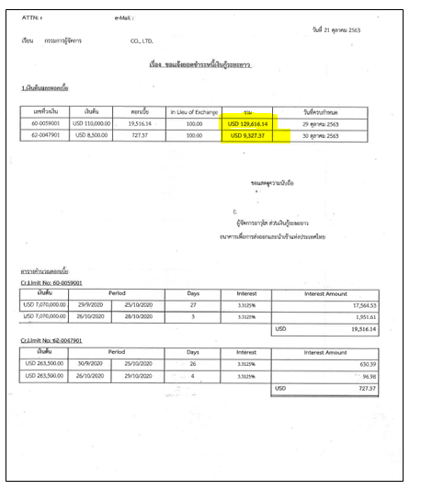

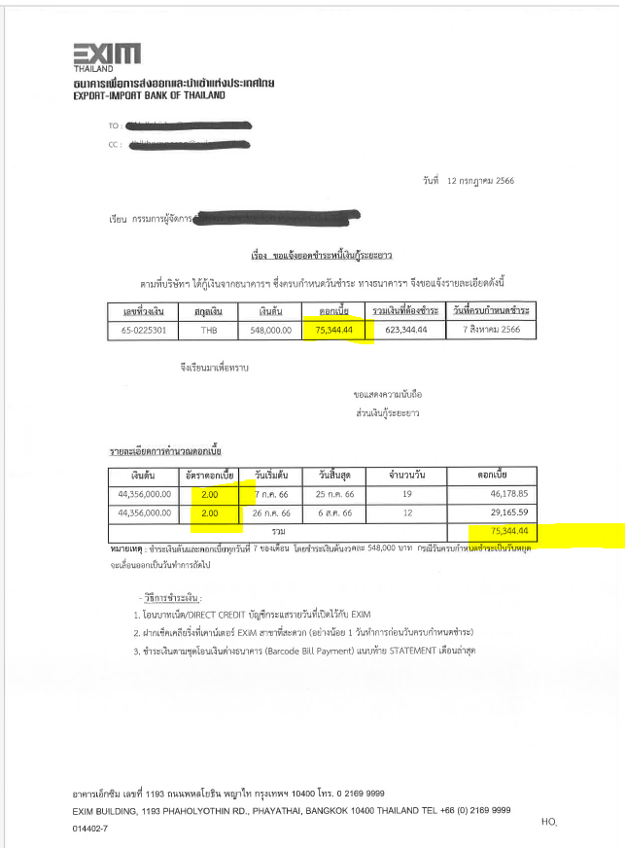

## Credit Note

### Supported Sample Transaction and Case from Customer

Template: Currency THB baht

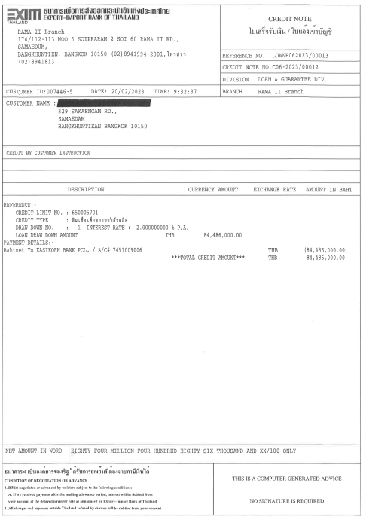

Template: Currency THB baht

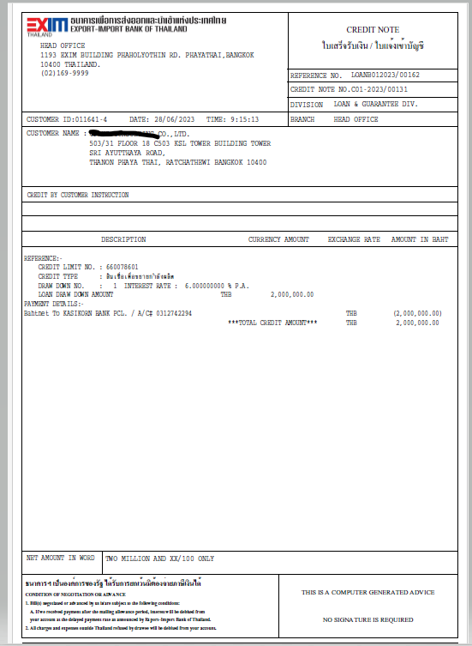

Template: Currency THB baht

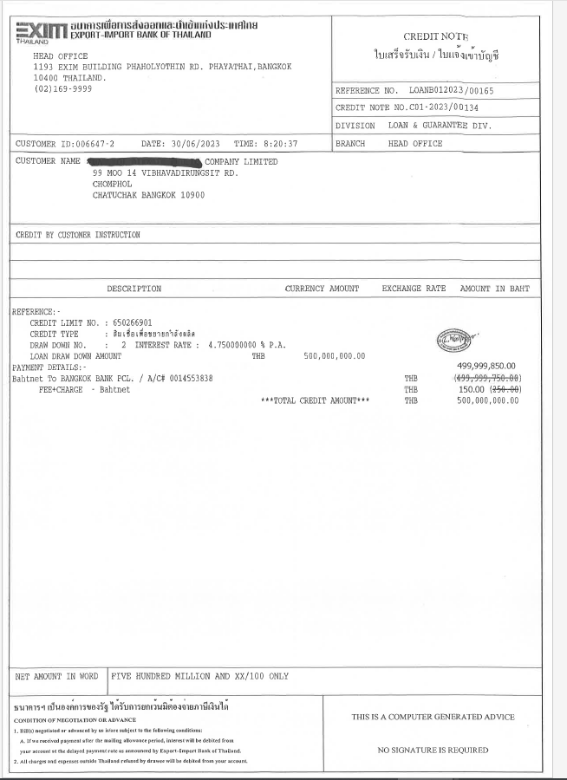

Template: Currency THB baht

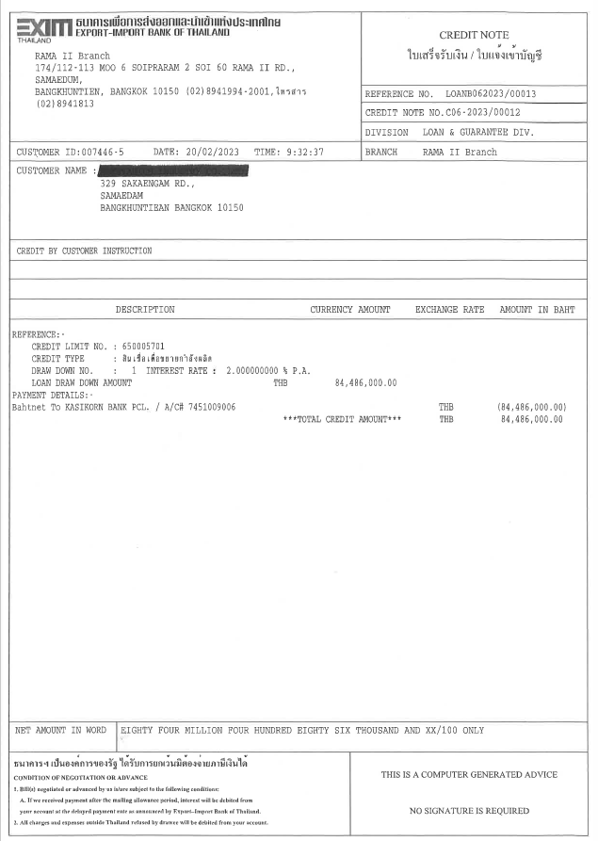

Template: Currency FCY

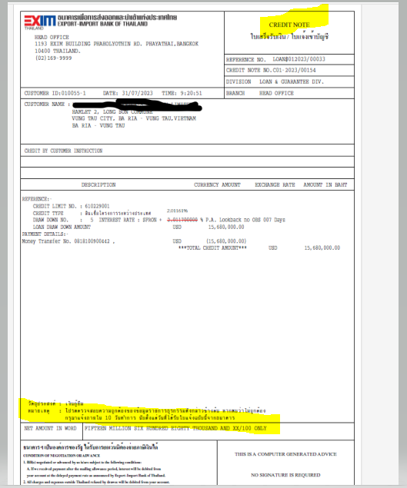

### To-be Process

AS IS CBS9

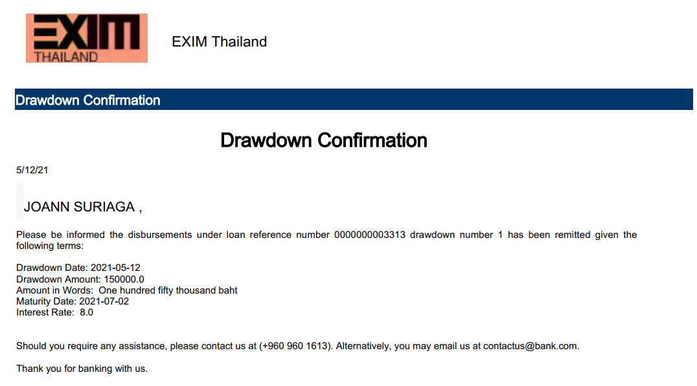

Requirement in CBS9

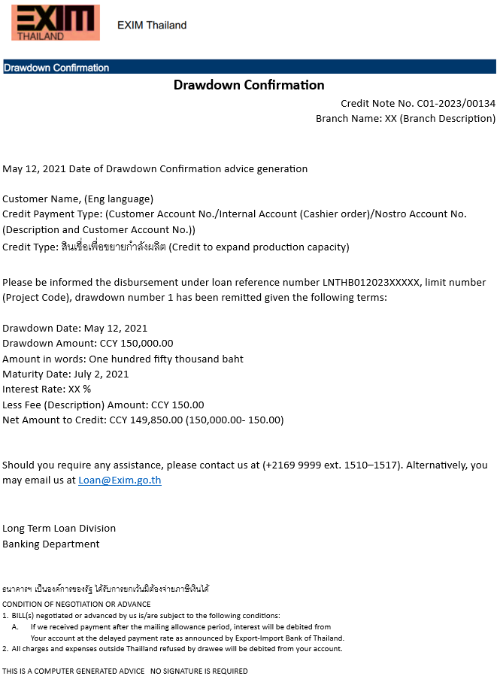

|  |  |
| --- | --- |
| Paper size | A4 |
| Reprinting require | Reprint  Note  Can provide user to print physical copy /document for drawdown/receipt confirmation even though not yet verified the related transaction. |
| Searching criteria | Customer ID.,Customer Name,Loan account No./DD No., Due date ,Limit No./Project Code. |
| Generation Frequency | Online, On request, Interface |
| Report Purpose | To show the payment made to the customer, which was obtained through loan disbursements. |
| Actual Owner | Client |
| File Document sample |  |
| Information ‘ s details | Should be shown the detail as topic Requirement in CBS9.  Note   * Need use the template as Exim As IS   (แบบฟอร์มตาม Exim ที่ใช้อยู่ปัจจุบัน)   * If Loan is in FCY, a note for the customer is mentioned that:   “วัตถุประสงค์: เงินกู้ยืม  หมายเหตุ : โปรดตรวจสอบความถูกต้องของข้อมูลรายการธุรกรรมดังกล่าวข้างต้น หากพบว่าไม่ถูกต้อง กรุณาแจ้งภายใน 10 วันทำการ นับตั้งแต่วันที่ได้รับใบแจ้งฉบับนี้จากธนาคาร”  “Objective: Lending  Note: Please check the accuracy of the transaction information above. If found incorrect, please notify within 10 working days from the date of receipt of this notification from the bank.”  Reference: Template Currency FCY    Reference: Structure Credit note no. |

**Note: Subsidized Product (TG1, BIZ, TT1, TT2)**

Incase Product is subsidized no need to shown subsidized interest amount in Credit Note advices.(Show only actual interest rate which be collected from customer).

Example Picture:

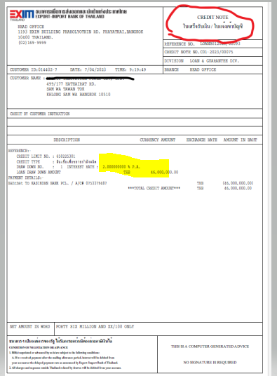

## Debit Note

### Supported Sample Transaction and Case from Customer

Template: Currency THB baht

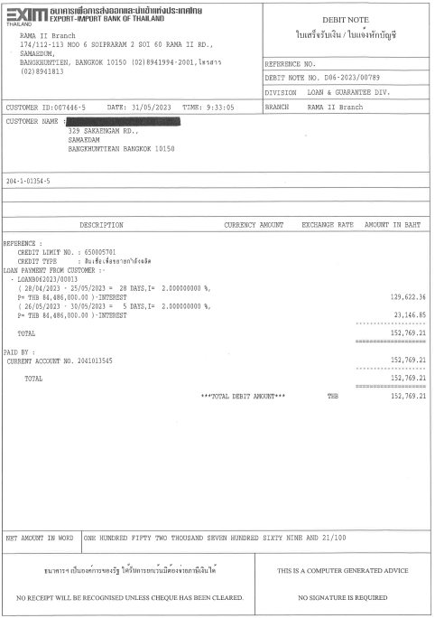

Template: Currency THB baht

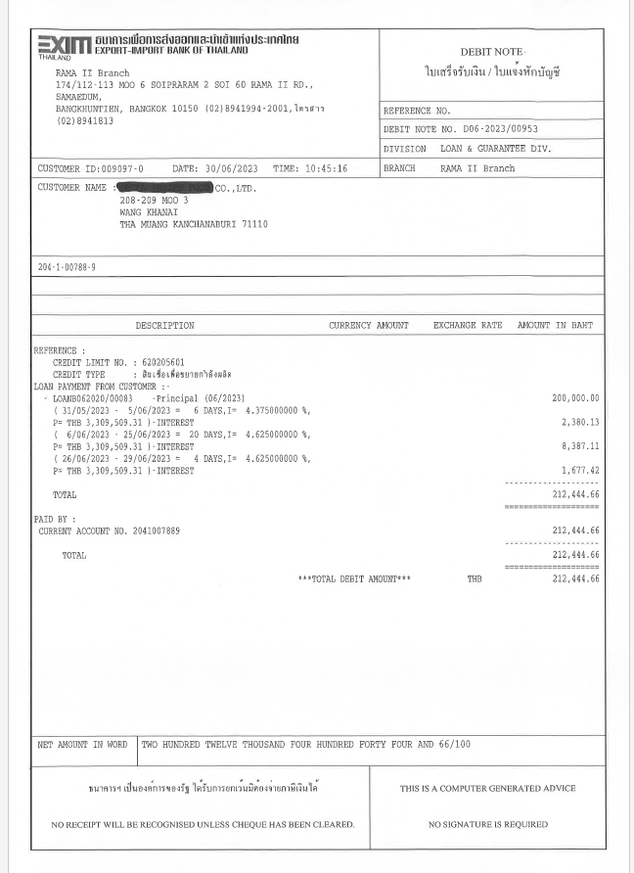

Template: Currency THB baht

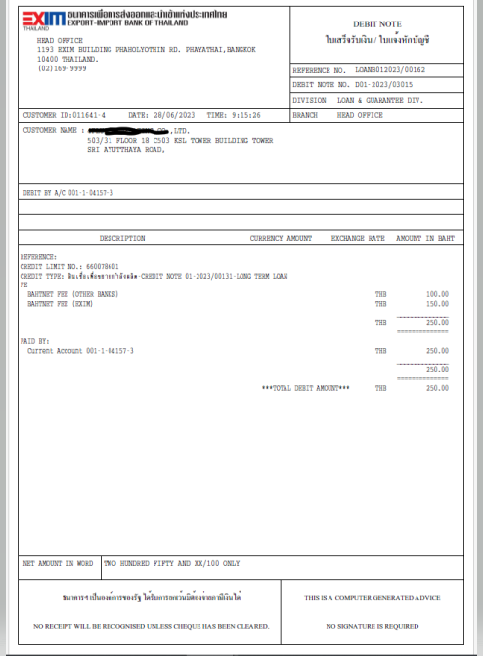

Template: Currency THB baht

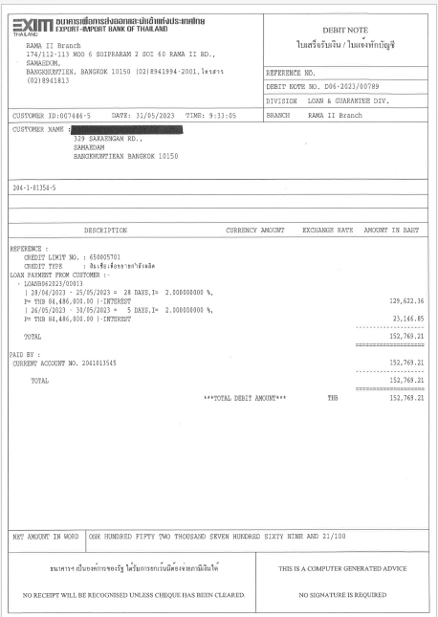

Template: Currency FCY

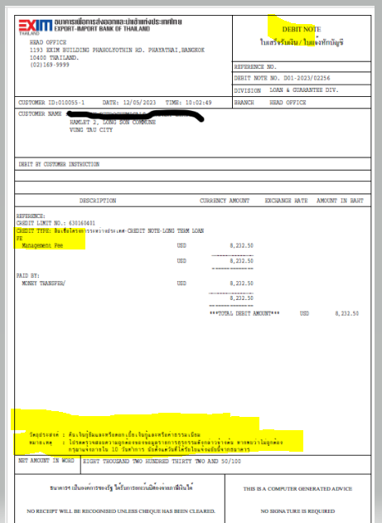

Template: Currency FCY

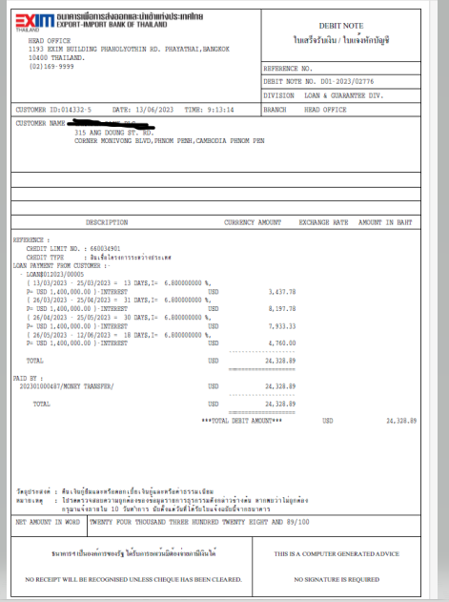

### To-be Process

AS IS CBS9

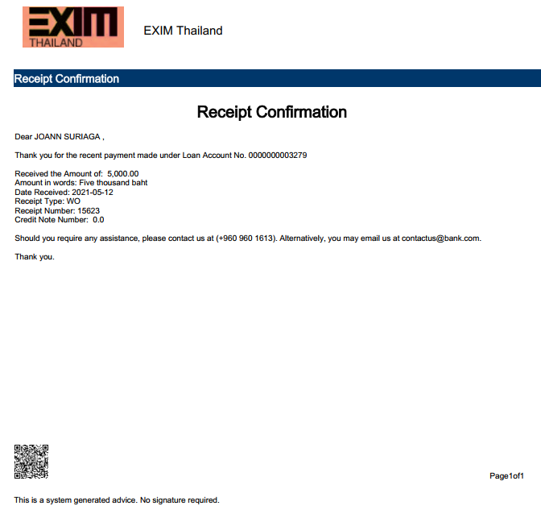

Requirement in CBS9.

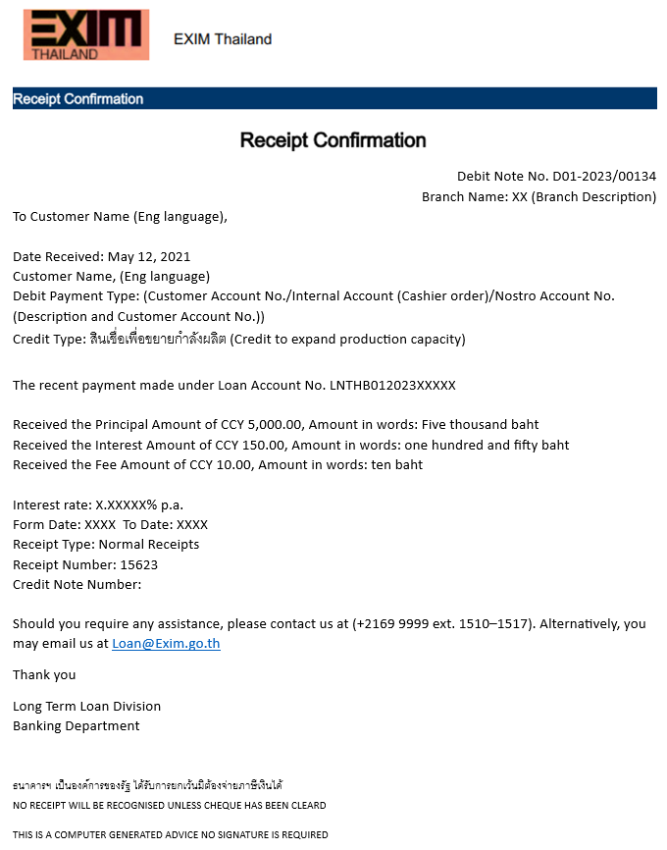

|  |  |
| --- | --- |
| Paper size | A4 |
| Reprinting require | Reprint  Note  Can provide user to print physical copy /document for drawdown/receipt confirmation even though not yet verified the related transaction. |
| Searching criteria | Customer ID.,Customer Name,Loan account No./DD No., Due date ,Limit No./Project Code. |
| Generation Frequency | Online, On request, Interface |
| Report Purpose | To show loan payment received from the customers including complete details of principal, interest, fees, etc. |
| Actual Owner | Client |
| File Document sample |  |
| Information ‘ s details | Should be shown the detail as topic Requirement in CBS9.  Note   * Need use the template as Exim As IS   (แบบฟอร์มตาม Exim ที่ใช้อยู่ปัจจุบัน)   * If Loan is in FCY, a note for the customer is mentioned that: “วัตถุประสงค์: คืนเงินกู้ยืมและหรือดอกเบี้ยเงินกู้และหรือค่าธรรมเนียม   หมายเหตุ : โปรดตรวจสอบความถูกต้องของข้อมูลรายการธุรกรรม ดังกล่าวข้างต้น หากพบว่าไม่ถูกต้อง กรุณาแจ้งภายใน 10 วันทำการ นับตั้งแต่วันที่ได้รับใบแจ้งฉบับนี้จากธนาคาร”  “Objective: Repay loan and/or loan interest and/or fees  Note: Please check the accuracy of the transaction information above. If found incorrect, please notify within 10 working days from the date of receipt of this notification from the bank.”  Reference: Template Currency FCY    Reference: Structure Debit note no. |

**Note: Subsidized Product (TG1, BIZ, TT1, TT2)**

Incase Product is subsidized no need to shown subsidized interest amount in Debit Note advices.(Show only actual interest rate which be collected from customer).

Example Picture:

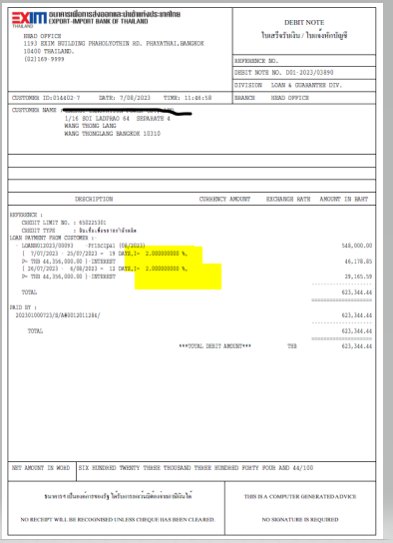

## Notice of the transfer of debt obligations and interest due

### Supported Sample Transaction and Case from Customer

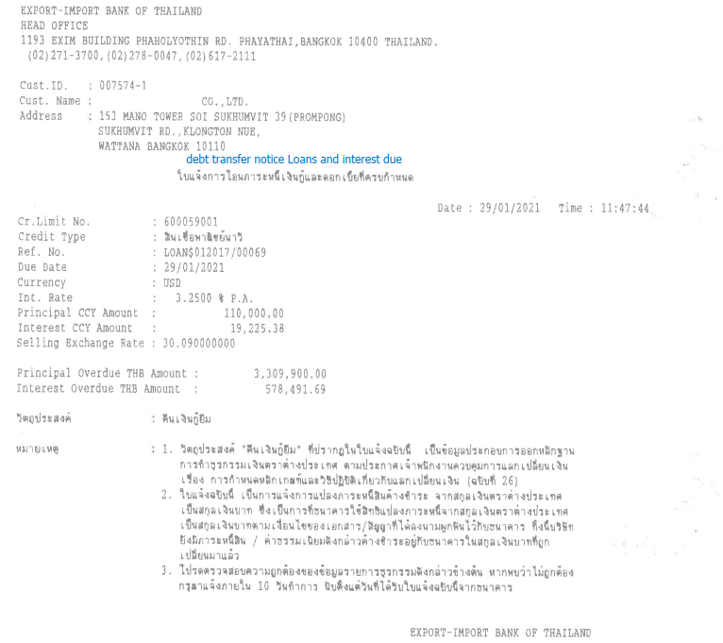

### To-be Process

|  |  |
| --- | --- |
| Paper size | A4 |
| Reprinting require | Reprint |
| Searching criteria | Customer ID.,Customer Name,Loan account No./DD No., Due date ,Limit No./Project Code., Adhoce convert from FCY to LCY. |
| Generation Frequency | Online, On request, Interface such as T4D, e-Service |
| Report Purpose | To show the total amount of loan which has been converted from foreign currency to local currency |
| Actual Owner | Client |
| File Document sample | Not available |
| Information ‘ s details | Need the details to be shown as topic 34.1 |

## Overdue Slip

### Supported Sample Transaction and Case from Customer

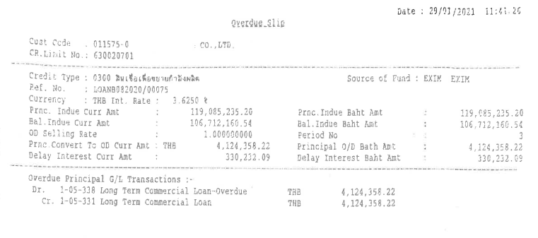

### To-be Process

|  |  |
| --- | --- |
| Paper size | A4 |
| Reprinting require | Reprint |
| Searching criteria | Customer ID.,Customer Name,Loan account No./DD No., Due date ,Limit No./Project Code. |
| Generation Frequency | Online, On request, Interface |
| Report Purpose | To show the loan due amount which is not paid by the customer. |
| Actual Owner | Lending |
| File Document sample | Not available |
| Information ‘ s details | Need the details to be shown as topic 35.1 |

## Fit/Gap Analysis Report

